Relative Atomic Mass

On the Periodic Table we note that the atomic mass for Hydrogen is listed as 1.01 g. This may appear odd as we know that the Hydrogen atom contains 1 electron (which has no significant mass) and 1 proton (which is a significant mass unit). We would thus expect that Hydrogen’s atomic mass for one mole of atoms would be listed as exactly 1g. For the same reason we would expect that sulfur would be exactly 32g as it contains 16 protons and 16 neutrons. How do we explain that the listed atomic masses are not exactly equivalent to the number of atomic mass units the atom contains?

The answer lies in the fact that the atomic masses that are listed on the Periodic Table take into consideration that in a natural occurring sample of hydrogen or sulfur, the atoms of the sample although all containing the same number of protons and electrons, on occasion, have variable numbers of neutrons. These atoms of an element that contain variable atomic mass units and thus have variable atomic masses are called isotopes. Since the neutrons are significant mass units, the atomic mass for an element in a sample must take into account that these isotopes do exist. Thus the atomic mass listed on the table is an atomic mass that takes into account the relative amounts of each of the isotopes in a sample. In essence, it is an indication of the average atomic mass found in the sample.

The idea of ‘relative amounts’ is difficult to understand. In order to understand let’s consider the ‘relative shoe size’ (SHr) of this chemistry class. Taking into account the makeup of this class, what do you think the average or ‘relative’ shoe size is for this class? This does not mean the most common (mode) or middle (median) size; we mean the average or mean size.

Shoe Sizes | Tally | Frequency | Percentage | Relative Amount (% x Shoe Size)

Total this final column to determine SHr
Complete the chart above to determine the ‘relative shoe size’ for the class. Use whole number sizes in order to hasten the process of completing the table.
Notice that the relative shoe size actually doesn’t exist in the sample. It is only a representation of the average size within this sample. For this sample of shoes we have variable amounts of each size and the ‘relative’ shoe size as a number takes into account the relative abundance of each – an average of all of the shoe sizes in the sample. Calculating the average shoe size might have been easier by taking the sum total of all the shoes sizes and then dividing by the number of students in the class. This is a possible strategy. This process though becomes too cumbersome when we have to sum total ALL of the atoms in a sample. This would be an impossible task. This can only be done realistically by knowing or determining percentage amounts of each of the isotopes and determining the portion of each that exists in the sample relative to the total composition of the sample.

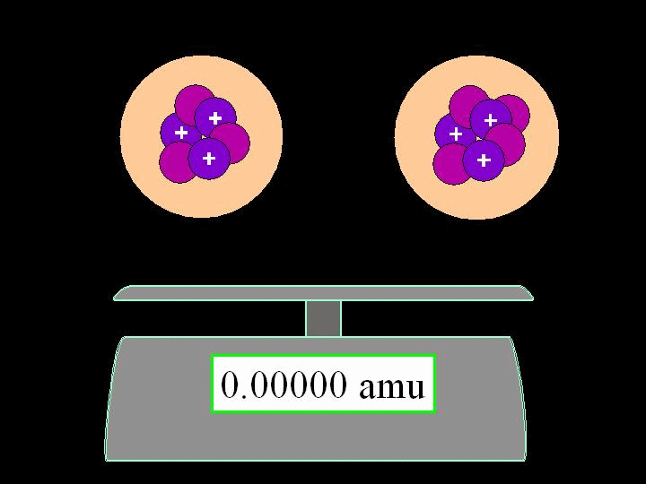

Let’s now take a look at a fictional sample of lithium. Lithium, atomic number 3, can have a variable number of neutrons in its nucleus. In the illustration above the nucleus of two lithium isotopes is illustrated. What would the mass of the left-hand isotope in atomic mass units (amu)? What about the sample on the right? Using the paper template provided on the next page and the three types of seeds on display create a realistic isotope of lithium by using the appropriate seed type and number on the Bohr model template. Remember to keep in mind when constructing your isotope model which sub-atomic particles and therefore seeds have the most mass.

What is its atomic number?

What is its mass number?

Express this symbolically in large letters in the top corner of your model template.

Li

Place this isotope in the lithium sample box at the front of the class. Someone will examine the sample to determine which isotopes are present in the ‘sample’. Complete the chart below as the sample is examined. Again determining a simple average is possible but in an authentic sample percentages of each isotope would be used to determine relative amounts because of the immense number of atoms present in the sample.

Lithium Mass Number | Tally | Frequency | Percentage | Relative Amount (% x Mass Number)

Total this final column to determine Ar for the Li sample.

Notice, again, that the relative atomic mass actually doesn’t exist. It is only a representation of the average size within this sample. Thus for this sample of lithium we have variable amounts of each isotope and the relative atomic mass as a number takes into account the relative abundance of each – an average of the entire lithium isotopes in the sample.

It is important to note that for our studies in chemistry the relative atomic mass provided by the Periodic Table is used in determining the atomic mass of individual atoms and the molecular mass of compounds. Although the atomic mass unit provides us an approximate atomic and molecular mass, it fails to take into account the presence of isotopes in a sample. Thus, when calculating the atomic or molecular mass of a substance, use the relative atomic masses provided on the Periodic Table rather than adding the number of neutrons and protons in the atoms.

Summary:

- Why is the atomic mass of oxygen listed on the Periodic Table as exactly 16.00 g whereas that of Carbon is 12.01 g?

- What is the difference between atomic mass and an element’s relative atomic mass?

- Why is it important to use an elements relative atomic mass in calculating the number of moles of a sample rather than just taking the total sum of atomic mass units for the element?

Bohr Model Template

Li
Bohr Model Template

Li

