Electricity: Changes in Inuit Society

A Two-Way Science Learning Unit for Northern Elementary School

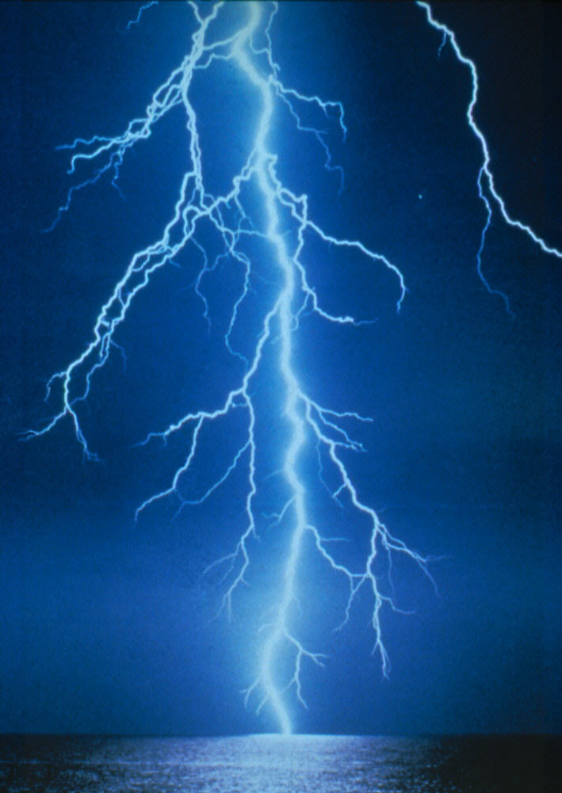

University of Manitoba
Centre for Research, Youth, Science Teaching and Learning
November 2007



Table of Contents

Topic Page

Guiding Principles of the Unit 3

Cross-Curricular Applications 4

Conceptual Framework 5

Skills Development 7

Attitudes and Beliefs Development 8

Curriculum Applications 9

Things to Consider in Preparing to Teach the Unit 10

About the Activities 11

Activities 12

Inuit Qaujimajatuqangit Background 61

References 66

Appendix 67

Guiding Principles of the Unit

- Provide two-way learning experiences by integrating Inuit knowledge, ways of knowing, beliefs and values and contemporary scientific knowledge, processes and attitudes.
- Draw upon traditional and contemporary Inuit cultural examples as contexts for student learning.
- Include the local community and its people in students’ learning opportunities as the classroom is an extension of the school and local community
- Foster language development in Inuktitut and, where required or encouraged, English.
- Use locally recognized pedagogical practices to promote student learning.
- Use science experiences as a rich context for promoting literacy and numeracy skill development.
- Use diagnostic and formative assessment to inform planning and teaching and monitor student learning.
- Engage students by starting lessons by providing first-hand experiences for students or drawing upon common experience.
- When using story to engage students, use the interrupted-story-line as a vehicle to prompt first-hand investigations.
- Deliberately promote scientific attitudes of mind (curiosity, problem-solving, working to end) student through thoughtful independent consideration of questions and challenges posed.
- Move from the experiential, first-hand experiences to the psychological; that is, after providing concrete experiences assist students in making sense of experiences by using purposeful strategies to promote understanding such as role plays, illustrations and analogies.
- Assist students in their consolidation of ideas only as an extension of the initial experiential and psychological learning experiences.
- Within the lesson and throughout the unit, move from concrete to more abstract ideas.
- Provide opportunities for student-initiated and directed investigations.
- Provide opportunity for students to make connections among science and all other learning areas.
- Foster student independence, creativity and curiosity by providing opportunity for students’ ideas and questions and follow-up opportunities for problem-solving and investigation.
- Provide students the opportunity to make connections between what they are learning and career opportunities.

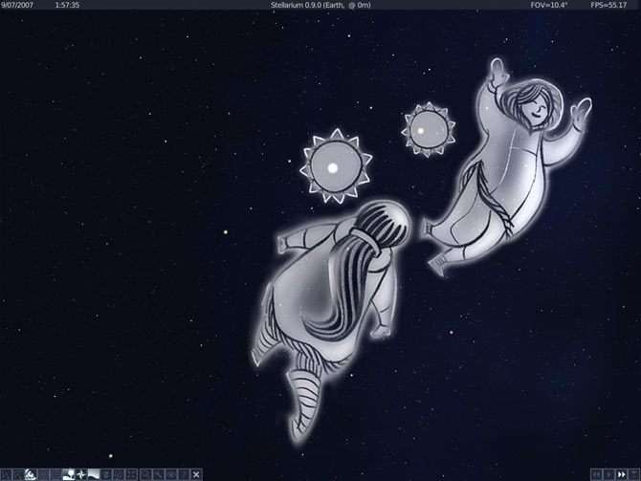

http://www.albertolucas.com/blog/wp-content/uploads/2007/08/0_9-inuit-art.jpg

Cross-Curricular Applications

This unit is developed with an emphasis on developing oral and written language skills within the context of electricity. The activities that are recommended encourage student expression of their experience in written, visual and oral form.

The unit has strong connections to appreciating the historical changes experienced within Nunavut as a result of technological change. Students are encouraged to consider how energy sources within our immediate world have changed, informed and improved the quality of our life, and supported our very survival. The emphasis on electricity within a societal context is inextricably linked to our understanding of electricity as a science phenomenon.

Students are encouraged to explore the sources of and uses of electricity within their immediate context, especially with the assistance of persons within the community who have experience and expertise in the suggested activities, both in traditional and contemporary knowledge. It is anticipated students will understand how reliant we have become on electricity and the safety issues associated with electricity use. Students will learn about simple electrical circuits and relate simple circuits to circuits within the home and circuits within the community. It is also anticipated that there are environmental implications associated with our current electricity sources.

There are obvious connections to social studies, personal health and well-being. Teachers are encouraged to make reference to social change and the environmental implications of our current electricity sources. The activities suggested are starting points. Broaden the focus by adding stories and activities of your own or from the experiential base of your community.

Conceptual Ideas and Progression

The recommended sequence for supporting student conceptual development of the phenomenon of electricity is suggested below. For the most part, the activities and the conceptual and skill development embedded within the activities are sequential. Lower elementary experiences and ideas primarily focus on experiencing and communicating these experiences. Upper elementary experiences focus on understanding and investigating these experiences and appreciating applications of this understanding to their students’ everyday world. It is suggested teachers address the following key ideas:

Lower Elementary (Grades 1-3):

- There are many things we use everyday that depend on electricity to work.
- The things we use electricity for can be categorized into groups such as heating, lighting and operating machines.
- Life in our community would be very difficult without electricity.
- Life was very different before electricity arrived in our community.

Upper Elementary (Grades 4-6)

- A battery is a source of electricity
- An electrical circuit requires and energy source, a means of carrying the electricity and a component that will use the electricity.
- A bulb contains a filament and resists electrical current causing friction which causes the filament to glow to produce light.
- A switch can be placed in a circuit to open and close the circuit.
- Insulators and conductors influence and electric current.
- Electricity can flow in circuits that are arranged in series or in parallel.
- Heating appliances are similar in that they form heat because of resistance.
- In our town the major source of electricity is the local power generator is run by burning diesel fuel
- Before the diesel generator there were wind turbines.
- The town’s electricity lines among households are arranged in series and in parallel.
- There have been many changes in our community because of the arrival of electricity.
- There are safety concerns associated with electricity.
- We need to make wise decisions about energy use in our community.
- Lightning and thunder are associated with electricity.

http://www.moonraker.com.au/techni/lightning.jpg

Skills Development

This unit emphasizes that the learning of science ideas is inextricably linked to the development of the processes of science. As asserted by the Northwest Territories Elementary Science Primary Program Guide, the legislated curriculum for Nunavut schools, science experiences should provide opportunity for the development of conceptual understanding within the context of relevant investigative experiences. Although individual scientific process skills may be emphasized in specific activities, they are to be supported more holistically in teacher-facilitated or student-directed inquiry.

The skills to be developed are expected to be appropriate to the level of the learner. These skills and a typical developmental sequence are outlined in detail in the NWT Primary Program Guide. Attention is given to providing students with first-hand experiences that promote skills such as:

Observing Communicating
Classifying Measuring
Predicting Planning Investigations
Inferring Interpreting Information
Recording Formulating Investigative Questions

These skills involve coordination between cognitive and muscular skills, often referred to as psychomotor skills. Handling and manipulating equipment require not just the physical ability to perform a task but also the intellect to know how to measure or observe accurately. It is anticipated that by the end of upper elementary a student might be able to, with assistance, conduct a scientific investigation. This unit provides opportunities for students to work physically and cognitively towards this end.

Attitudes and Beliefs Development

An explicit goal in the development of this resource and the other resources being developed in this Qikiqtani project and the accompanying professional development provided for teachers is to use these as a vehicle to contribute to student ‘success’ in science. Although success in science is often attributed to measurable outcomes such as knowledge acquisition and development, the intent of this development project is much more encompassing. It extends this notion of success to investigate the influence of ‘two-way’ learning experiences on students’ perceptions of success in their personal attitudes and beliefs.

What does success in science mean to Inuit students? It is anticipated that students will experience success in a variety of ways, beyond the border of knowledge into the domain of attitudes and beliefs. Attitudes are regarded as states of mind, behavior or conduct regarding some matter, as indicating opinion or purpose. The program of study suggested in the activities that follow will foster student curiosity and creativity, and openness to new ideas of thinking. As well students will develop confidence in their perceptions of self as students of science. Similarly they will develop confidence as evidenced in risk-taking and their effort to conduct science investigations. Their participation in the processes of science will foster their perseverance, precision and objectivity in solving scientific problems. As members of a team they will develop in their respect for and ability to work co-operatively towards purposeful goals with their peers.

Above all, it is anticipated that students will develop a more positive sense of themselves as Inuit in contemporary society as they learn about the inextricable link between science and the world in which they live. It is anticipated that students will see science as part of their life trajectory both in future formal and informal settings as a result of science study that advocates ‘two-way’ learning.

Curriculum Applications

In this context, the conceptual knowledge base and essential skills identified by these curricula are paired with Inuit cultural values, beliefs, and heritage to become the cornerstone of the learning provided in this unit. Both the Pan-Canadian and NWT curriculum address the concept of Electricity at Grade 3 and 6.Consequently, this unit addresses both lower and upper elementary learning objectives. It is suggested that teachers of Grade 6 use many of the Grade 3 (Lower Elementary) introductory activities as starting points for the Grade 6 learning objectives. The specific learning outcomes for the NWT Curriculum and Pan-Canadian Curriculum are not detailed here.

The General Learning Outcomes for both these levels include: Students will learn through investigations how electricity is used, how we have become dependent on it, how life has changed because of it, how circuits work in things like flashlights, houses and the community work and safety and environmental implications of energy use.

Lower Elementary:

- Identify how electricity is used,
- Understand how we have become dependent on it,
- Understand how life has changed because of it.

Upper Elementary:

- Demonstrate an understanding how circuits work in things like flashlights, houses and the community work.
- Demonstrate and awareness of the social, safety and environmental implications of energy use.

Things to Consider in Preparing to Teach the Unit:

In order for you to foster the development of the conceptual knowledge base and essential skills paired with Inuit cultural values, beliefs, and heritage in this unit give consideration to the following:

Your students’ capabilities and interests:

- What will be the language of instruction? If the language of instruction is English, how can you include and affirm Inuktitut in your instruction?
- Will students be keeping a written learning log? Again, will it include and affirm Inuktitut?
- What contexts suggested are likely to be of most interest and relevance to your students?
- Should the investigations suggested be teacher- or student-directed?

Your capabilities and interests:

- Consider the conceptual knowledge base, essential skills and Inuit cultural values, beliefs, and heritage affirmed by this unit. Where will you find the teaching challenging?

- What personal experiences, knowledge and skills can you bring to this unit? The unit provides opportunity for your strengths to be incorporated into the unit

The capabilities and interests of your teaching context:

This resource has been developed with consideration for northern Qikiqtani regions and its students. How can you work collaboratively with the school community to see the intentions of the unit a reality? Who are the individuals that can assist in ensuring Inuit Qaujimajatuqangit is incorporated into this unit.

About the Activities

Select a Starting Point:

Although a sequence of instruction has been provided for this unit of study your starting point will be a reflection of your students’ backgrounds and interests. Upper elementary teachers are encouraged to start with the lower elementary activities.

Select Knowledge, Beliefs & Values to Develop:

Again consider the interests of your students especially in terms of their Inuit Qaujimajatuqangit background.

Select Appropriate Skills to Develop:

Consider the investigative abilities of your students. What investigative skills are most appropriate for your students? The investigations suggested could either be teacher-facilitated or student-directed depending on the capabilities of your students. What is most appropriate?

Develop an Instructional Sequence:

Use the information provided in previous sections of this resource to assist in developing a coherent instructional sequence. The list of activities is only a suggestion of what might be addressed. Focus on the General Learning Outcome: Students will learn through investigations how uses and sources of electricity have changed, how a circuit works, how circuits are evidenced in things like flashlights our homes and the community and become more aware of the social and environmental implications of electricity use in our community and Nunavut.

Activities

Lower Elementary: Grades K-3

What do we know about electricity?

What You Need

Copies of the sheet: “What Things Need Electricity?”
Some actual objects illustrated on this sheet ensuring some are electricity users and some are not or at least larger images of each.

What You Do

- Write the word ‘electricity’ on the board and state the word.
- Ask students if they have heard or seen this word, a word that is commonly communicated on television and in video games. Ask the questions: “Have you heard of this word? If so, in what does it mean?
- Write down students’ responses paying attention to the contexts and meanings they attribute to this word. Most students will use it in reference to power or characters in stories or videogames that have power. Few students will associate electricity with things other than wires, plug-ins and switches. Few will be able to relate electricity to things like skidoos and flashlights that also use electricity from a battery source or with lightning. To confirm, ask students if electricity has anything to do with skidoos, 4-wheelers and lightning.
- Distribute the activity sheet that shows various objects that use or require electricity. Ask students in pairs to consider whether these objects use or require electricity. Have students circle those objects that do. Or, have students cut out the squares and place them in the correct category. Ask students to explain why they reason so. That is, what reason do they have for believing it requires electricity?
- As they finish, take larger images of these objects or the actual objects, if available, and get students to put them in two categories: objects that use or require electricity and objects that do not require or use electricity.
- Using their completed sheets as guides, move the images or actual objects into the ‘yes’ or ‘no’ I need electricity’. Get students to provide some justification as to why they belong in one category or the other.
- Ask students what the objects that need electricity have in common. Move towards students’ recognizing that all objects that need electricity require a source of energy from a source such as a plug-in or a battery. As well, the operation of the device will need some sort of a wire system to carry the electricity to the part that works, such as the light or the heater.
- Have students check and change their answers in response to the class discussion.
- Conclude the lesson by having students consider objects very familiar to them: skidoos, digital cameras, Ipods, flashlights and boat motors and ask if they need electricity to work. Can they suggest why?

What You Look For

The following questions should assist you in formatively assessing student learning. As well they might guide the entries students might make into their science journals.

- Can students identify objects that need electricity to operate?
- Can they give reasoning to support their answer? That is they need a power source such as battery or plug-in, wires and a part that uses the electricity.





What Things Need Electricity? How do you Know?

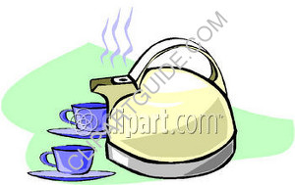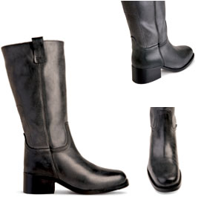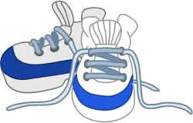

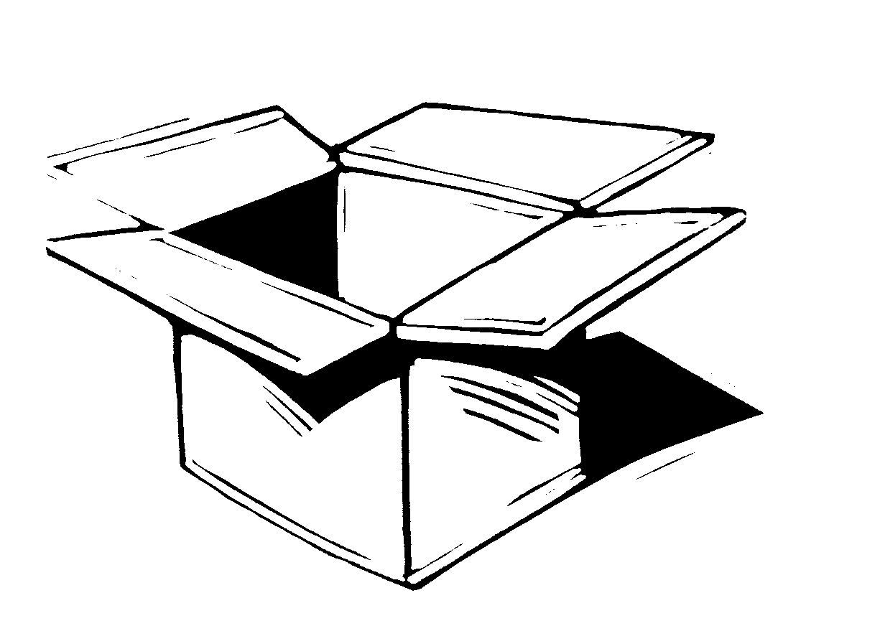
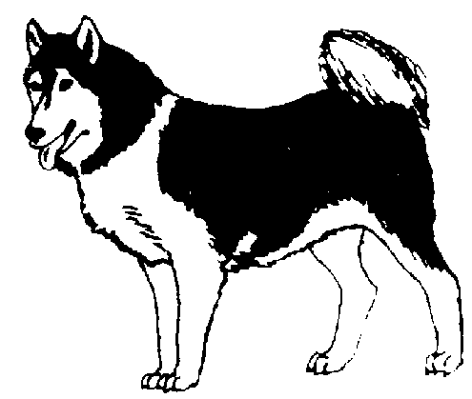

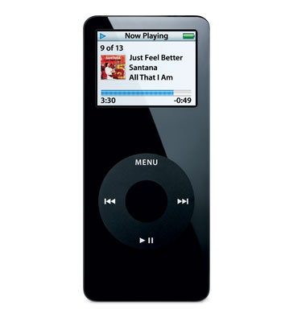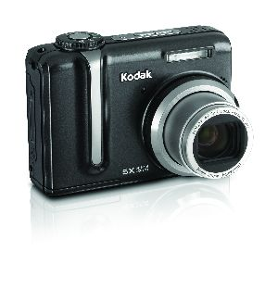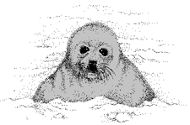

What Things Need Electricity?

Draw pictures of things that need electricity to work.

Draw pictures of things that do not need electricity to work.

What do you look for to find out if something needs electricity to work?

The things we use electricity for can be categorized into groups such as heating, lighting and making things work.

What you need:

“Which one does not belong?: Sheet that show various objects that use electricity
Plan of a house
Catalogue Pictures

What you do:

- Start the lesson by showing and listing on the board pictures from the “Which one does not belong” sheet of household objects that require electricity.
- Ask students to give the names of all of these objects.
- Take these objects and arrange them in a manner as shown on the sheet where two are for lighting and a third is not for lighting (lamp, flashlight, stove).
- Ask students to identify, with justification, which one does not belong.
- Emphasize that two the items use electricity to produce light, one using batteries and one using electricity through the community’s power grid.
- Ask students to provide the names of other examples of objects in the home that produce light by electricity and list these names on the board.
- Again take three objects and arrange them in a manner where two are for heating and a third is not for heating (oven, toaster, television).
- Ask students to identify, with justification, which one does not belong.
- Emphasize that two of the items use electricity to primarily produce heat.
- Again, ask students to provide examples of objects around the home that provide heat and list these names on the board.
- Again take three objects and arrange them in a manner where two are for making things work and a third is not (radio, television, toaster).
- Emphasize that two of the items use electricity primarily to do work.
- Summarize the activity by asking students to give further examples of objects that require electricity to do work and list these names on the board.
- Extend this activity by giving students the plan of the house. Get students to draw pictures of the objects on their sheet and on the board on the house plan provided. Get them to draw electrical cords to show how they receive their electricity assuming most, if not all, are from the town’s electrical supply.
- Get students to describe their completed picture to each other.
- You may wish to extend this activity by having students draw a house plan and glue pictures from a catalogue into the plan.

What you look for:

- Can they differentiate among the appliances as to what purpose they require electricity for?
- Can they provide further examples of appliances that require electricity for heating, lighting or doing work?

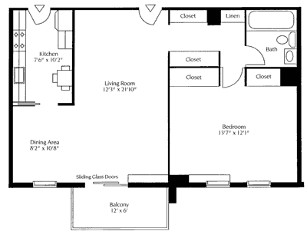

Objects in the Home that Need Electricity

Draw these things in the house that need electricity.

Kettle Computer Toaster Socks

Light Jacket Stereo Oven

Lamp Fridge PS3 Bread

CD player Telephone Knife Milk

Chair Table Camera Shoes

Which One Doesn’t Belong?

Below are three sets of household items. Which one does not belong in each set? Explain to someone why it doesn’t.

1. Group One

.  

2. Group Two

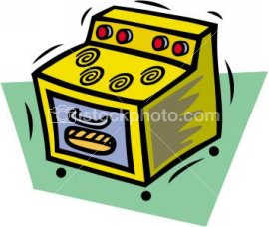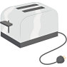

3. Group Three
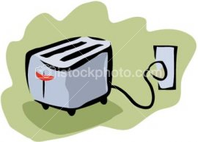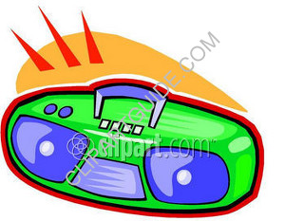

Life in our community would be very difficult without electricity

What you need

Piece of blank paper for illustrating
A Daily Sequence sheet

What you do

- Start the lesson by having students section their illustration paper into 4 sections by folding it into quarters.
- Ask students to illustrate in the four quadrants (1) a picture of them doing their favorite thing to do in the world; (2) a picture of them inside their house in the dark season doing their favorite thing; (3) a picture of them at school in the dark season doing their favorite thing and (4) a picture of them doing their favorite thing in the dark season in or near the community.
- After they have finished ask them to consider what would happen if there was no electricity, would these activities be affected in any way?
- Record their responses on the board and ask them to complete this sentence for each section of their illustration: “If there was no electricity….”
- Discuss the implications of their being no electricity in the dark season.
- Discuss, with reference to their picture, what the implications would be of no electricity if there was no electricity in the light season.
- Discuss the importance we play on electricity. Possibly students can recall a more recent and longer power shortage and how that influenced their lives.
- Discuss what serious situations arise because there is no electricity: e.g., health, emergency services, GPS, police communication.
- Have students with support complete the Daily Sequence sheet by circling or underlining activities that would be affected by a lack of electricity.
- Re-write the sequence by having students explain what might happen if they had no electricity what they might have to do.
- Students might respond to sentence completion questions like:
If there were no lights in our house……
If there was no hot water…….
If there was no stove……
If there was no television or radio……
If there were no telephones…..
If there were no computers…
If there were no skidoos or trucks….

What you look for

- Can students identify activities that would be affected by having no electricity?
- Can they understand that most forms of transportation also require electricity through batteries to activate the motors?
- Can students suggest alternative activities when they have no electricity?

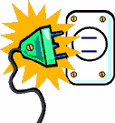

Things I Enjoy Doing

My Favorite thing to do at Home | My Favorite thing to do at School
My Favorite thing to do in my Town | My Favorite thing to do in the World

Part of a Day in the Dark Season without Electricity

1. I wake up when I hear the radio playing.
2. I turn on my bedroom light.
3. I go to the toilet and flush the toilet.
4. I wash my hands in hot water.
5. I turn on the television.
6. I go to the kitchen and plug in the kettle.
7. I take a piece of bread and put it in the toaster.
8. I put hot chocolate in a tea-cup.
9. I put water in the cup.
10. I stir the water to make a drink.
11. I butter the bread and put jam on it.
12. I talk to my family.
13. I begin to watch television.
14. I eat my bread and drink my hot chocolate.
15. I go to the bathroom and brush my teeth.
16. I get dressed for school.
17. I say good-bye to my family and walk to school.
18. My brother’s friend gives me a ride to school on the skidoo.
19. I go in the school and go to my classroom.
20. We drink hot soup in the classroom and have crackers and cheese.
21. We listen to O Canada and the announcements on the school intercom.
22. We do our morning journal writing.
23. We learn some mathematics.
24. We read a story together as a class.
25. We go to the gym to play soccer.
26. We watch a video on the whales in our area.
27. An elder comes to our classroom and talks to us about whale-hunting long ago.
28. We ask questions and then draw a picture and write a story about what the elder tells us.
29. We get a ride home for lunch in the truck with my mother.
30. We have macaroni and cheese and bannock for lunch.
31. I listen to the radio with my family.
32. I help wash the dishes.
33. I walk back to school.
34. We go to the computer room and look at pictures of whales and whaling.
35. We write a story about whaling today.
36. At our classroom we take turns reading our stories to others.
37. We go to EL2 or Inuktitut and learn about words for whales in English or Inuktitut.
38. I go home after school and ……

Life was very different before electricity arrived in our community

What you need

Elders’ stories pertaining to life without electricity

What you do

- The previous activity focused on helping students to appreciate the dependence we have on electricity and the impact of having no electricity on our lives. This ‘lesson’ focuses on helping students to see that life without electricity was THE way of life just two generations ago. It is essential that students are given the opportunity to listen to the stories of this life through the visitation of an elder or elders.
- In advance of the elders attendance gauge students’ understanding of what life was like for Inuit in your area. What stories have they heard? What did they do for heat, light and machines to get work done? What objects that are present in our life to day were not present in their life?
- Possibly a good way to approach this diagnostically is to use the sheet the follows or get students to cut out pictures from a catalogue of objects that use electricity from the community power plant or from batteries (e.g., stove, lamp, telephone, skidoo, radio, GPS, toaster, flashlight, 4 wheeler, computer, refrigerator) and glue these to a piece of paper divided into 8 sections.
- Can they illustrate beside each picture what alternative was used when there was not electricity?
- There are a variety of sources that students might use to prepare for an elders visit including the stories that follow. Use the interrupted story line as a means of piquing students’ curiosity.
- Let the elders focus on their life without electricity, especially in regards to what they did for heating, cooking, light and transport in the dark season. Also encourage them to give attention to the rapid changes they have experienced in their life time.
- Get students to illustrate or model these stories. Possibly get students to develop two models or illustrations: one of a traditional winter camp out of materials or posters of and another of the community. Ensure students focus on sources of heat, light and machines used to do work and communicating among themselves and to the class or other classes these differences.

What you look for
- Can students communicate the differences in sources of energy for heating, light and making things work in past and present northern
society?

What Did our Elders do Before Electricity?

Life Today | Life Long Ago

Life without Electricity: The following story is an adaptation of an interview with Jaco Peterloosie of Pond Inlet

At first all we had for light and cooking was the oil lamp, the qulliq. In the dark season we sometimes had the moon for light and cooking, but still, even with the moon, it was so important to have the qulliq. It was very important to us.

If we were working inside the iglu and needed to see well, we could light more of the qulliq to get more light. The qulliq had a wick of cotton flower in it and by lighting more of it we got more light. We could take a stick and dip it in the oil of the qulliq and light the stick. Then we could carry the stick and use it to look for things in the iglu.

When we worked outside the iglu we would have the qulliq near the entrance to the iglu. Then the light from the qulliq would give light outside and we would be able to do work like fixing the komatiq.
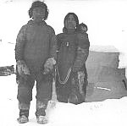
Then when the kerosene lanterns and primus stoves came it was so different. We could light up the night around the igloo because of the great light it gave off. We used to be amazed that there could be such bright light from the kerosene oil lamp. We took care of the lamp because the glass was so fragile. It was easy to break and it was very important to us. We used these things sparingly as we needed to conserve the fuel. The qulliq was still used.
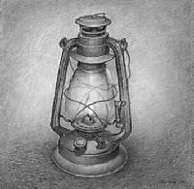 http://www.dianefarrisgallery.com/artist/xiong/ex96/images/image08s.jpg

When Electricity Came: The following story is an adaptation of an interview with Annie Peterloosie of Pond Inlet

We would always be excited when people came back to the camp from Mittimatalik (Pond Inlet: the place where Mittima is buried). Mittimatalik was where the store was and it was here that special things would always come from. There was one time they brought a lantern back to the camp. It was so bright. I would look at it really closely for a long time and then when I would look away I would see lots of black spots because I had looked at the light too closely. Or, sometimes you would get black suet on your face from the lantern because we would put our face so close to it.

Then, one time when I was still in my mother’s amouti I remember coming to Mittimatalik and coming near the store. It was so bright inside and the light was hanging from the ceiling of the store. I was fascinated that there could be so much light and that it came from this object hanging from the roof.

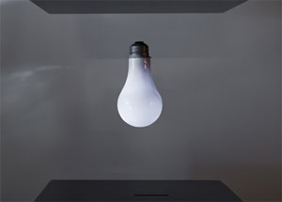

The light was in the store and in the police station and the church mission. These were the only places that this light was found. The mission, police station and store all had wind generators. The wind would make or generate electricity and this would be used to make the lights go.

It was only when we moved to the houses provided by the government in the 1960s that we had lights like this from electricity. By that time the electricity did not come from a wind generator. By then it came from fuel generators. I think sometimes that we should still be using wind generators.
How Things Have Changed: This is an adaptation of an interview with Peter Tatigat Arnattiaq of Igloolik

It was not easy living at the outpost camp. I recall there were many times we did not have enough food or fuel for cooking. Within our family, we used to help each other especially when we had to hunt in one location. We would help out the people that needed to be assisted in any way which included food to eat. Wherever we lived we found that it was very difficult to do it on our own. We were constantly faced with difficulty. Little do they realize today that even drinking water was hard to get. My late sister-in-law at one time tried to drink her own urine. There was no source of drinking water as it was difficult to make fire in order for them to melt ice. Of course she could not drink her urine as it tasted terrible. Thirst is something that is hard to endure.

When we moved to the community life changed. The things that before were hard to come by like heat and shelter were now given freely to us. We were very thankful we were given all of this. It was not like we asked for it. In the beginning we would do things for each other. For example, when we were running short on ice for drinking water we would hitch up our dog team and go out to get some ice for drinking water. So after the community had been settled, they used to cut blocks of ice in the fall so that there would be some ice for the coming winter. We use to get some ice for the whole community. If we saw that a certain household needed ice for their drinking water we would take it upon ourselves to go and get some water for them. So this was the way we youngsters would do things in our time. If we felt that another household needed some more ice, we would go back and get some ice for that certain household.

Soon, those who were made to cut some ice blocks were earning a pay to do the cutting of blocks of ice. We had never been paid before for getting some ice for drinking water. Indeed, it never occurred to us for any type of cash payment when we were getting some ice for drinking water. Then it became expected that you would be paid. Soon, it was expected you would be able to be given ice or water. What was first given freely was now expected to be given. I began to not give so willingly when people expected it.

Now we are assisted with everything. Indeed we have changed, even at our outpost camp we are assisted by the government. All of the heat and light are provided for by the government.
An electrical circuit requires an energy source, a means of carrying the electricity and a component that will use the electricity. A battery is a source of electricity.

What you need

D cell batteries: enough for groups of two
Insulated wires
Flashlight bulbs

What you do

- Provide students with an illustration or diagram drawn on the board like that shown below that contains a bulb, 2 wires and a battery. Ask students to consider how they might be connected to make the bulb go. Provide them with the opportunity to share their ideas with each other.
- Get some students to share their ideas on the board by showing the connections they would make. It is likely that many students will incorrectly think that the light will go if the wires go from the end of each battery to the BOTTOM TIP of the bulb, as it were meeting at the tip to light the bulb.

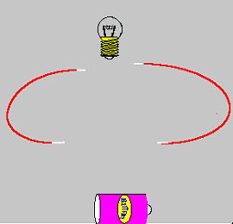

- Provide students, in pairs with a bulb, two wires and a battery. Get them to test their ideas. They will likely soon realize that the bottom is not where the wires should connect.
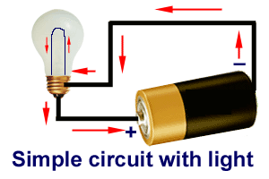

They will soon find, with perseverance that one wire must touch the side of the bulb and the other from the other end of the battery must touch the tip.
- Have students illustrate on the board how they have connected the wires to make the bulb go.
- Further get students to only use only one wire to get the bulb to go. They should soon realize that the bulb must sit directly on the battery and the single wire must connect the side of the bulb to the bottom of the battery.
- Use the ‘test’ sheet that follows as a means of gauging student understanding of how contact is necessary in an electrical circuit. Students should look at the possibilities provided and then make predictions with justification if they think the circuit will work. Once they have made the prediction they should trail the configuration to see if it works.
- Once they have done his can they try to make a mini-lamp out of the bulb, battery and single wire. Possibly students might be given a piece of tape to secure one end of the wire to the bottom of the battery. As well by wrapping the other end of the wire around the metal part bulb they can ‘hold’ the bulb in place.

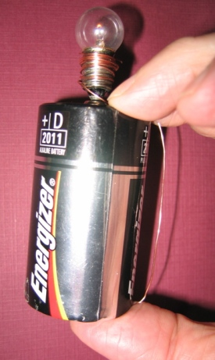

      - This construction activity could be extended by using plasticine to secure the bulb to the battery and a further piece of tape to hold the wire alongside the battery. By so doing, the students have constructed a stand alone lamp or flashlight.
      - Read the story with the students about the hunter’s experience near Igloolik. Stop at the point in the story where they are expected to address the challenge. Have them consider how a simple broken flashlight could be used to get someone’s attention. Provide them with the scenario that is at the end of the story and get them to participate in the challenge to create and construct the best flashlight. They are likely to realize that the two batteries can be put end-to-end and that the aluminum foil can be used as a reflective surface around the bulb to create a more luminous light.
      - If you wish, there are some simple ways to test whose flashlight is ‘best’. A convenient manner is to turn off the lights and place a page of white paper in front of the flashlight at a distance of say 10 cm from the light. Have someone stand 3 metres away from the light and state whether than can see the light. Continue to add pieces of white paper to gain thickness and stop when the light can no longer be seen through the paper.
      - Have other students try this and determine whose flashlight can penetrate the greatest thickness of paper.
      - Complete the story allowing for discussion about the ability of a flashlight to attract attention.
      - Get students to illustrate the story and provide a written description of the story.

What you look for

- Do they persevere in trying to find solutions to the tasks provided?
- Do they come to an understanding of how the wire, bulb and battery need to be connected?
- Do they understand that the energy source, wires and the light bulb are essential components of the electrical circuit?
- Can they identify reasons for some of the illustrated connections in the Test Sheet not working while others may do so?
- Can they recognize the limitations of their ‘flashlight’ as compared to the light that must have been used in real life for the Igloolik hunter to attract attention?
- Can they understand that the ‘best’ flashlight can only be gauged best by ‘testing’ and that testing requires a consistent, fair procedure?

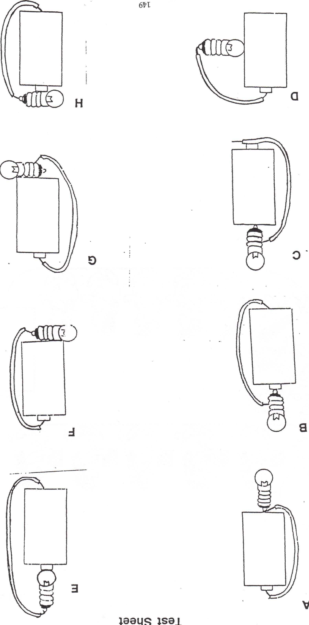
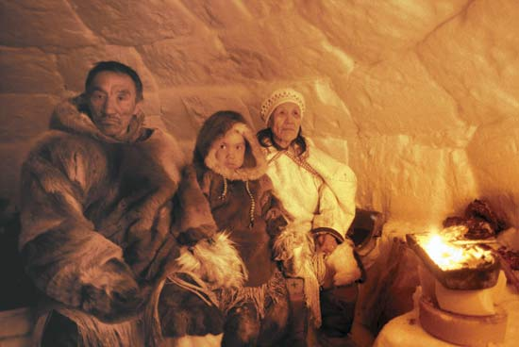

http://cache.eb.com/eb/image?id=92893&rendTypeId=4

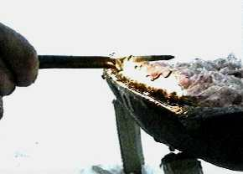

http://www.isuma.ca/Images/catalogue/qulliq2.JPG

Calling for Help: This is an adaptation of an interview with George Kappianaq of Igloolik

I recall a very difficult time when we were traveling. When we were traveling back by canoe to Igloolik from hunting we were running through ice floes that had just formed in October We had difficulty running through them, but we were able to pass them slowly. We left to cross into Igloolik, and this was now towards evening.. There were times when the canoe had to be rocked in order to go through thin ice and to prevent it from getting a hole from the ice.

The sun soon set. It was getting dark. We would try to go to ice free areas, where we would go fast, but then soon we would have to go through thin ice again. It was a wonder that the canvas skin of the canoe did not get punctured as there was so much thin ice that we had to go through.

We passed the Igloolik point and we could see the community. We were getting close to home. But, we got too close to the shore. The day had seen easterly winds, so the thin ice was in contact with the land. We got into the ice too much due to darkness. We were almost free from the thin overlapped ice when our motor could no longer propel the canoe. As it turned out the piston in the motor was shot. We had to get the attention of the community but we had no way of getting their attention. When the motor became useless, the people on board were trying to get attention of the community. Then we considered that we could use our broken flash light to get their attention.

YOUR TASK: The travelers found that their flashlight was broken but they still had the two batteries, a 10 cm square piece of aluminum foil, bulb, wires and tape to make a flashlight to get their attention. Your task is to make a flashlight that will get their attention.

Soon we could hear a sound of a canoe in the dark. Then it came right to us. Using his trail he started to tow us back. It so happened that we were almost free on the thin ice when we got stuck and we were now using the trail that the canoe had made when it came for us. The light from the community were bright so that we could see in front of us. When we finally arrived, there were a lot of people on the beach near the Peter Head, they all had come down to greet us. It was a joyous occasion.
A bulb contains a filament and resists electrical current causing friction which causes the filament to glow to produce
light and heat

What you need

Batteries, bulbs and wires from previous lesson

What you do

- It is important for students to understand what is happening within the electrical circuit in terms of how light and heat energy are produced from electrical energy. Start by having students to again create a circuit using the battery, wires and bulb and to add tape to the device so it is free-standing.
- Get students to observe the source of illumination in the bulb; that is the fine filament wire found within the bulb.
- Draw a picture of a bulb on the board showing the filament. Make reference to the picture below that shows the internal wiring of the bulb. Note that the one of the two wires that suspends the filament attaches to the base of the bulb and the other wire attached to the side of the bulb. This explains why when students previously constructed a circuit they had one wire touching the side of the bulb and one touching the base of the bulb.
- Understanding how the filament works is rather complex and to help students understand how it works is likely to be best done by role play. In the classroom it is likely best to use masking tape to create a rectangular box on the floor. This space represents the battery. From the battery run a line of masking tape on the floor in a large circuit back to the battery. This circuit line represents the wire of the circuit. Along the line use tape to create a bulb shape.
- Have five students stand in the battery. Have two students stand in the bulb. The role of the students in the bulb is to ‘resist’ electrical current. That is, as the current comes through they should try to stop it. Refer to the battery as an “Energizer’ and get the students role play being energized within the battery. The battery is in reality an electric current pusher and the students should move out of the battery energized and pushed, possibly with you as the lead. Move through the wire and enter the bulb. In the bulb the students as current are resisted. There is ‘friction’ created and heat and light because of the friction is generated. As the current moves through the bulb the current has less energy that it went in. It sluggishly returns to the battery to get re-energized. In reality there is a steady stream of electrical current. Again the current goes through the circuit and again is resisted. Ultimately the battery cannot energize the particles and the battery is said to be flat. The current moves through with less energy and there is less friction and less heat and energy created. Other models for explaining this include giving the students in the battery monopoly money representing they are being energized. As they travel through the bulb the money is given over to the bulb students because it is transferred or ‘spent’ on light and heat. The students return to the battery energy-less (without money) and get recharged. Ultimately the battery will not be able to recharge as it itself loses its energy and becomes flat.
- Have students move through the circuit repeatedly re-emphasizing the key ideas presented.
- Have students draw an illustration of an electrical circuit showing the detail of the bulb, especially the internal wiring (#8 below) and providing a description of why the bulb creates light and heat.

What you look for:
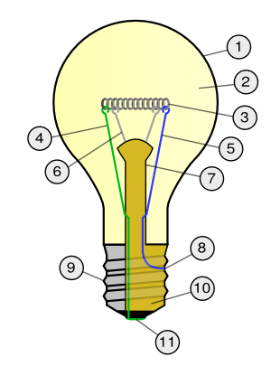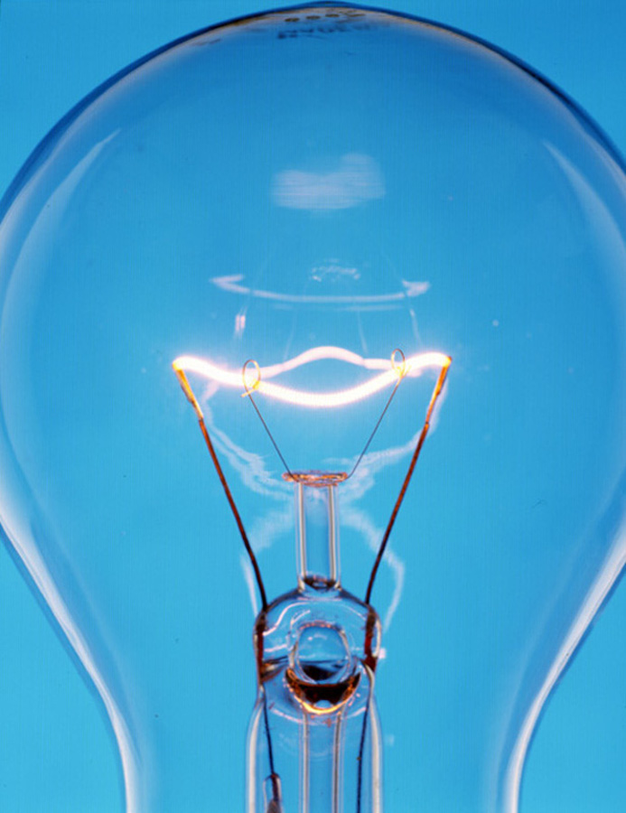

- Can students provide a description of what causes the light and heat to be produced by the bulb?
- Does their illustration and explanation provide the detail to explain this?

Insulators and Conductors can Influence an Electric Circuit

What you need

D-cell batteries
Wires
Bulbs
Objects to put in the circuits – paper clips, aluminum foil, pencils, pens, water, paper, pennies, any objects of interest
Access to objects such as light switches, plug-ins and electrical cord where students can see insulators being used for safety purposes.

What you do

- Have students construct the one battery circuits that they made last class ensuring that there contacts are good and that they can keep the circuit closed and the light on without holding the wire in place. Try to ensure they are using a wire length that is quite long, at least double the length of the battery.
- Show students that the circuit can be broken by cutting the wire with a pair of scissors.
- Ask students what could be put in between the objects to repair the cut. They will likely suggest that the wires need only be twisted together or contacted to repair the circuit.
- Draw the damaged circuit on the board asking students what might be placed in between to repair.
- Let students try a variety of objects in their circuit gap and by so doing identify what objects are conductors and insulators.
- Have them record their answers on the chart on the Learning Sheet.
- Once completed, ensure they look for a pattern in the objects that conduct electricity.
- Students should realize that metals which are usually shiny and flexible are characteristics of metals.
- Possibly get students to be creative in making a circuit breaker – connector although the idea of a switch will be looked at in the lessons to follow.
- Once completed get students to observe here insulators and conductors are used to either stop or make an electrical circuit.
- Examples to look at are the plastic insulation on wires, plug-ins and light switches. Conductors may be used to bridge a connection like in using aluminum foil in a flashlight to make it go if the batteries don’t connect.

What you look for

- Can students identify objects that are conductors and insulators and explain what conductors and insulators are used for?
- Can students identify examples of conductors and insulators around them and their reasons for use?

Lights Going Off and On

Object | Light Off or On? | Insulator or Conductor

Draw pictures of where we use insulators

Draw pictures of where we use conductors

A switch can be placed in a circuit to open and
close the circuit

What you need

Clothes pins
D-cell batteries
Wires
Bulbs
Templates for bulb & battery holder
Scissor Paper clips to hold the bulb holder together

What you do

- Using the template for the battery and bulb holder provided below have students create a simple flashlight with a single wire that connects the base of the battery to the bulb. It is important to use a paper clip to secure the battery holder together so that a metal-metal contact can be created from battery-bulb-wire-battery.
- It is likely that already students have been toying with trying to create points along the circuit where the circuit can be broken and then restored and thus the next step in including a switch in the circuit is relatively straight forward.
- Provide student with an ‘alligator-type’ clothes peg and ask them to consider how they could create a device that will open and close the circuit. Let them think this process through to the end and discuss their idea with a friend.
- Discuss their suggestions and allow students to trial their ideas.
- It is likely that an option like that provided below is the most likely solution they will find. Note that in the clothes peg switch illustrated the circuit only is open when the peg is pressed to open the peg. Students might be asked to consider how the switch could be designed to remain open when in the relaxed position.
- As well, they may wish to experiment with other types of switches made out of other materials such as paper clips and aluminum foil or any other materials that can be manipulated to create contact points.
- Once constructed discuss with students the importance of a switch in an electrical circuit. Relate this conversation to other switches that are in contact with such as light switches and off-on switches on toasters, electric kettles and stove tops. In all cases ‘on’ means that the circuit is closed or uninterrupted and ‘off’ means the circuit is open or interrupted.
- It may be that you might wish to repeat the role play showing enacted in previous lessons to show how the circuit is broken when the witch is open.
- If you have long lengths of wire you may ask students to construct a larger circuit possibly by placing the lamp inside their desk and controlling the light bulb by a switch placed outside and on top of the desk. Students might be given a box and again create a circuit with the light coming through the side of the box with the control switch on one of the walls. It is good to experiment with ‘house’ models as in the next section students will be placing more objects in the circuit just like their might be multiple lights in a single circuit. It is noteworthy that these simple electrical circuits were similar to what were used in outpost camps where a singly battery may have provided the only light within a cabin.
- Have students draw a picture of their circuit with the switch included and provide a description of how the switch influences the circuit.

What you look for

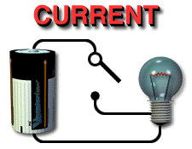

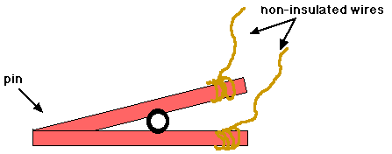

- Can students provide a description of how the switch controls the circuit?
- Does their illustration and explanation provide the detail to explain this?

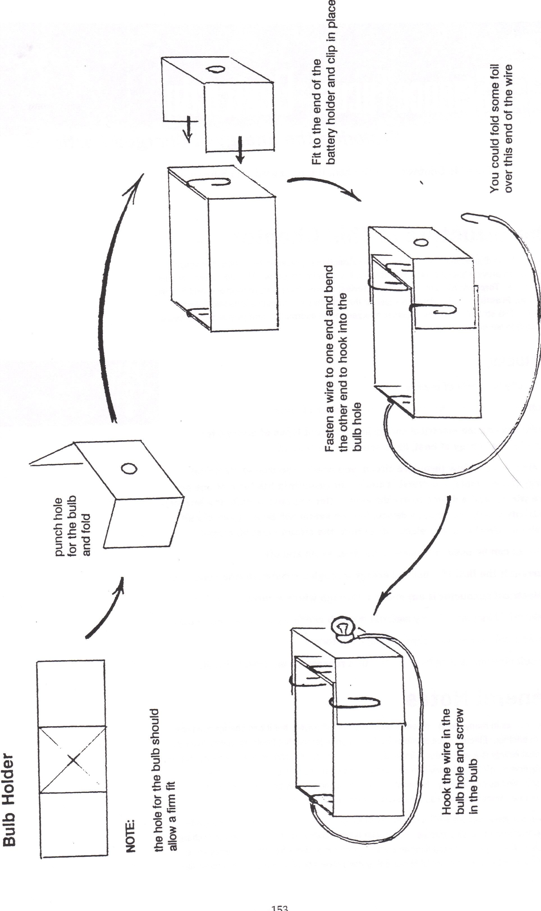
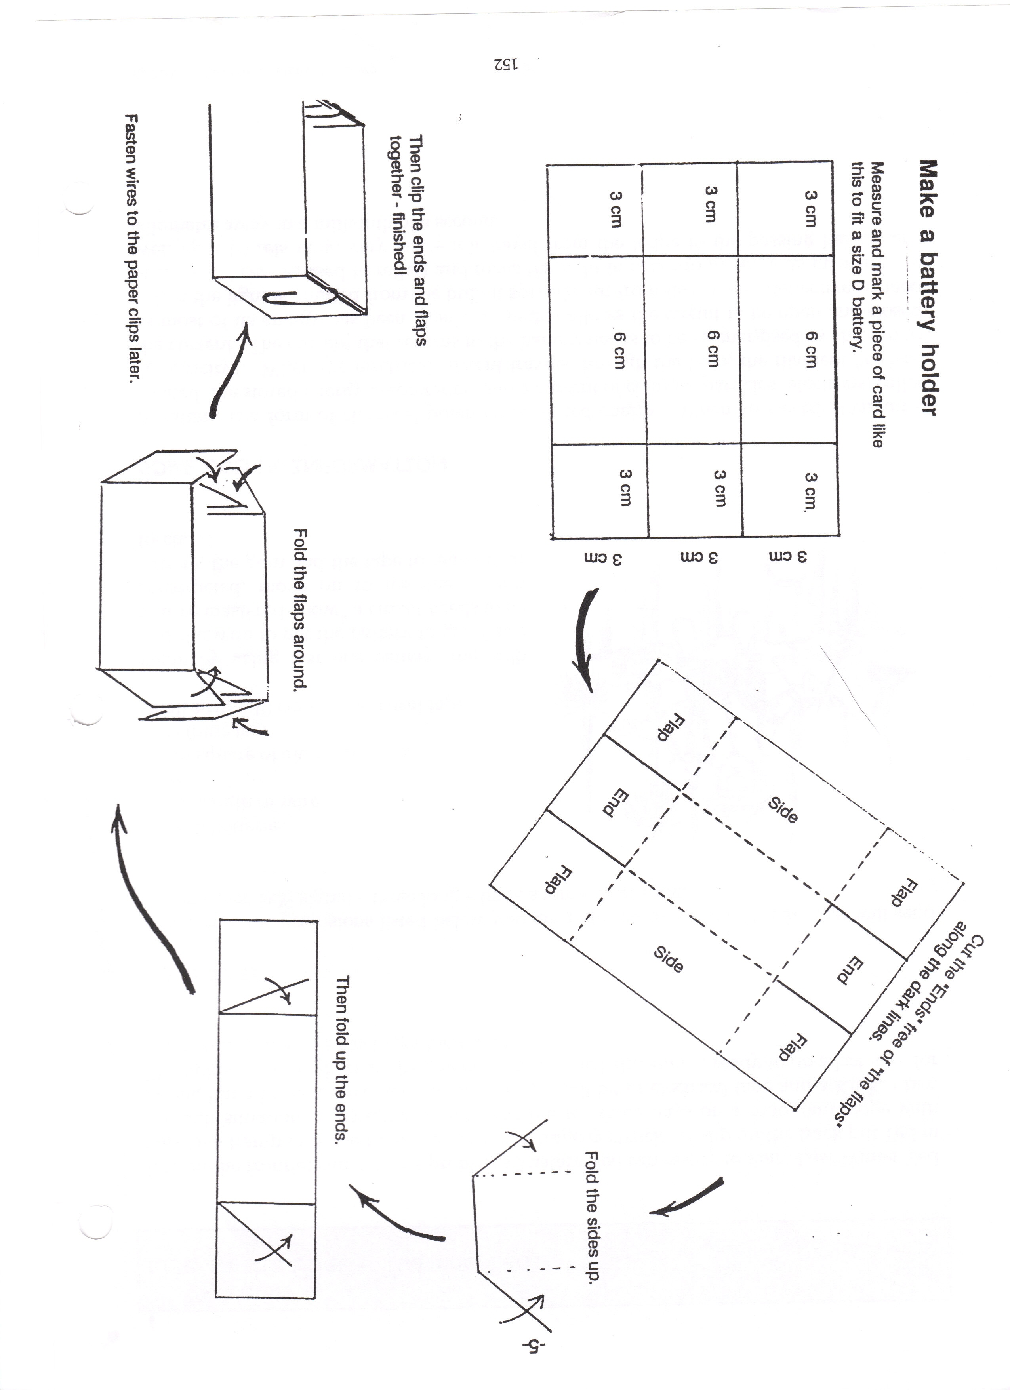

Electricity can flow in circuits that are arranged in series or in parallel

What you need

String of Christmas tree lights
D Cell batteries
Wires
Switches
Templates for battery and bulb holders

What you do

1. Start the class by turning off the classroom lights and plugging a string of Christmas lights into the wall.
2. Ask students to consider why the bulbs are lit and what the role of the plug-in is.
3. Ask students what will happen if a single bulb is removed. Students are likely able to predict the outcome based on their experience and to suggest why this will happen.
4. Verify their prediction and discuss how the circuit is broken as this bulb is removed.
5. Get students to consider the role of the bulb in completing the circuit and how the removal and replacement of a bulb operates like a switch. Use the picture that follows to explain the idea that the current travels from bulb to bulb through the circuit.
6. Get students to consider why a headlight can be broken on a truck and yet the other might still go. Get students to consider that the electricity travels through independent circuits.
7. Using the bulb and battery holders previously constructed get students in groups to construct circuit pathways that are in series like the Christmas tree lights and in parallel like the independent circuits like a truck’s headlights. Students have likely been shown the ‘series’ circuit in step 5 and now should be able to consider what a parallel circuit should be like.
8. Once constructed students should be able to provide reasoning as to what makes a parallel and series circuit and how they differ.
9. Students should draw their set-up and explain the difference between a parallel and series circuit.
10. Students should consider where there are further examples of series and parallel circuits in their home, the school and community by considering what lights stay on or go on when there is some failure in electricity supply.

What you look for

- Can students provide a description of the difference between a series and parallel circuit?
- Does their illustration and explanation provide the detail to explain this?
- Can they provide further examples of series and parallel circuits in their community?

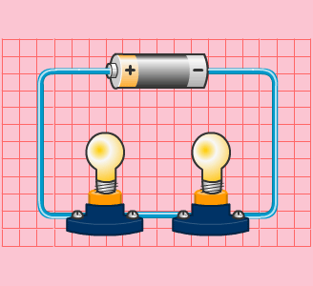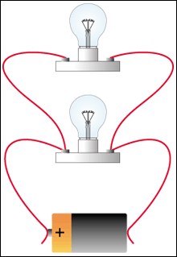

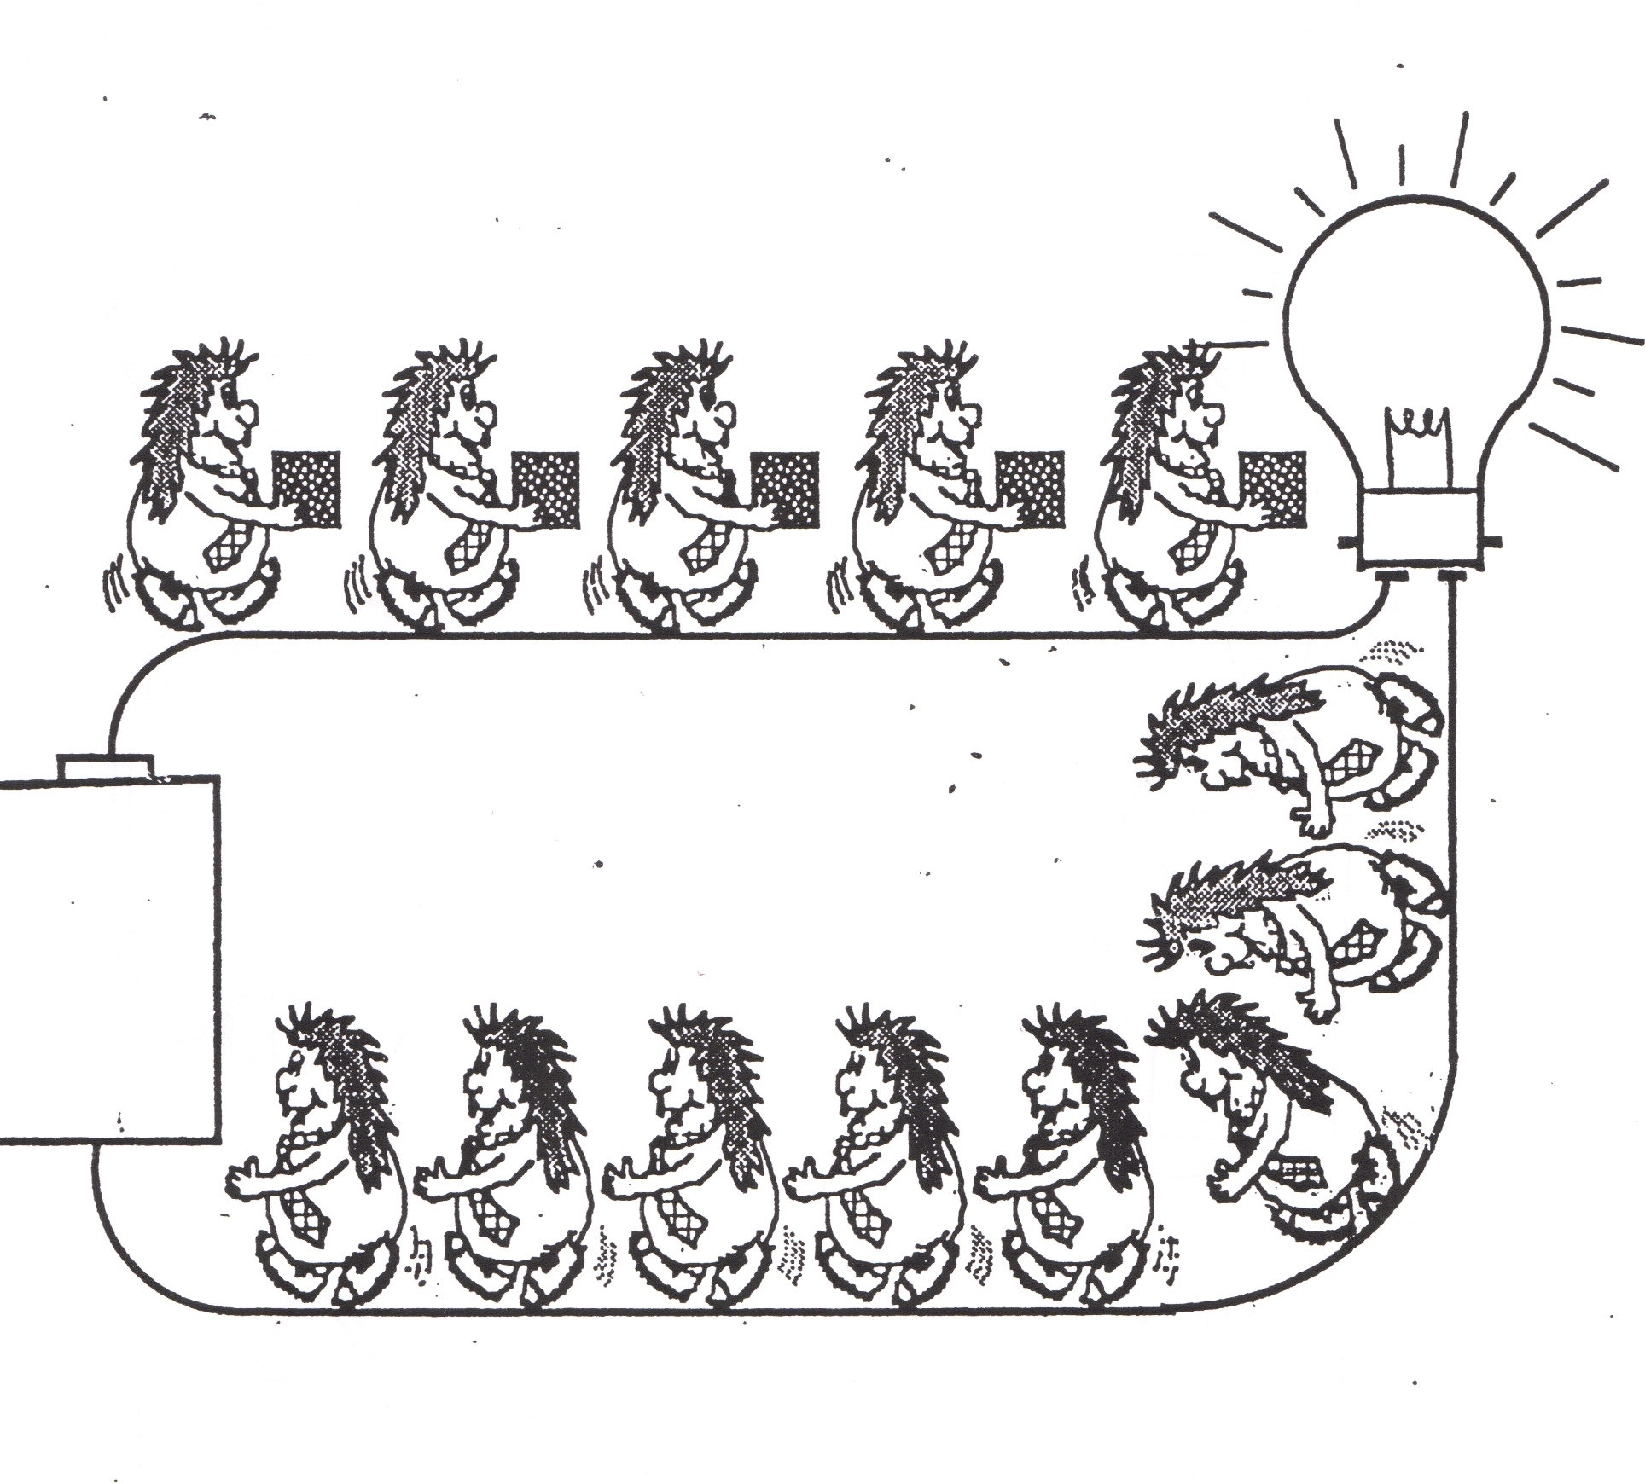

In our town the major source of electricity is the local power generator is run by burning diesel fuel. The town’s electricity lines among households and businesses are arranged in series and in parallel

What you need

Plan of the community showing houses and businesses including the local power generator (likely available through Hamlet office)
Contact the local power generator and organize a visit at the generator.
Objects to serve as models for the community – thread for power lines, small boxes for houses, etc.

What you do

1. Start by showing students a drawing of the town layout and some of the objects shown on the handout that are found in most communities. Students will likely want to identify various objects and locations in the community.
2. Get students to focus on the layout of the community in terms of the power line location and distribution of power from the town power source. It is likely that students will want to verify this layout of power lines. If opportunity permits take students for a walk of the community showing how the power-lines are organized for power distribution. It might be best to have a picture of the community and have students draw in the power distribution network in the community.
3. Get students to focus on what homes and businesses are on the same circuit and how power failures within a community can affect one, several or all of the circuits depending on where the circuit breakage occurs.
4. Focus on the location of the local power generator and where it is situated. Also focus on the fuel lines from the sea so that when the diesel barge arrives the fuel can be piped to holding tanks and ultimately the diesel generator.
5. Once they have identified the distribution network, have students in groups develop ‘models’ of the community power network. Possibly each group could develop a model for a different part of the community and have these once completed integrated into a community-wide network.
6. Ensure to include some consideration of the use of generators at outpost camps.

What you look for

Can students identify through their illustrations or models of the town’s power distribution what households and businesses are on the circuit?
Can they reason the importance of the diesel generator as a source of electrical energy?
Where are these objects in My Community?

Where have you seen these objects and what do they have to do with electricity?

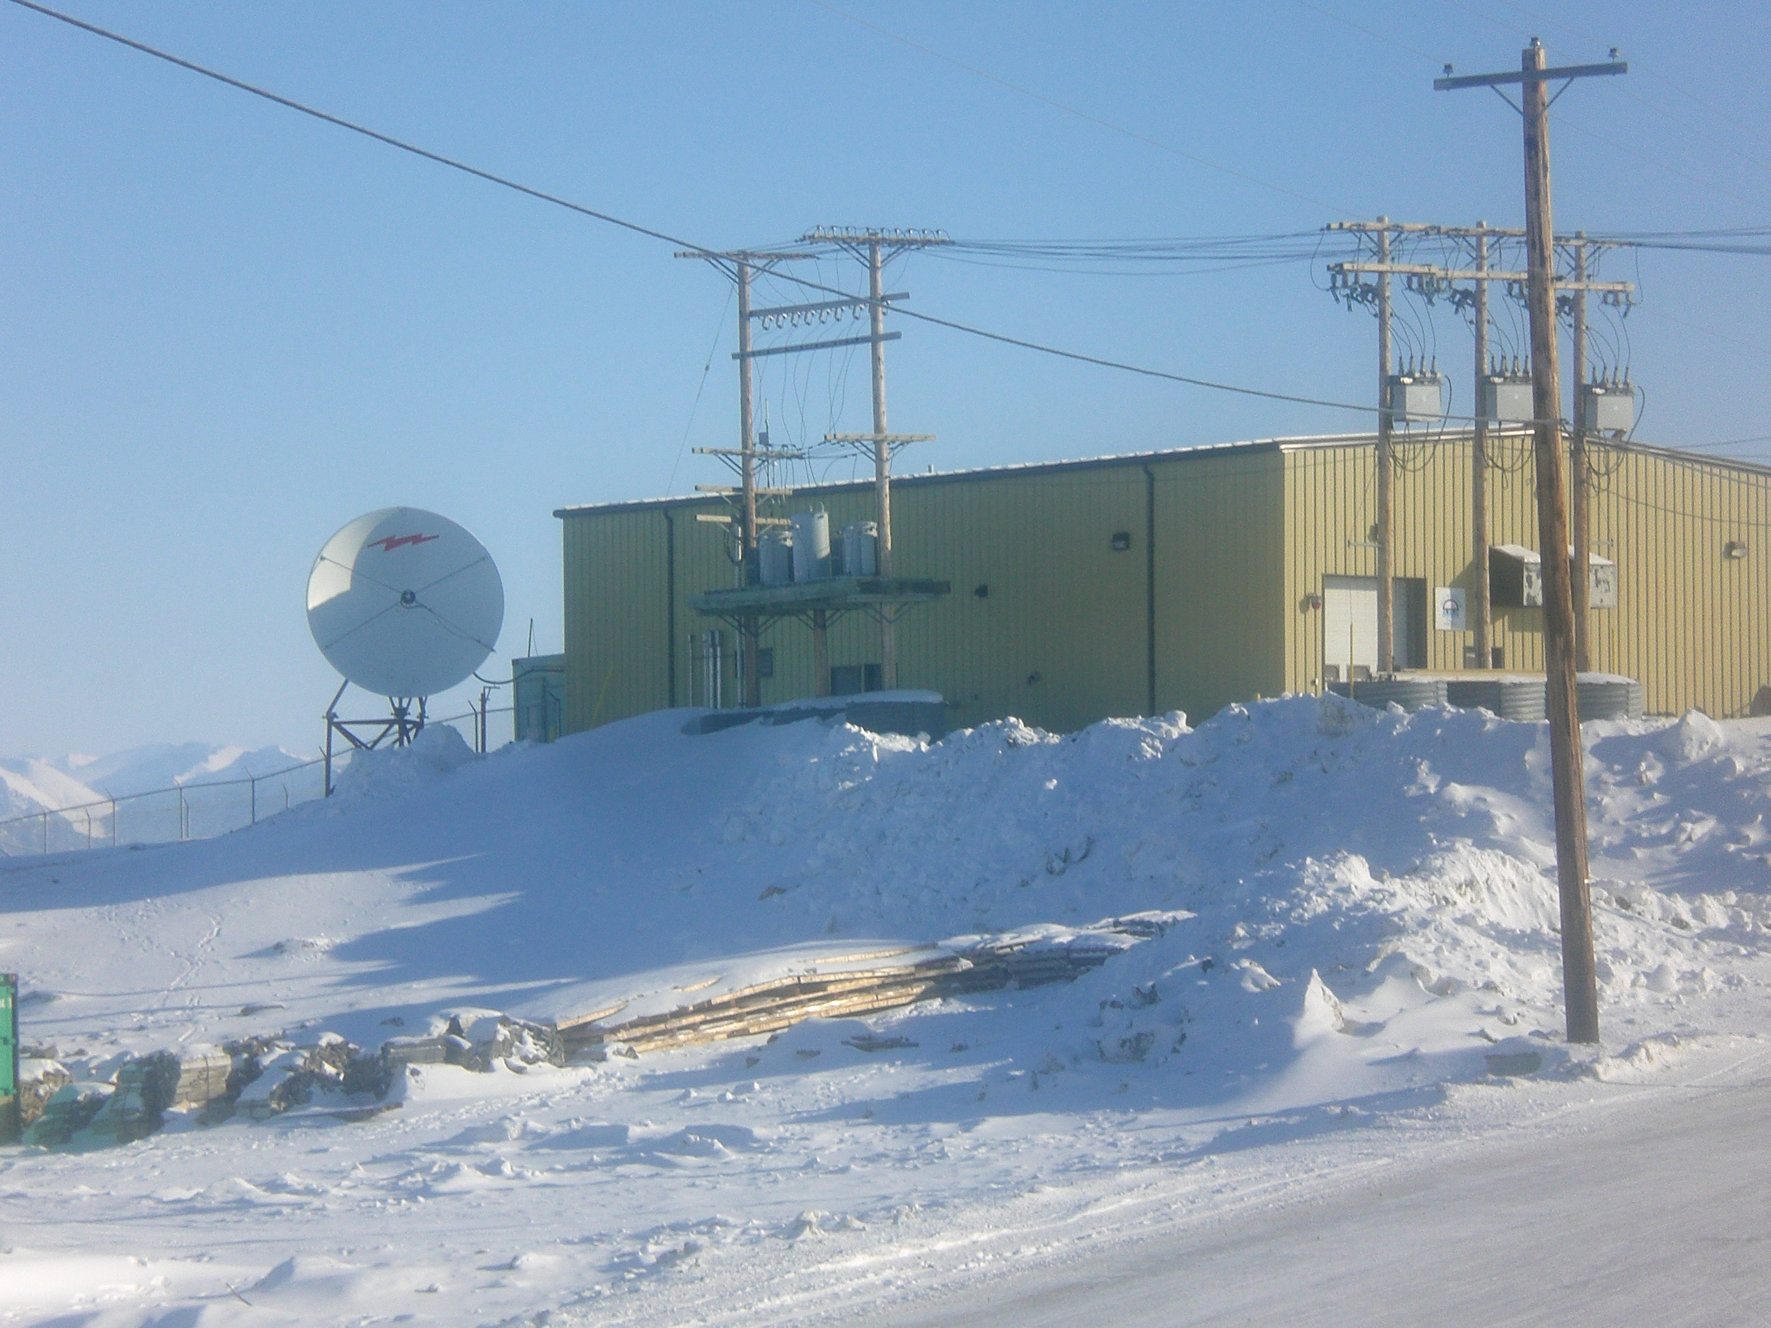

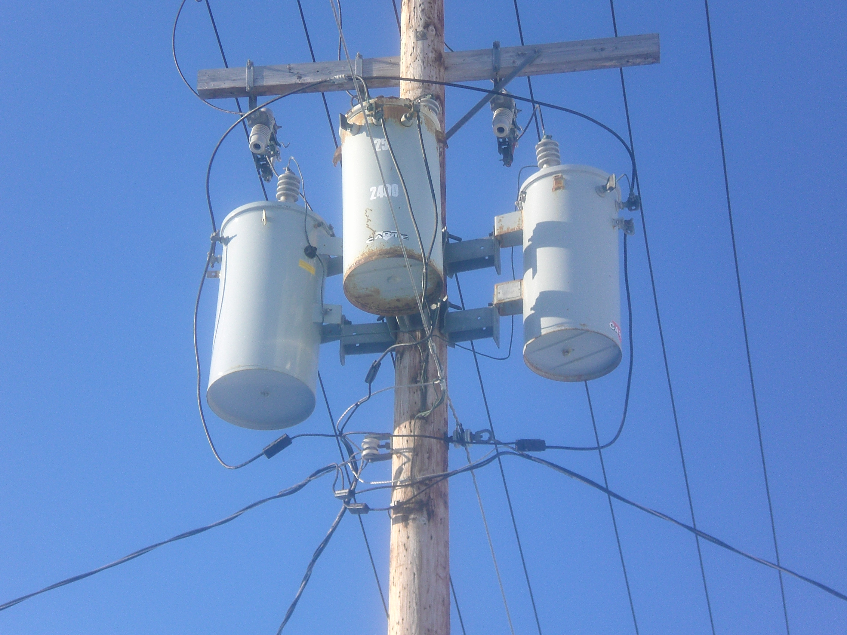



Before the diesel generator there were wind turbines

What you need

Elders and community member’s accounts of early developments associated with the early sources of electricity in the community

What you do

1. Ask students to consider what might have been the earliest source of electricity in the community.
2. Read the account provided by some of community members associated with the use of wind turbines for electricity generation.
3. Get students to consider the implications of the use of wind energy as an alternative source of energy both during these early development days and today. Consider the benefits and drawbacks of wind energy options. Possibility get students to interview a community or family member about their knowledge of wind generated power in their community.
4. Investigate the feasibility of wind turbine development in your community.
5. Consider making savonious rotors as a practical example of how wind energy can be used to do work, although in this case no electrical energy is produced. Provide students with the illustration of the savonious rotor that follows suggesting ways in which it might be constructed. Simplym a plastic cylinder such as a pop bottle with the top and bottom cut off to retain an open cylinder is cut in half longitudinally to make two u-shaped troughs. These can be mounted a variety of ways to make an s-shaped savonious rotor that went rotated can wind up a string and by so doing lift or drag objects.

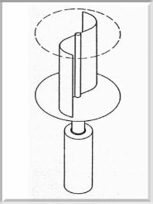

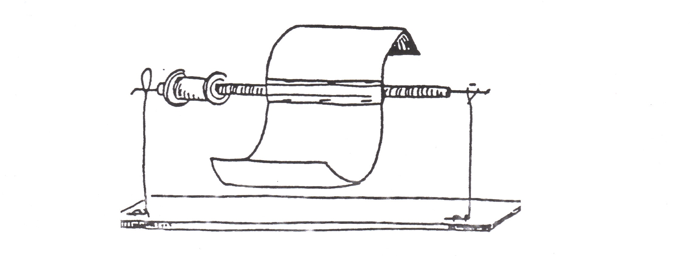

Get students to make a rotor and suggest ways in which the rotor might be improved and capability measured. It is important for students to develop a basic understanding of how a generator works, especially in the conversion of wind energy into electrical energy.
6. This topic allows for significant opportunity for your class to pursue an understanding of this very important issue in northern communities. There are many groups advocating the development of wind turbine generation in the north. Explore these sites with a focus on assisting students in understanding the complexity of the issues associated with this development.

What you look for

Can students appreciate the reasons why wind energy was used in the early development of your community?
Can students appreciate the risk and protective factors influencing the establishment of wind turbines for electricity generation in your community and other Nunavut communities?

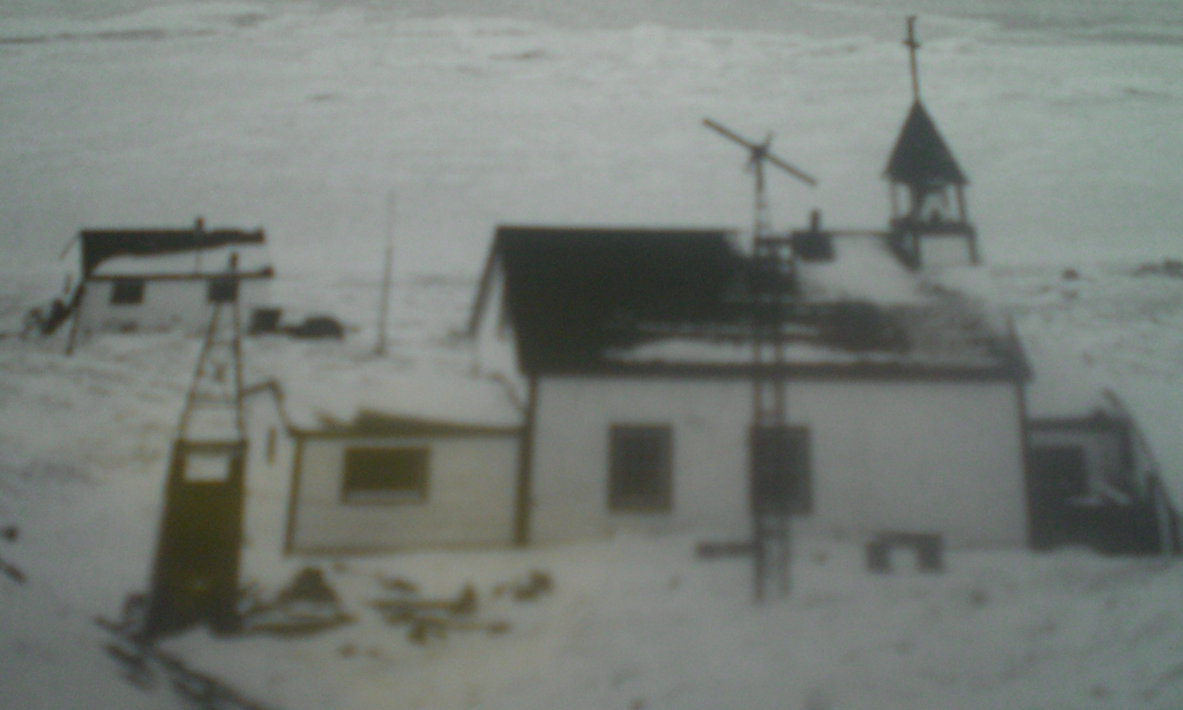

HBC Archives: Wind Generator at Local Church Mission (Pond Inlet 1952)

When Electricity Came: The following story is an adaptation of an interview with Annie Peterloosie of Pond Inlet

We would always be excited when were able to go from our camp to Mittimatalik (Pond Inlet: the place where Mittima is buried). Mittimatalik was where the store was and it was here that special things would always come from.

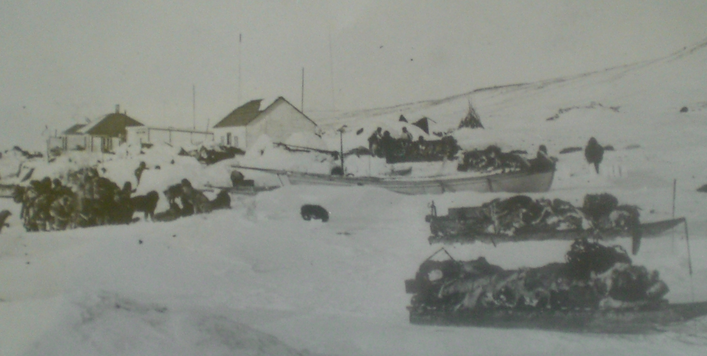
HBC Archives Photo

The store had many things I had never seen. They say it was built in 1921. We would bring the skins there and buy things there as well.

The store in the 1950s had lights and these got their electricity from a wind generator that was on a tall pole near the store. There was a wind generator for he RCMP as well.

The wind generators are not here today. That was only when we moved to the houses provided by the government in the 1960s that we had lights like this from electricity. By that time the electricity did not come from a wind generator. By then it came from fuel generators.

I think sometimes that we should still be using wind generators.

Before the Diesel Generator There Were Wind Turbines

This a picture of a Nunavut Church Mission in the 1950s (HBC Archives)

1. Read the story about the early life in Nunavut. Why did the Hudson’s Bay Company and Church use wind power?

2. Draw a picture of your best wind turbine.
3. What is a generator?

4. Why are Nunavut communities thinking more today about using wind to generate electricity?

5. Is this a good idea? Why or why not?

There are safety concerns associated with electricity

What you need

Access to things such as a computer that bares safety labels or areas in your town that have limited access because of electricity and carry signs that state concern about access.

Consider having a local power employee visit the class or allow for a visit to the local power generator.

What you do

1. Start the class by giving students the Learning Sheet showing students signs within their community. Ask students where these signs mean and where they might be located. Assist students in understanding that signs have a purpose. Often they give us information that can keep us safe. Give students the second Learning Sheet with the symbols representing hazards with electricity.
2. Ask students what the symbols mean and where these symbols are within their community.
3. If appropriate seek out the accuracy of their suggestions by getting them to check out whether there are signs posted at the local generator.
4. Students will likely also have seen these signs on doors in some buildings in town such as the school electrical-heating room.
5. Ask students to consider why these signs are there. They will obviously understand that the electricity will kill but why does the electricity of a battery not kill?
6. The answer is not easily understood but both voltage and current kill and since a simple battery is 1.5 volt and household wiring is 110 volts the energy within the electrical circuit is much higher and able to both burn and effect our heart which is controlled by our nervous system which is an electrical system. Remind them that the power station in town operates at much higher risks.
7. Show students the electrical safety symbols on various electrical devises which are put on objects like computers and kettles to ensure we don’t open things to expose the live wiring.
8. Get students to look on the internet at sites that talk about electrocution accidents.
9. Get them to develop a safety picture or poster based on what they learn.

What you look for

Can students understand why there is risk associated with household an the local town generator voltage but not a battery.

Can students identify objects that are potentially hazardous because they contain live wiring.

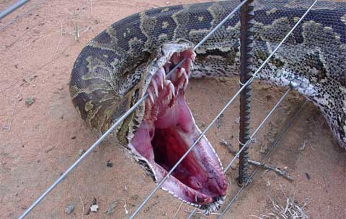

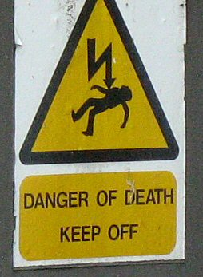

Signs in Our Community

Where do you find these signs in our community and what do they mean?

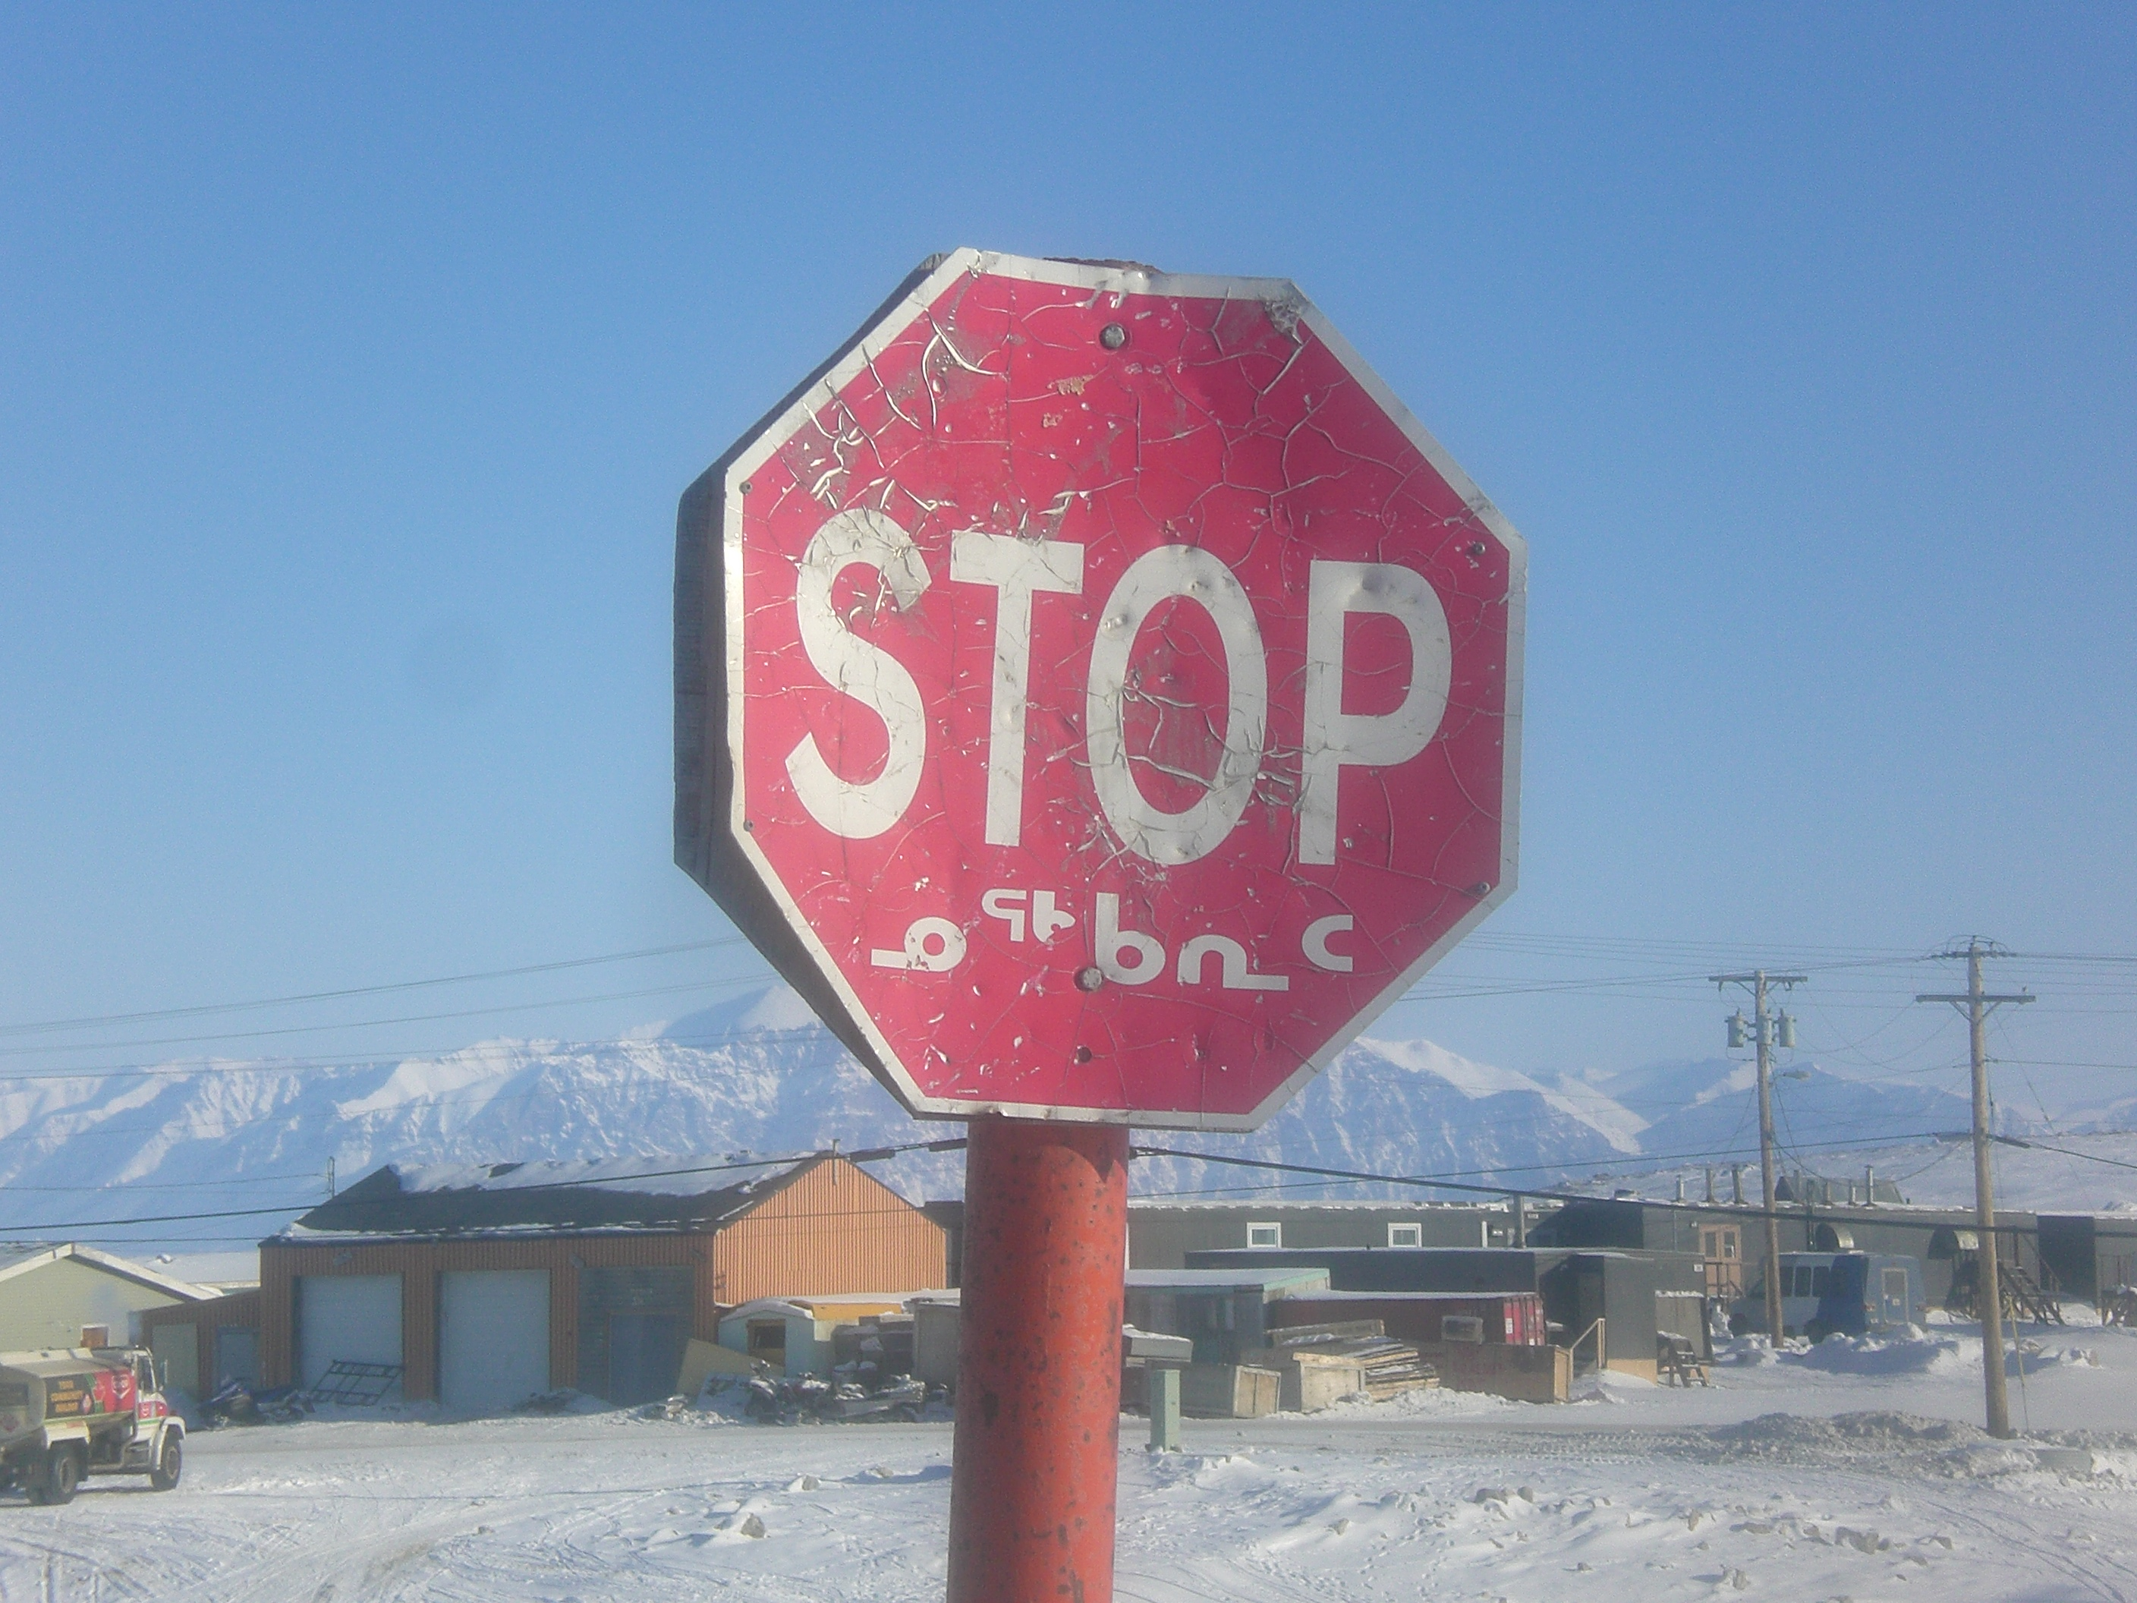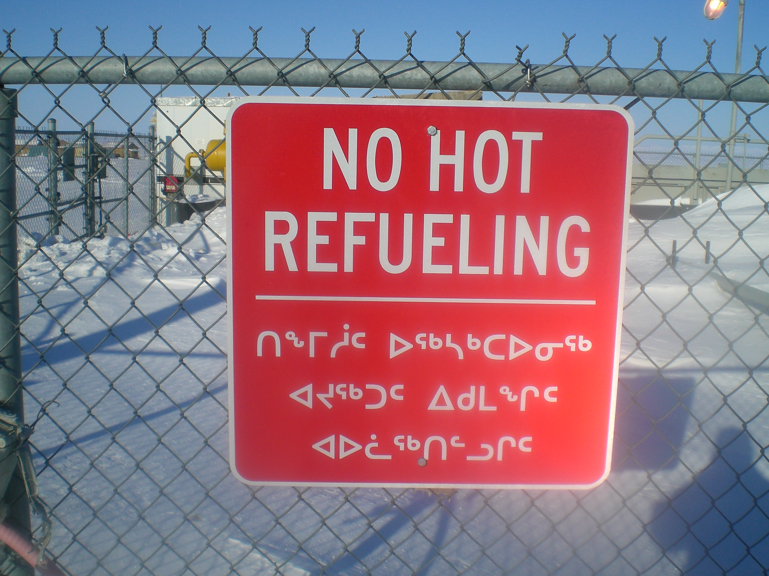

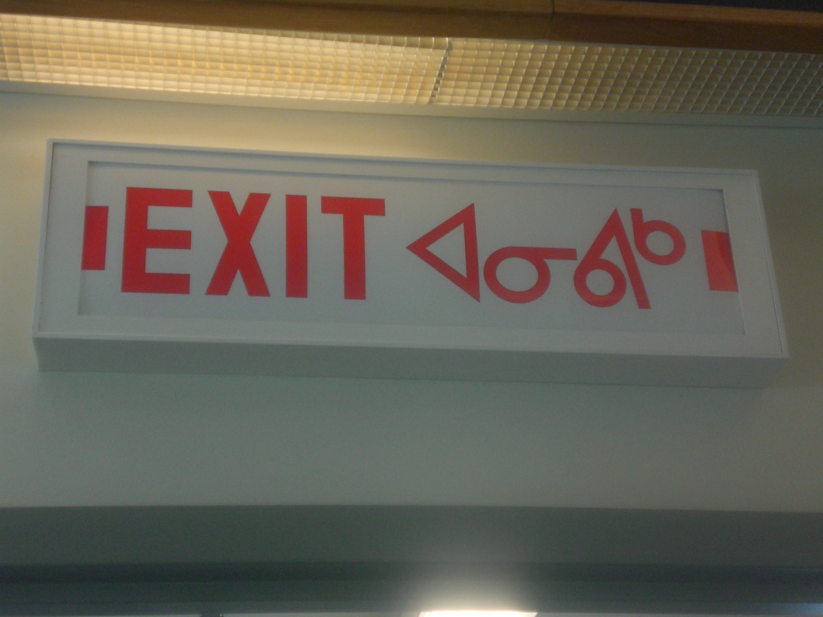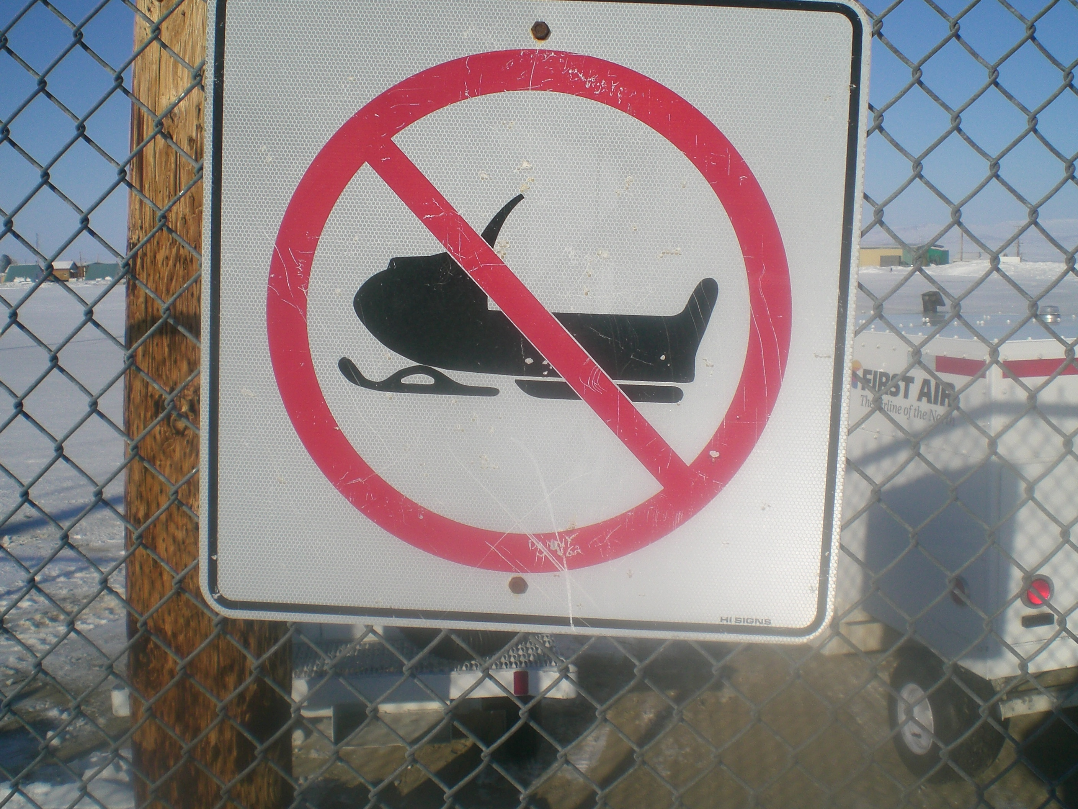

Safety with Electricity

What do these symbols mean?

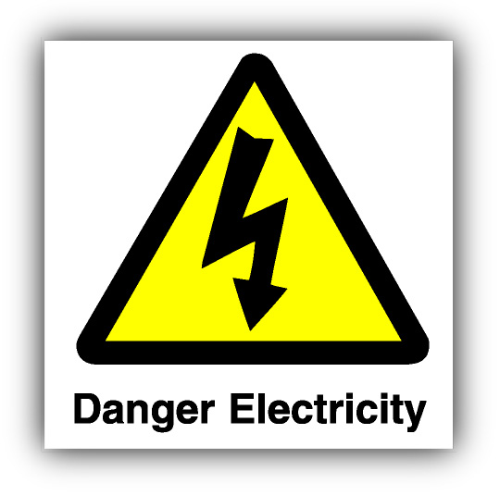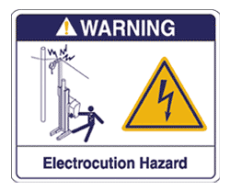

1. Where would we find these signs in our community?

Your teacher will help you find internet sites that deal with electrical accidents. Look at internet sites by Google ; electrocution + accidents

2. Develop a small poster based on what you learn

Lightning and thunder are associated with electricity

What you need

Stories about thunder and lightning
Internet access to You Tube

What you do

1. Start the activity be asking students if they have experienced thunder and lightning. If so, what do they think causes the lightning and thunder?
2. Ask students if they have heard or read the story about the origin of thunder and lightning. In some communities there is also a song based upon this event and the song may be one the children have heard. There are many accounts and one of these has been documented in the Pond Inlet stories that follow testify to. Ensure you discuss the idea of ‘pay back’ and how the actions towards the girls must have been very serious to cause such a serious response. It is said that in some stories the girls had been abused and this was the reason for their retribution.
3. Read the stories. Possibly allow students to act out the story. Possibly get students to draw out the picture.
4. Provide opportunity for students to see dramatic examples of lightning. There are many examples on You Tube of dramatic lightning hits on objects, including human beings.
5. Use the experiences they have observed to provide a brief explanation of what causes lightning. Basically, lightning is produced when liquid and ice particles above the freezing level collide, and build up large electrical fields in the clouds. Once these electric fields become large enough, a giant "spark" occurs between them, like static electricity, reducing the charge separation. The lightning spark can occur between clouds, between the cloud and air, or between the cloud and ground. Cloud-to-ground lightning usually occurs near the boundary between the updraft region (where the darkest) clouds are, and the downdraft/raining region (with the lighter, fuzzy appearance). Sometimes, however, the lightning bolt can come out of the side of the storm, and strike a location miles away, seemingly coming out of the clear blue sky. As long as a thunderstorm continues to produce lightning, you know that the storm still has active updrafts and is still producing precipitation. The temperature inside a lightning bolt can reach 20,000 degrees C, hotter than the surface of the sun. Objects that are struck by lightning can catch on fire, or show little or no evidence of burning at all.

What you look for

Can they tell the story through their illustration of lightning and thunder?
Can they understand that retribution and anger are common emotional experiences but we need to deal with our anger in a constructive manner?
Do they understand what causes lightning and thunder?

Lightning and Thunder

Draw a picture of the two girls and how they became lightning and thunder.

Draw a picture of one thing you learned from looking at lightning and thunder on the internet

What causes lightning and thunder?

Lightning (ittutuuqtuq) and Thunder (kallik): The following story is an adaptation of an interview with Annie Peterloosie of Pond Inlet

There is a story of two sisters. When they were young they were always being bullied and teased. They were often depressed and sad because they were being bullied by others. They did not know why this happened to them.

To get away from this, they walked up to a little mountain above the town. They built little houses with the rocks that were around them. They enjoyed playing alone away from the others that were bullying them. They wished they could become something else so they could back at the others. The older sister asked the younger sister if she could, what would she like to become. Was there something she would like to become so she could pay back or get revenge by becoming something else?

The younger sister started singing. "ALIQAAK, ALIQAAK, SUUNAUVINUK." [Aliqaak aliqaak: what are we?]. She sings that she wants to become some kind of an animal. While she is singing, the older sister asks her what she would like to become so she could get revenge. She asked her if she would like to become a caribou. The younger sister said no. Did she want to become a polar bear? The younger sister said no? What about thunder [ittutuuqtuk]? The little sister stops singing and she says yes.

So, during the night the girls very quietly collect seal skin and seal oil. They also yellow ingnitt [flints for striking to make sparks] from the Salmon River and take them up on the mountain. One girl shook the skin and oil and the other starts striking the rocks. They did this with much energy. This was the cause of the thunder. As well the striking made sparks [umma] that made the oil ignite. This called the lightning. There was also rain and this came from the girls peeing.

They wanted to pay back for being badly treated. It rained, thundered and there was lightning. The lightning struck the tent of the people that were bullying them. It went down the pole of the tent that was made of whale bone and this electrocuted the children that were bad.

The girls were satisfied that they had done this. After this, they did not return to the town. They became thunder and lightning.

Thunder and Ptarmigan Feathers: The following story is an adaptation of an interview with Annie Peterloosie of Pond Inlet and Philip Qipanniq of Igloolik.

The ptarmigan is a very special bird (tingmia). It is not that common and it tastes very good. It tastes very good, even when it is raw. Even today it is a bird that is very special and not everyone gets to eat it very often. In some places it is a bird just for the elders to eat.
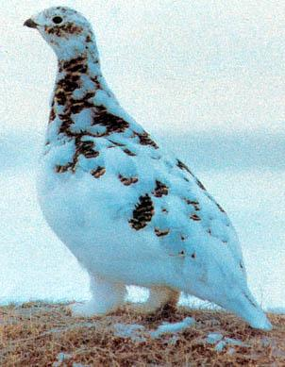

The two little girls who made the thunder and lightning really cherished and enjoyed eating ptarmigan too. It was all that they had to eat on the mountain. These girls lived away from the town and they had chosen to become thunder and lightning. They were very jealous girls and did not want other people to have these birds. So, to stop people from eating them they would make the lightning and thunders come if anyone else but them ate the birds. It was there way of making sure that other people did not eat the birds.

One time they were very upset with people in the town. Someone caught ptarmigan and when they were eating it, they decided to only eat the back of the ptarmigan and burn its feathers.

As you can imagine, the girls became very upset and the thunder and lightning came. Today it is still the same way. When the thunder and lightning come it is maybe because someone has not treated the ptarmigan well and the girls have been angry with them. Even today, you cannot burn their feathers. And, you are not to test this myth.

Communication and Changing Technology

IE 477
Computer Number: - IE-477
Tape Number: - IE-477
Interview with: - Louis Alianakuluk Utak
Interviewed by: - Louis Tapardjuk
Interview date: - April 1, 2001
Translated by: - Louis Tapardjuk
Word Processed by: - Louis Tapardjuk
Processed date: - April 16, 2001

How would they get ready in the morning, would they have gathering, or each hunter left on their own, how was that?
A. They would never just leave for hunting. For instance you usually have meetings to discuss matters and how to deal with issues at hand. In those days, they too discuss their hunting, so in a sense it was the same. In the morning invitations would be sent out for a cooked meat, failing that it would be for walrus liver, or cooked meat. The reason for this was to gather the hunters so that they all can join in the discussion, they would discuss things like how they can be successful this day. Opinions would be sought and discussed, and they would have a leader type of an individual. All of the camps had a leader amongst them. This was usually their Elder, who would act as their leader. This person may not be as useful at this age, but his words were something that on must listen to, and his wish and decisions were to be followed.
Then there were those that had left on a hunting trip without consulting others, this type of individual was seen as annoyance. In fact others were displeased with his action. He was seen as individualistic and looked at as someone that you would not want to share with. This was because he had chosen himself to act alone, rather than cooperatively participant. There were not many and far apart. Even at that he will not be treated lightly by others. This behavior will not be taken likely, and would become subjected to lecture, telling him about his unacceptable practice of individualism.
This was done so that hunting area is reaped to its full potential. Any animal does not have an owner of their own. Any animal that becomes available will be caught by anyone. If anyone that goes seal hunting through MAULLIQ or go down to the floe-edge to hunt seal or walrus, the hunter will not consider this animal the property of certain individual. Even at that, they made certain that their hunting area was treated and hunted cooperatively. It is not like, that this certain animal is already owned by someone in particular. Anyone, not one, who sees an animal will catch the animal, this animal is not a property before it is caught. Anyone, that can hunt will catch that animal.
Q. So then they would take this opportunity to discuss where they had seen breathing holes and that?
A. Very much so, if a hunter knows the location of his find, that is the breathing hole. They would have had hunted in that area, but they did not succeed in securing the hunted, they might have lost it. So in these gatherings they will discuss this matter and conclude that it may have a breathing hole that have not been found, the would think that it might be on a location that have not been checked in a specific area. It might be at MANIILAGALAAQMANIILAGALAAK: is small ice ridges that is not an obstacle to travel on or it might be on the SAIKKASAIKKA: is an aglu that is out side the lead., this is in the event that they had hunted on the lead, so they might suspect that it is hidden in the SAIKKA. They will give details like, they heard the seal in a certain breathing hole, so from that they will determine that it is in that general direction. This is then they start planning.
Q. Would they also discuss how they would approach that general area?
A. Yes, they would discuss how they would go about positioning themselves. As a matter of fact, they know where there are a group of breathing holes in one particular area. Before they get to that area, they will stop their dog team. It is at this time they will ready their hunting implements, then only after that had happened, they will go to the breathings holes individually at the same time. If one hunter took his position in one breathing hole, the rest would go to theirs concurrently, this of course is all preplanned. Each would position themselves, as for ourselves we would be forbidden to go beyond the bounds of this particular area that they area hunting. In those days we use to probe the snow with a harpoon in search of a breathing hole. There such things as not being allowed too far from the rest, in there were cases when it has been a long time since the seal was heard, then you can get close to a man in position and check adjoining area by probing your harpoon. We were discouraged from wondering too far from the rest, as they would go to that area after they had hunted this particular area. The problem would be is that if you were to wonder far, you would alert the seals who might be established in that area, with the sound of your walking the ground.
Q. If a seal was caught, would everyone go to that person?
A. Very much so. When a seal was caught, everyone would go to him. The rest would get to the place where he caught the seal. Of course we are all jubilant knowing that we will get something to eat. They will slit a tiny incision just above the liver, through this small hole. MIRPIKMIQPIK: Meaty part between the hips and the rib will be removed. After that, sometimes this hole would be plugged with an ice piece. The hind flippers are also going to be incised, while it is frozen. When the hole is not plugged with a piece of ice, in order to avoid spillage of the blood, when it is not plugged it will be toggled together to close the cut, so that it does not spill blood. The blood will be used, that is why they try to keep it in.

Telephones and Communication

IE 498
Computer Number: - IE498
Tape Number: - IE-498
Interview with: - Rachel Pittaaluk Ujarasuk
Interviewed by: - Leonie Qrunnut
Interview date: - November 20, 2002
Translated by: - Louis Tapardjuk
Word Processed by: - Louis Tapardjuk
Processed date: - November 29, 2002

At the time when we started to live in houses, where there are good lighting and fuel to heat the house, and we are being served by others, we do not need to provide our own heat, nor do we have to work to get lighting in our dwelling, it is for this we are cared for in comfort. Then there came a time when we were provided with telephone. Then we were provided with these things that we watch - what do you call these? TV? Yes these things. When we got all of these things in our dwellings, now we are even more living in comfort.
In those days, we had to visit our neighbor to check to see if they were okay, but now it is only a matter of using the phone to talk to them even if they live right next door. So then they are okay or it might that they are sick, so now know the state he is in. If it was not for these conveniences we would have to go and visit them to see what state they were in. So we are given all of these conveniences which give us all the comfort. Then for those that live far away, someone that live in a different community, we now can hear if something had happened, using these conveniences. Then there are these radios that we listen, we are informed about things that we should not have known otherwise. In fact we tend to react, “so this is the way it is.” So with radios we are informed about happenings, things that we did not know before.
Then there are those that have gone out hunting, we are informed about their activities. This is amazing, in fact it is unbelievable. Even we can now hear what is going on elsewhere, long distance from us. “How did they here about it?” or something else, this was the case when we started to use them, “how is that possible?”. These are the things that we use to say . “Man, how skillful the white people are, who able to come up with all of these gadgets”. These are the things that really amaze us. This was because we were Inuit who were not familiar with these things. When we get use to them we take it for granted, but at the time when we saw them used for the first time, we use to be really amaze with them, particularly able to hear someone that is so far, far away. Or we can see pictures on this gadget, they are moving with sound when you watch them, you are astonished, “How is it possible?” these were the things that we use ask. But now we use them for conveniences as we are now used to them. In fact, sometimes we can call long distance. In fact, we get call from long distance. That is the way we are.
In the earlier years when we were introduced to telephone, we could not figure out how they worked, how did the sound travel? We use to be so astonished, but after we had gotten use to them, it is not so astonishing anymore.
In the earlier years, we were real Inuit with our own customs. I consider myself as Real Inuk, but at the time when we lived in QARMAQ we were more Inuit, with old customs. This was the time when we did not have or heard of these types of gadgets. In those days we did not live in one big community. We never lived in a community with lots of people, of course there were times when numbers of family would live in one community, but there would not be many people. That was the way we use to live. When we had to move away from our relatives, it might be our sib and siblings, and our parents, as we have started our own family in our adulthood, because we are now living with our husbands. After you had been separated from them, you would not be able to hear from them, as there were no radios or radio to hear from them. Though we would think about them, but it was livable. The only time you could find out the their state was only after the freeze up, and you had started to use the dog team again. For the people living close by, our relatives, our parents, we would only hear from them after a dog team had been to their camp. So then when they started to visit each other.
In addition, during the preceding summer, they might have had a death in their camp, and the only time we would hear of that was when it was possible to travel by dog team to them. We did not hear a lot of death, but there might have been a death at so and so is camp the preceding spring. Or it might be that preceding spring or the summer. We would hear of death, not many, that was the way we were. But now, when there is an incident, even in a community far from us, immediately you hear of the news using the telephone system. That is the way we are now, so we now have all of these conveniences. These are the things that white man has provided for us to help us with these things, we tend to be grateful for them, when we think about it, and about the fact that we are cared for and being helped. These are the things that really move us.
At the time when they had to travel only by dog team we were never sure what news we were going to hear. It was sometimes anxious to await the news. We were never sure who might have passed on during the course of our separation. There were times, on rare occasions, we would hear of deaths. Then there are the things that we were really encouraged to do, which was to do and see our parents, when there was a deep desire to see someone in our relationships, persons that we must see, and we too became subjected to ‘need to see’, from our parents. This is because we had become husbands living elsewhere. The man use to take away the women when they were to get married, though, they would live with the parents of the wife for a little while, or in some cases, as soon as the women was taken as a wife he would immediately take her away. That was the way it was, men use to take home their new bride. Because the man have a strong feeling towards his in-laws, as soon as it is possible to pay them a visit, which was usually at the time they could travel by dog team, as they are not far from their camp. Because they have strong feeling for them, they will take their wife along so that his wife can be with her own relatives for a period of time. This seemed to have been a good sound behavior.
The man will then start to help his in-laws when they needed help. He will hunt for them or secure what they need. He treats them as if they were his own parents. That was the way they use to have their in-laws. They get good bonding in those days, brother-in-law, and the wife of her brother, her sister-in-law is also welcomed to be part of the family and they get along well. That was how they bonded so well. While some, of course, were not like that. Because our life is not always the same, there are times when conflicts do occur, they are not the same. When they get along well, they treat each other as if they were related, well, they live as if they were their sib or sibling. Or it might be that if the in-laws are pleased with her, they can be loved, even more so, than their own children. They are well attached and loved by the in-laws. That was the way it used to be.
We use to be counseled, that if we had sister-in-law we should not treat them harshly. In addition, if you have material goods, or things that you have sewn, we should share them equally. Should one of us run out of something, we should not buy it from her, but we just should give it to her. When we were provided with something, if there was ways to divide it, we should give some to her, rather than buying from them. This was another way of keeping strong family kinship ties. That was the way we use to be. We were told, by our Elder’s that we should not become opponents. This also goes for men. We were encouraged to help each other as if we were kin, nor should we try to avoid each other’s possessions. However, when they tend to be overly protected towards their children, in which case, there were separation from the ties. This was when something was not proper. These are the things that we should make it known to each other, especially if you have a concern, you should voice it to the people affected, otherwise if it is not resolved we tend to severe our relationship. We use to discuss these matters so that we can have harmonious relationship. If we did not agree with each other, then we should tell that person about your concern. The habit of troubling thoughts, without voicing it, severs relationship. That is the way it is.

References

Several of the stories from elders have their origin in the Igloolik Elders Archives

Appendices

Life without Electricity: The following story is an adaptation of an interview with Jaco Peterloosie of Pond Inlet

At first all we had for light and cooking was the oil lamp, the qulliq. In the dark season we sometimes had the moon for light and cooking, but still, even with the moon, it was so important to have the qulliq. It was very important to us.

If we were working inside the iglu and needed to see well, we could light more of the qulliq to get more light. The qulliq had a wick of cotton flower in it and by lighting more of it we got more light. We could take a stick and dip it in the oil of the qulliq and light the stick. Then we could carry the stick and use it to look for things in the iglu.

When we worked outside the iglu we would have the qulliq near the entrance to the iglu. Then the light from the qulliq would give light outside and we would be able to do work like fixing the komatiq.
Then when the kerosene lanterns and primus stoves came it was so different. We could light up the night around the igloo because of the great light it gave off. We used to be amazed that there could be such bright light from the kerosene oil lamp. We took care of the lamp because the glass was so fragile. It was easy to break and it was very important to us. We used these things sparingly as we needed to conserve the fuel. The qulliq was still used.
http://www.dianefarrisgallery.com/artist/xiong/ex96/images/image08s.jpg

When Electricity Came: The following story is an adaptation of an interview with Annie Peterloosie of Pond Inlet

We would always be excited when people came back to the camp from Mittimatalik (Pond Inlet: the place where Mittima is buried). Mittimatalik was where the store was and it was here that special things would always come from. There was one time they brought a lantern back to the camp. It was so bright. I would look at it really closely for a long time and then when I would look away I would see lots of black spots because I had looked at the light too closely. Or, sometimes you would get black suet on your face from the lantern because we would put our face so close to it.

Then, one time when I was still in my mother’s amouti I remember coming to Mittimatalik and coming near the store. It was so bright inside and the light was hanging from the ceiling of the store. I was fascinated that there could be so much light and that it came from this object hanging from the roof.

The light was in the store and in the police station and the church mission. These were the only places that this light was found. The mission, police station and store all had wind generators. The wind would make or generate electricity and this would be used to make the lights go.

It was only when we moved to the houses provided by the government in the 1960s that we had lights like this from electricity. By that time the electricity did not come from a wind generator. By then it came from fuel generators. I think sometimes that we should still be using wind generators.
How Things Have Changed: This is an adaptation of an interview with Peter Tatigat Arnattiaq of Igloolik

It was not easy living at the outpost camp. I recall there were many times we did not have enough food or fuel for cooking. Within our family, we used to help each other especially when we had to hunt in one location. We would help out the people that needed to be assisted in any way which included food to eat. Wherever we lived we found that it was very difficult to do it on our own. We were constantly faced with difficulty. Little do they realize today that even drinking water was hard to get. My late sister-in-law at one time tried to drink her own urine. There was no source of drinking water as it was difficult to make fire in order for them to melt ice. Of course she could not drink her urine as it tasted terrible. Thirst is something that is hard to endure.

When we moved to the community life changed. The things that before were hard to come by like heat and shelter were now given freely to us. We were very thankful we were given all of this. It was not like we asked for it. In the beginning we would do things for each other. For example, when we were running short on ice for drinking water we would hitch up our dog team and go out to get some ice for drinking water. So after the community had been settled, they used to cut blocks of ice in the fall so that there would be some ice for the coming winter. We use to get some ice for the whole community. If we saw that a certain household needed ice for their drinking water we would take it upon ourselves to go and get some water for them. So this was the way we youngsters would do things in our time. If we felt that another household needed some more ice, we would go back and get some ice for that certain household.

Soon, those who were made to cut some ice blocks were earning a pay to do the cutting of blocks of ice. We had never been paid before for getting some ice for drinking water. Indeed, it never occurred to us for any type of cash payment when we were getting some ice for drinking water. Then it became expected that you would be paid. Soon, it was expected you would be able to be given ice or water. What was first given freely was now expected to be given. I began to not give so willingly when people expected it.

Now we are assisted with everything. Indeed we have changed, even at our outpost camp we are assisted by the government. All of the heat and light are provided for by the government.
Calling for Help: This is an adaptation of an interview with George Kappianaq of Igloolik

I recall a very difficult time when we were traveling. When we were traveling back by canoe to Igloolik from hunting we were running through ice floes that had just formed in October We had difficulty running through them, but we were able to pass them slowly. We left to cross into Igloolik, and this was now towards evening.. There were times when the canoe had to be rocked in order to go through thin ice and to prevent it from getting a hole from the ice.

The sun soon set. It was getting dark. We would try to go to ice free areas, where we would go fast, but then soon we would have to go through thin ice again. It was a wonder that the canvas skin of the canoe did not get punctured as there was so much thin ice that we had to go through.

We passed the Igloolik point and we could see the community. We were getting close to home. But, we got too close to the shore. The day had seen easterly winds, so the thin ice was in contact with the land. We got into the ice too much due to darkness. We were almost free from the thin overlapped ice when our motor could no longer propel the canoe. As it turned out the piston in the motor was shot. We had to get the attention of the community but we had no way of getting their attention. When the motor became useless, the people on board were trying to get attention of the community. Then we considered that we could use our broken flash light to get their attention.

YOUR TASK: The travelers found that their flashlight was broken but they still had the two batteries, a 10 cm square piece of aluminum foil, bulb, wires and tape to make a flashlight to get their attention. Your task is to make a flashlight that will get their attention.

Soon we could hear a sound of a canoe in the dark. Then it came right to us. Using his trail he started to tow us back. It so happened that we were almost free on the thin ice when we got stuck and we were now using the trail that the canoe had made when it came for us. The light from the community were bright so that we could see in front of us. When we finally arrived, there were a lot of people on the beach near the Peter Head, they all had come down to greet us. It was a joyous occasion.
HBC Archives: Wind Generator at Local Church Mission (Pond Inlet 1952)

When Electricity Came: The following story is an adaptation of an interview with Annie Peterloosie of Pond Inlet

We would always be excited when were able to go from our camp to Mittimatalik (Pond Inlet: the place where Mittima is buried). Mittimatalik was where the store was and it was here that special things would always come from.

HBC Archives Photo

The store had many things I had never seen. They say it was built in 1921. We would bring the skins there and buy things there as well.

The store in the 1950s had lights and these got their electricity from a wind generator that was on a tall pole near the store. There was a wind generator for he RCMP as well.

The wind generators are not here today. That was only when we moved to the houses provided by the government in the 1960s that we had lights like this from electricity. By that time the electricity did not come from a wind generator. By then it came from fuel generators.

I think sometimes that we should still be using wind generators.

Lightning (ittutuuqtuq) and Thunder (kallik): The following story is an adaptation of an interview with Annie Peterloosie of Pond Inlet

There is a story of two sisters. When they were young they were always being bullied and teased. They were often depressed and sad because they were being bullied by others. They did not know why this happened to them.

To get away from this, they walked up to a little mountain above the town. They built little houses with the rocks that were around them. They enjoyed playing alone away from the others that were bullying them. They wished they could become something else so they could back at the others. The older sister asked the younger sister if she could, what would she like to become. Was there something she would like to become so she could pay back or get revenge by becoming something else?

The younger sister started singing. "ALIQAAK, ALIQAAK, SUUNAUVINUK." [Aliqaak aliqaak: what are we?]. She sings that she wants to become some kind of an animal. While she is singing, the older sister asks her what she would like to become so she could get revenge. She asked her if she would like to become a caribou. The younger sister said no. Did she want to become a polar bear? The younger sister said no? What about thunder [ittutuuqtuk]? The little sister stops singing and she says yes.

So, during the night the girls very quietly collect seal skin and seal oil. They also yellow ingnitt [flints for striking to make sparks] from the Salmon River and take them up on the mountain. One girl shook the skin and oil and the other starts striking the rocks. They did this with much energy. This was the cause of the thunder. As well the striking made sparks [umma] that made the oil ignite. This called the lightning. There was also rain and this came from the girls peeing.

They wanted to pay back for being badly treated. It rained, thundered and there was lightning. The lightning struck the tent of the people that were bullying them. It went down the pole of the tent that was made of whale bone and this electrocuted the children that were bad.

The girls were satisfied that they had done this. After this, they did not return to the town. They became thunder and lightning.

Thunder and Ptarmigan Feathers: The following story is an adaptation of an interview with Annie Peterloosie of Pond Inlet and Philip Qipanniq of Igloolik.

The ptarmigan is a very special bird (tingmia). It is not that common and it tastes very good. It tastes very good, even when it is raw. Even today it is a bird that is very special and not everyone gets to eat it very often. In some places it is a bird just for the elders to eat.

The two little girls who made the thunder and lightning really cherished and enjoyed eating ptarmigan too. It was all that they had to eat on the mountain. These girls lived away from the town and they had chosen to become thunder and lightning. They were very jealous girls and did not want other people to have these birds. So, to stop people from eating them they would make the lightning and thunders come if anyone else but them ate the birds. It was there way of making sure that other people did not eat the birds.

One time they were very upset with people in the town. Someone caught ptarmigan and when they were eating it, they decided to only eat the back of the ptarmigan and burn its feathers.

As you can imagine, the girls became very upset and the thunder and lightning came. Today it is still the same way. When the thunder and lightning come it is maybe because someone has not treated the ptarmigan well and the girls have been angry with them. Even today, you cannot burn their feathers. And, you are not to test this myth.

