MailMan 3 Suite

User Guide

Contents
Introduction 3
Functional Overview 3
Learning Objectives 3
1. As a general user (u of m account or external) 3
2. How to create an account 3
3. How to log in 3
4. How to add myself to a public list 3
5. How to unsubscribe 3
6. How to access the archive 3
7. Any other functionality 3
Prerequisites 3
How to Create an Account and Log in (Internal & External Users) 4
First-time user INTERNAL 4
First-time user EXTERNAL 6
How to… 9
How to Add Myself to a public List 9
How to unsubscribe from a Mailing list 10
How to access the Archive 10
Other Functionalities 11
How do I view my Listings? 11
How do I disable/enable my mail delivery? 13
13
How can I start or stop getting the list post grouped into one big email? 13
How do I stop or start getting copies of my own posts? 15
How can I get Mailman to tell me when my post has been received by the list? 16
How can I hide my email address on the subscriber list? 16
How Do I… As a List Owner 18
How to Log in 18
18
How to moderate content (approve) as a list owner 18
How to add/Remove Users 19
How to Ban Users 21
How to Remove messages from the archive 22
How to Promote Members to list owner or moderator 23

Introduction

Mailman is free software for managing electronic mail discussions and e-newsletter lists. Mailman is integrated with the web, making it easy for users to manage their accounts and for list owners to administer their lists. Mailman supports built-in archiving, automatic bounce processing, content filtering, digest delivery, spam filters, and more.

This guide contains instructions for members of Mailman mailing lists so they can learn to use the features available to them. This focuses on the web interface and includes sections on joining and leaving lists, editing options and other subscriber-level tasks.

This guide is written for Mailman 3.1. If you are using Mailman 2.1 (our popular previous stable release)
It may be easier to think of Mailman 3 as a single piece of software that does mailing list management, but it's a set of interconnected pieces of software under the hood.

Functional Overview

Mailman Core - This is the "core" of Mailman that handles getting and sending emails and stores all your email-related preferences.
Postorius - This is the web interface to Mailman, which allows users to subscribe and unsubscribe from mailing lists and set preferences from the web.

Learning Objectives

Upon completion of this course, learners will have the information to perform the following tasks:

As a general user (u of m account or external)

How to create an account

How to log in

How to add yourself to a public list

How to unsubscribe

How to access the Archive

Any other functionality

Prerequisites

Participants using this guide/manual should have the following prerequisite:

  - All users outside of the University will need to be logged into the VPN.

Intended Audience

This course and user guide have been created for the following audience:

- University of Manitoba User Community (Student, Staff and Researchers)
- External Users

How to Create an Account and Log in (Internal & External Users)

First-time user INTERNAL

- Navigate to the link https://lists.umanitoba.ca/accounts/login/?next=/mailman3/ to sign in with your username and password

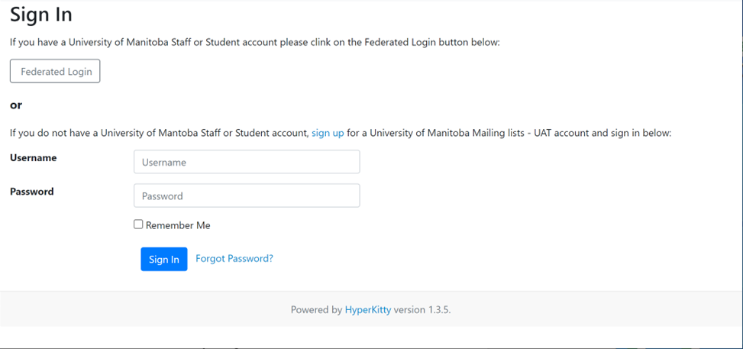

- From this page, click on the Federated Login button to continue.

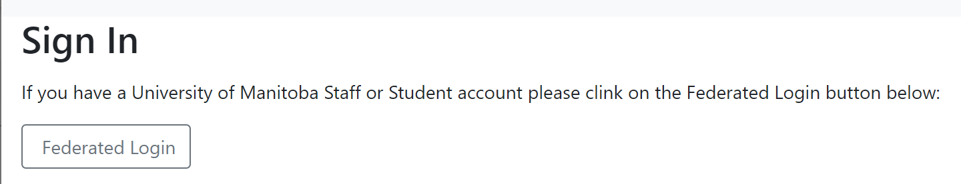

- Enter your user information. A message prompt will state, "Confirmation email sent to your email address," as shown below

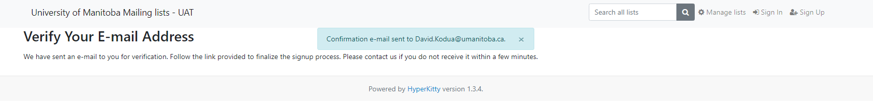

- Check your outlook email for the confirmation email as shown below. Click on the email confirmation link to continue and confirm your Login information
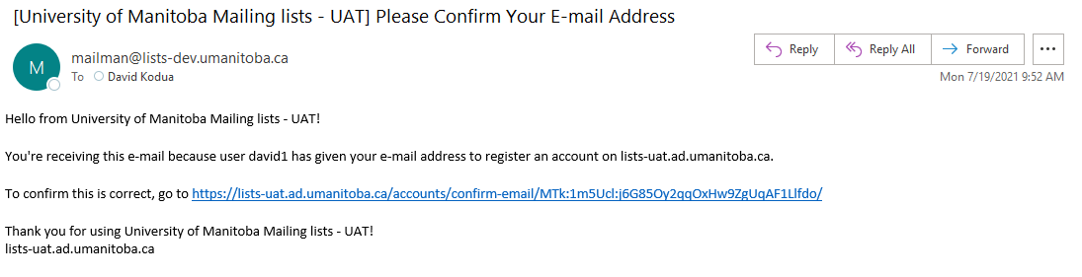

Your email path will be different

- The Confirm Email Address page will display. Click on the Confirm blue button to continue.

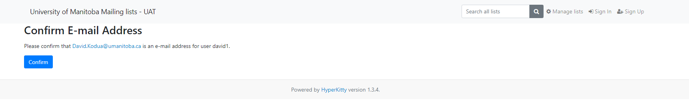

- The Sign In page will allow you to log in with your University of Manitoba email and password. Click Sign In after entering your credentials to continue.
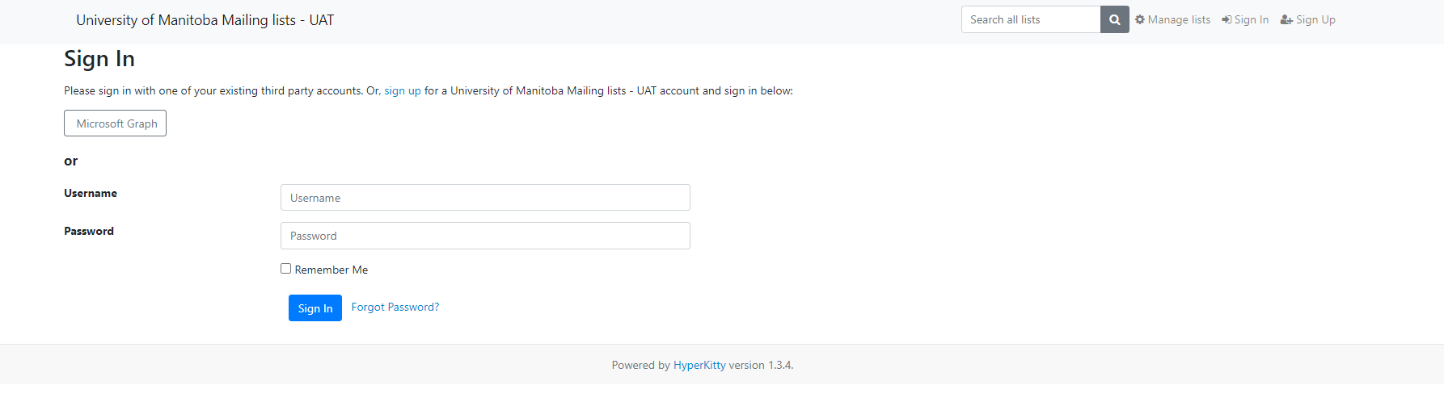

- The Mailing list page will display as shown below
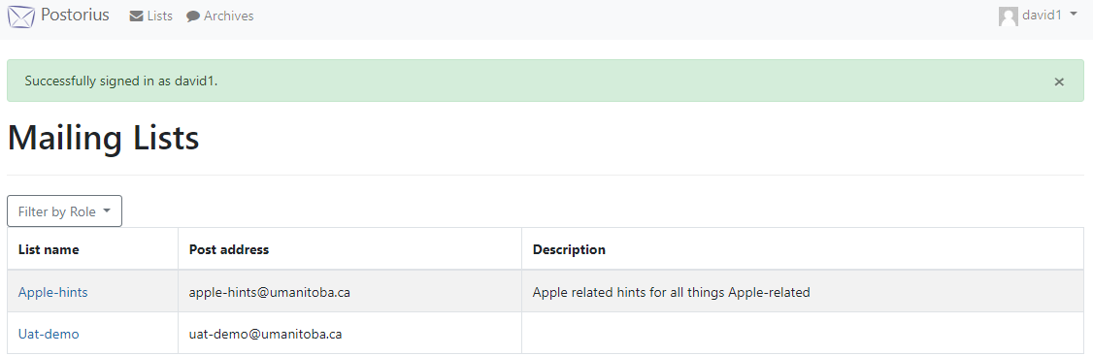

First-time user EXTERNAL

- Navigate to the link https://lists.umanitoba.ca/accounts/login/?next=/mailman3/ to sign in with your username and password.

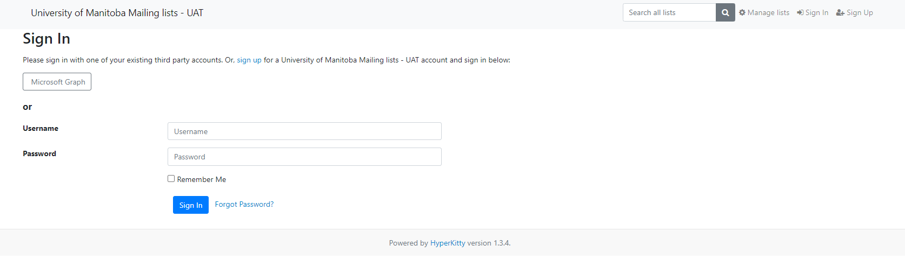

- Click Sign-Up at the top right corner, as shown below

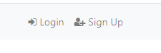

- The Sign-Up Page will display as shown. Enter your external credentials with your Email, Username, and Password and click Sign Up to continue.
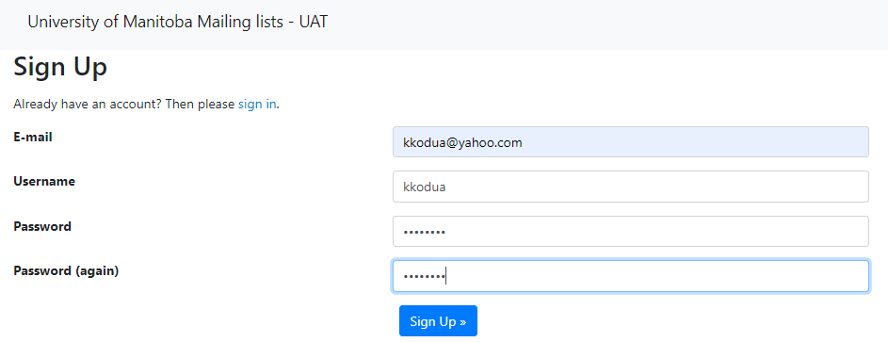

Note: Password must be 10 Characters

- The Verify Your Email Address page will display the prompt "Confirmation email sent to your email."

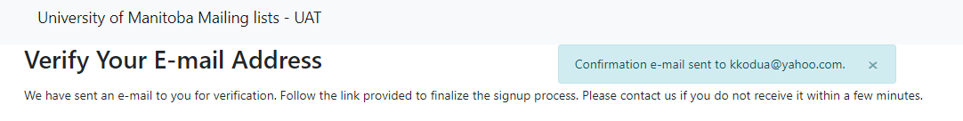

- Check your external email and click the link as shown below.

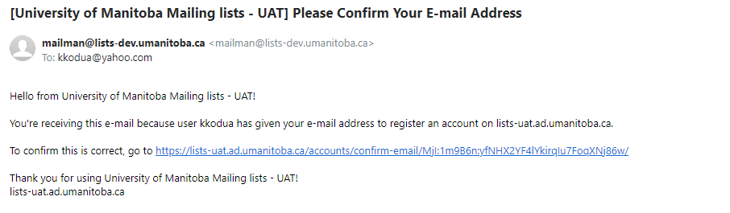
Your email path will be different

- The Confirm Email Address page will display. Click Confirm to continue
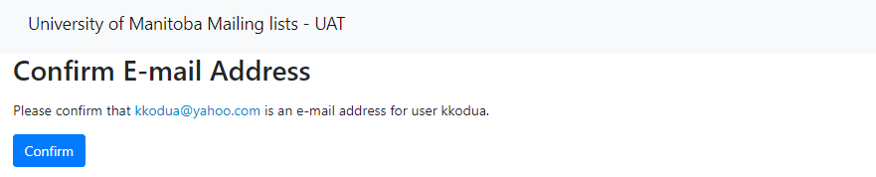

- The Sign In Page will display. Click Sign In to continue

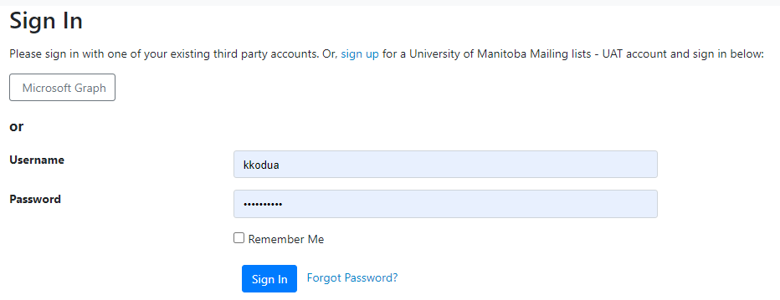

- The Mailing list page will Display as shown below

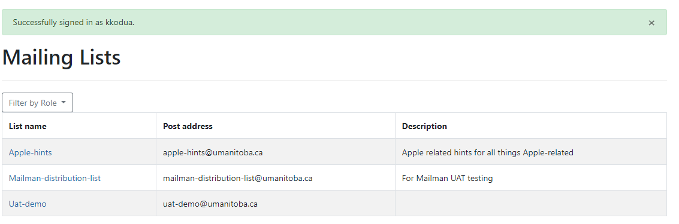

How to…

How to Add yourself to a public List

- On the Mailing list page, click on the list name you wish to add yourself. In this example, we would click the Apple-hints list name as shown below
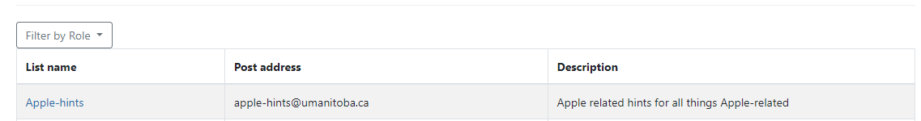

- The Apple-hints list page will display. Verify you have the correct email address. Click the Your name field (Optional) to add your name. Click Subscribe to continue.

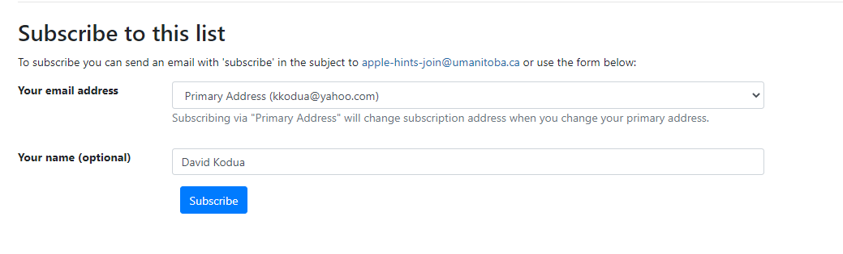
- A prompt will display informing the user; You are subscribed to apple-hints@umanitoba.ca
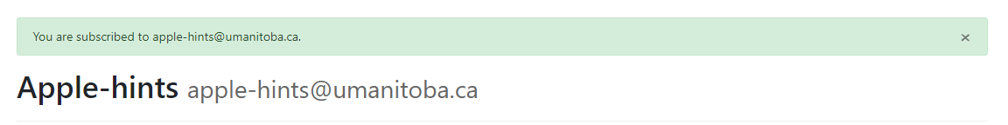

How to unsubscribe from a Mailing list

- On the Mailing Lists page. Click the Mailing list you wish to unsubscribe from, as shown below.

- The Mailing List page Apple-hints will display as shown below. In the Subscription/Unsubscription section. Click on Unsubscribe to continue.
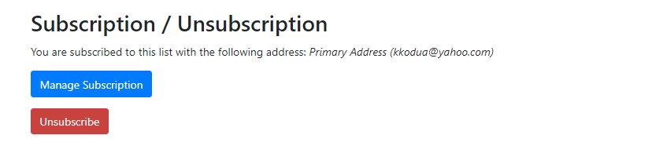

- A message prompt will display, letting you know the email has been unsubscribed.

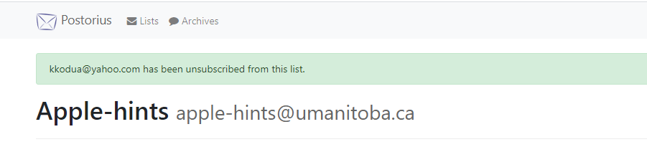

How to access the Archive

- From the main page, Mailing List. Click the list name you wish to access the Archive to continue. In this example, we would click Apple-hints list name.

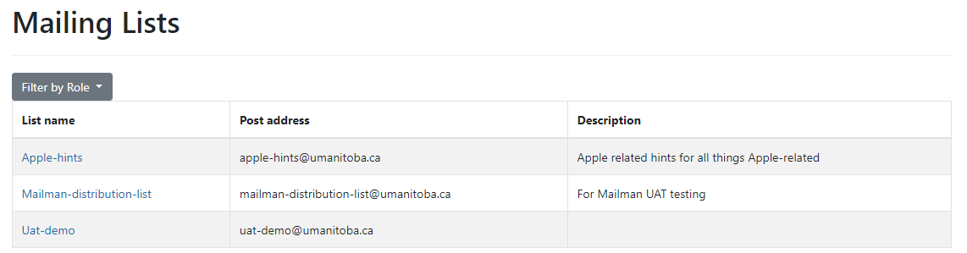

- The list name Apple-hints page will display. Click the Archives blue button to continue

- The Archives page will display for you to continue

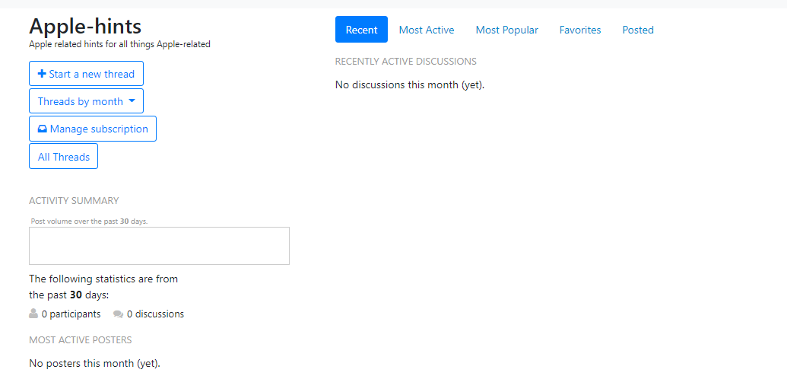

Other Functionalities

How do I view my Listings?

- Login into Mailman with your username and password. Click Sign In to continue.

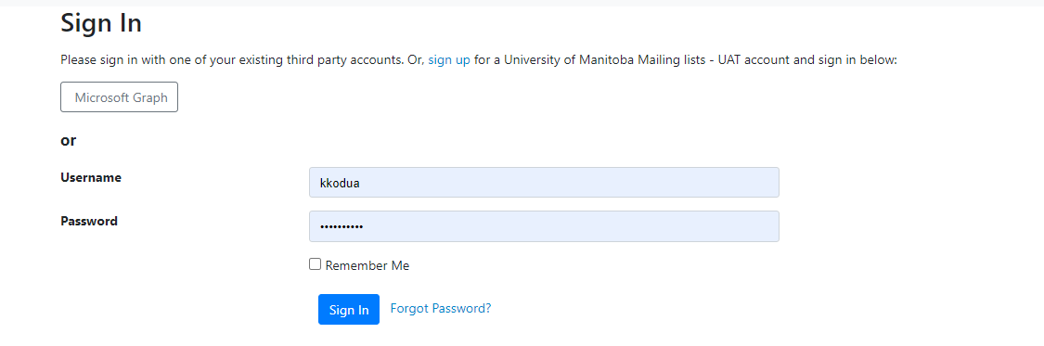

- The Mailing list page will display. Click on the drop-down menu by your username (in the upper right) and select "Mailman settings."
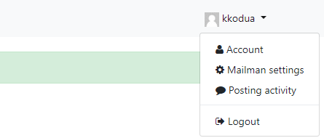

- The Mailman settings will display four tabs, as shown below. Subscriptions, Global Mailman Preferences, Address-based preferences, and List-based preferences. Click the Subscriptions and select the list name you want to view the settings. In this example, we will select Mailman-distribution-lists.umanitoba.ca to continue.

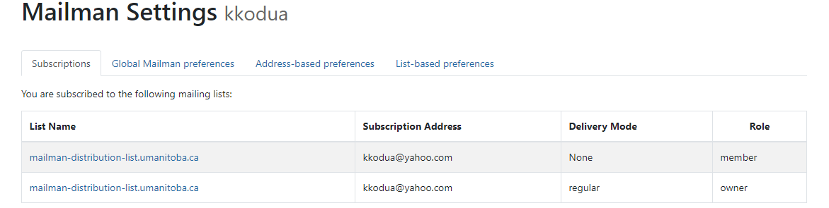

- Mailman-distribution-lists.umanitoba.ca list will display for you to continue with the settings. Please see below.

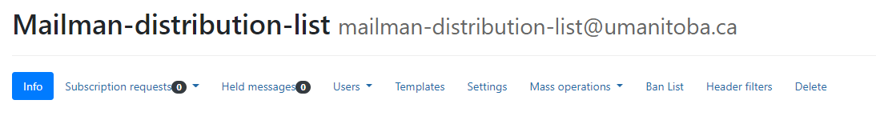

How do I disable/enable my mail delivery?

- You may wish to stop getting messages from the list without unsubscribing temporarily. If you disable mail delivery, you will no longer receive messages but will still be a subscriber and will retain your other settings. To do that, Log in and go to your list setting page and click on Global Mailman Preferences

- The Global Mailman preferences will display a list of options. Click on Enable or Disable radio button as shown below and then click Save Changes to complete the process.

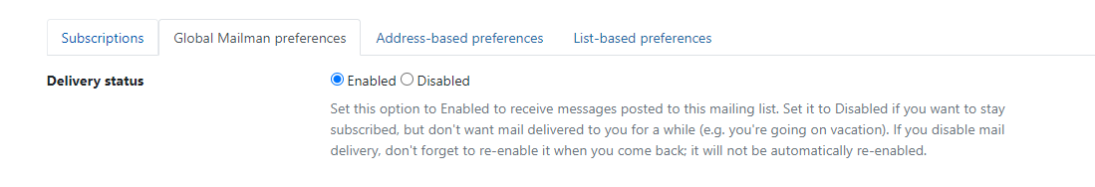

Note: This can be handy in many different cases. For example, you could be going on vacation or need a break from the list because you're too busy to read any extra mail. Many mailing lists also allow only subscribers to post to the list, so if you commonly send mail from more than one address (e.g., one address for at home and another for when you're travelling), you may want to have more than one subscribed account, but have only one of them actually receive mail. You can also use this as a way to read private archives, even on a list which may be too busy for you to have sent directly to your mailbox. All you need to do is subscribe, disable mail delivery, and use your password and email to log in to the archives.

How can I start or stop getting the list of posts grouped into one big email?

- Groups of posts are called "digests" in Mailman. Rather than get messages one at a time, you can get messages grouped together. To change the Digest settings, log in and go to the listing page, as shown below. Click on the Global Mailman preference to continue.

- The Global Mailman preferences will display a list of options. There is an option labelled "Delivery Mode," which you can set on your preferences tabs globally, per address, or per list subscription. Click the drop-down menu to view the different options Regular (Multipurpose Internet Mail Extensions), Mime Digest and Plain Text Digests if you select.
- Regular - You get an email every time the list sends one out.
- Mime Digest - It is used to send things by email which are not necessarily simple plain text. (For example, MIME would be used if you were sending a picture of your dog to a friend.) A MIME digest has each message as an attachment inside the message, along with a summary table of contents.
- Plain Text Digests - this is a simpler form of a digest, which should be readable even in mail readers which don't support MIME. The messages are simply put one after the other into one large text message.

In this example, we will select Regular and click Save Changes.

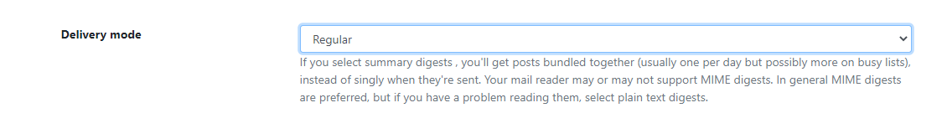

Note: Most modern mail programs do support MIME, so you only need to choose plain text digests if you are having trouble reading the MIME ones.

How do I stop or start getting copies of my posts?

By default, in Mailman, you get a copy of every post you send to the list. Some people like this since it lets them know when the post has gone through and means they have a copy of their own words with the rest of a discussion, but others don't want to bother downloading copies of their posts.

- To receive or stop receiving your posts: Log in and go to the listing page below. Click on the List name to continue. In this example, we will select Mailman-distribution-list.

- The Mail distribution list page will display as shown below. Click on the Users tab on the Info tab to continue.

- The settings page will display for you to continue. Click the Members option in the drop-down menu and then click on Member Options.
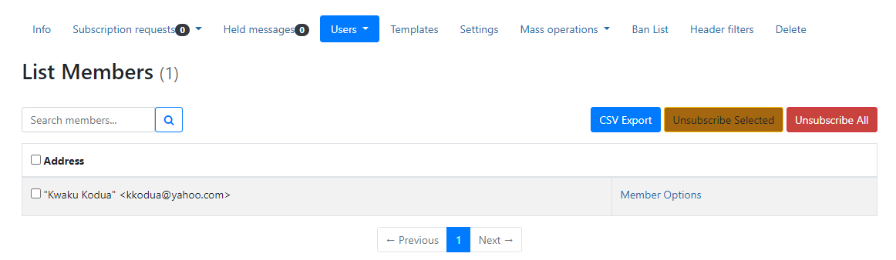

- The Subscription Options page will display. On the Receive own posting. Select the yes or no radial button to choose which option you prefer. As shown below.

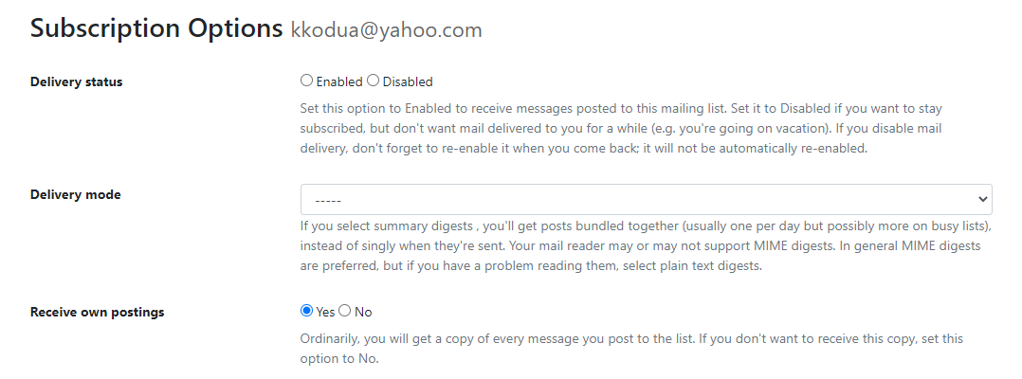

- Click the Save Changes button at the bottom to save the changes made.

How can I get Mailman to tell me when my post has been received by the list?

- On the Subscription page, scroll down to Acknowledge post and select Yes or no to receive acknowledgment mail when you send mail to the list. See below.

How can I hide my email address on the subscriber list?

Mailman can't completely stop you from getting duplicate messages, but it can help. One common reason people get multiple copies of a mail is that the sender has used a "group reply" function to send mail to both the list and some number of individuals. If you want to avoid getting these messages,

- Log in and go to the listing page, as shown below. Click on the List name to continue. In this example, we will select Mailman-distribution-list.

- The Mail distribution list page will display as shown below. Click on the Users tab on the Info tab to continue.

- The settings page will display for you to continue. Click the Members option in the drop-down menu and then click on Member Options.

- The Subscription Options page will display. On the Receive list copies. Select the yes or no radial button to choose which option you prefer.

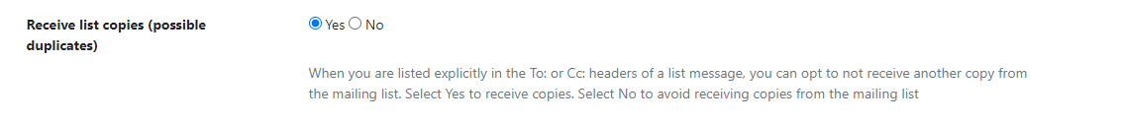

- Click the Save Changes button at the bottom to save the changes made.

How Do I… As a List Owner

How to Log in
- Navigate to the link https://lists.umanitoba.ca/ as shown below. Click Log in to continue.

- The Sign In page will display for you to enter your username and password as shown below. Click the Sign In blue button to continue

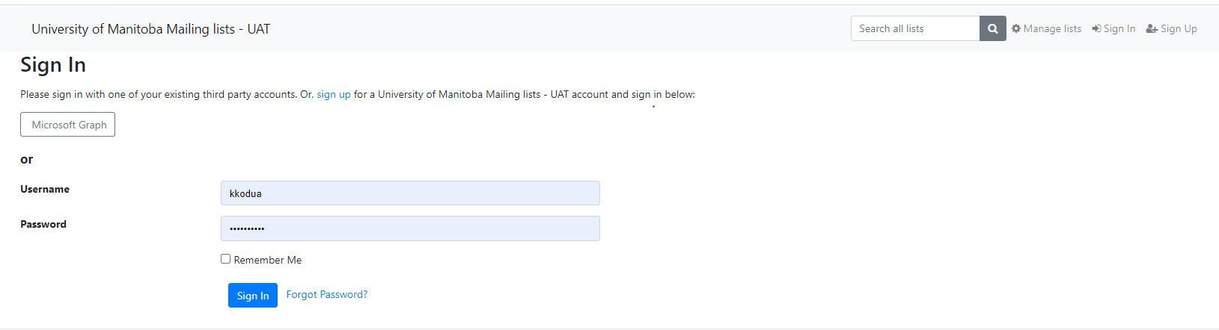

- If you are a List Owner, the Mailing list page will display all the list names you belong to. In this example, Mailman-distribution-list is what the user belongs to. Click the List name to continue

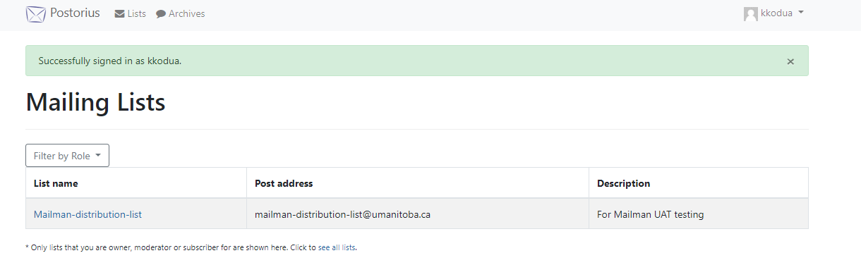

How to moderate content (approve) as a list owner

- On the Subscription Options page, click the Users drop-down and select Members, as shown below.

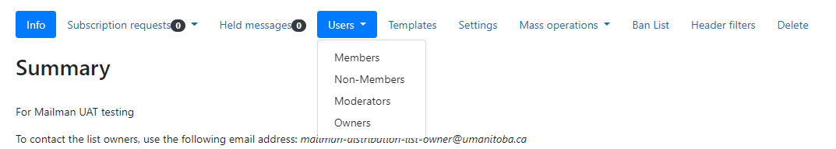

- Click on Member options to continue.

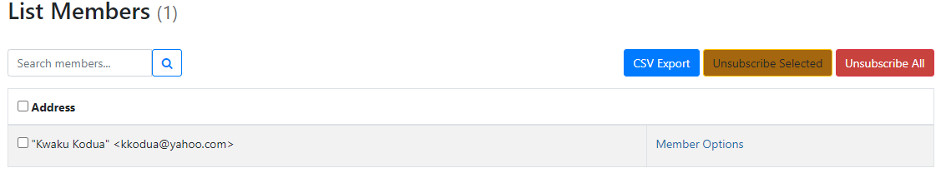

- On the Subscription page, scroll to the bottom of the page to Administrative Options Moderation. Select the drop-down menu and select Hold for Moderation. Click Save Changes. This holds the message for approval by the list moderators.

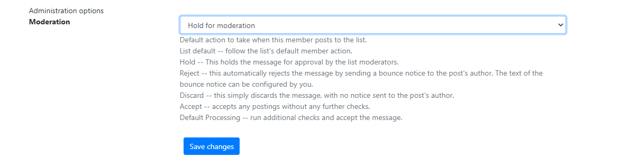

How to add/Remove Users

- Once you are logged in to the Mailman suite, click the list name as shown below to continue.

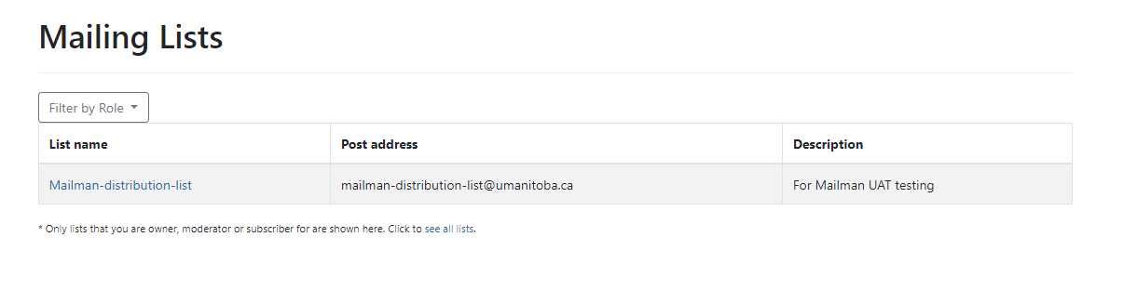

- Click on the Mass Operations drop-down menu to select adding or removing users. Click on Mass Subscribe to add users. The Mass subscribe page will display for you to add emails to the Mass subscribe.

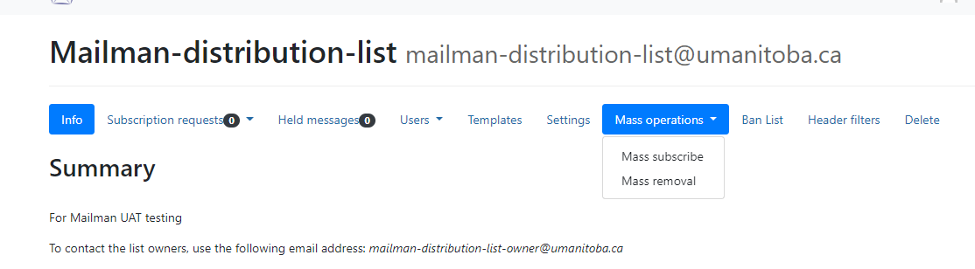

- Add the users you wish to add. On the checkboxes below, select the settings you prefer and continue. In this example, I selected Pre confirm, Pre approved with a list default. Cl.ck Subscribe to add the users

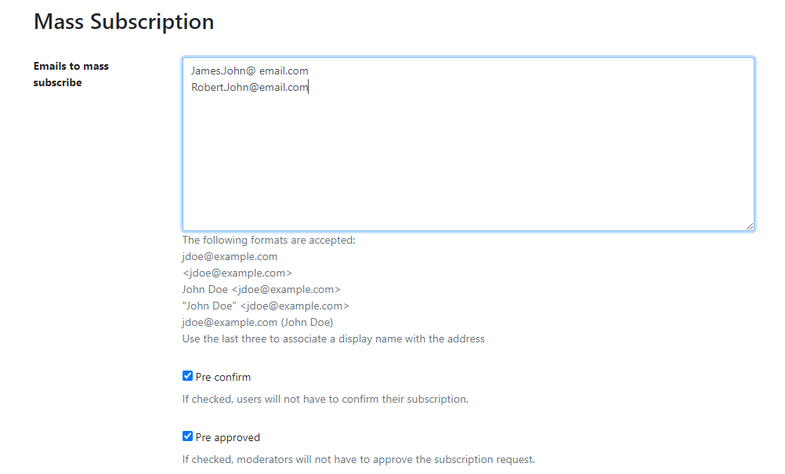
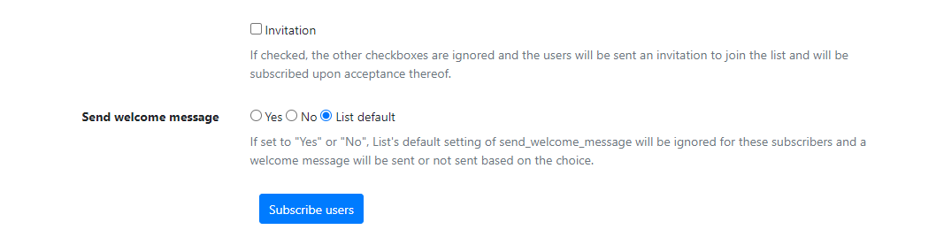

- To remove users from the subscription, click Mass Removal to continue. The Mass removal page will display as shown below. Add your email address and click Unsubscribe users or Unsubscribe all to remove all the users.

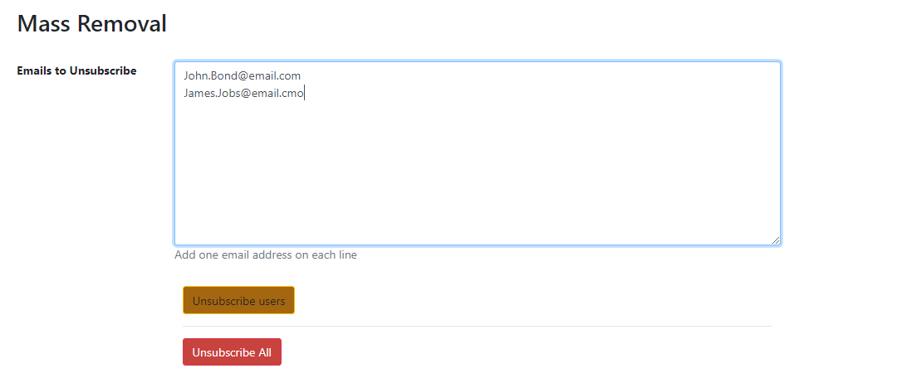

How to Ban Users

- Click the Ban list Tab to display the Banned Addresses Page. Add the email to the Add Ban Field and click Ban Email.

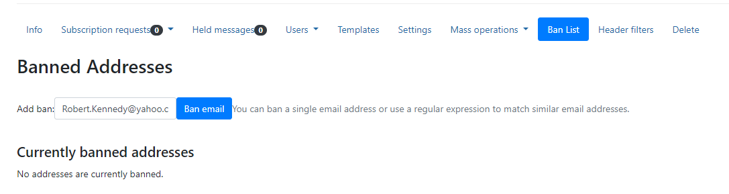

- The Banned email will display for you to know which is currently banned, as shown below.

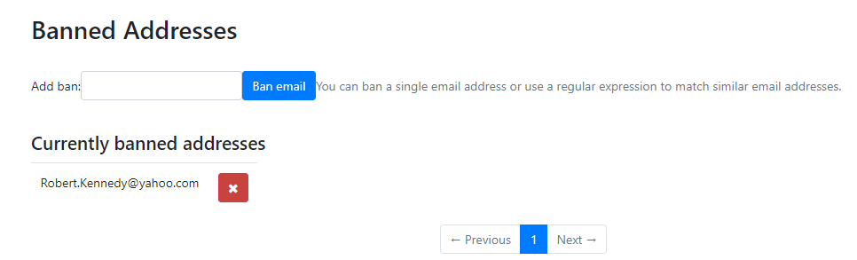

How to Remove messages from the Archive

- Click the setting tab on the mail distribution page. Browse to the list-administration panel
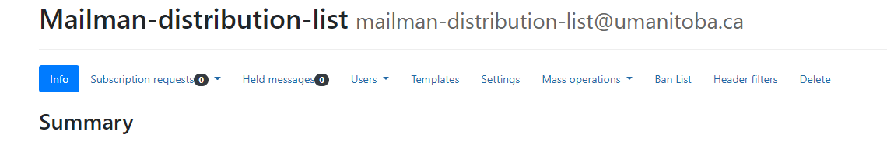

- Click on Archiving button and turn off archiving (option archive) and switch Archive from public to private if it's public (option archive private). Click Save Changes to continue

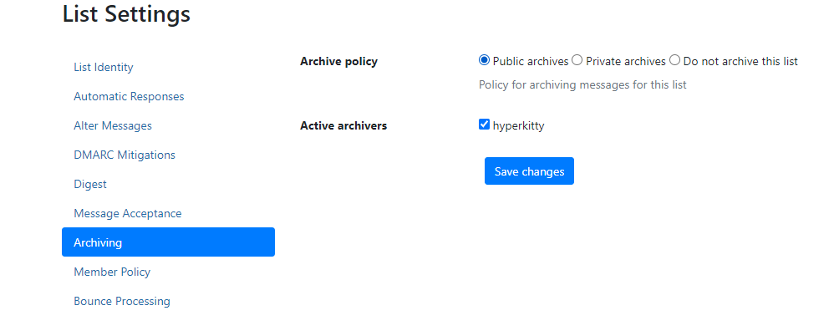

Note: Do the things as described above. When editing the raw Archive (mailbox), just delete all entries. If you like to reenable archiving later, just turn on archiving in the list-administration panel (and set it to the public if you want to). If you wish not to archive the list, click on the button "Do not archive this list."

- To delete the archives after setting. Click Archives on the main page as shown below to access any recent active discussion. If there is, you can select and delete it.

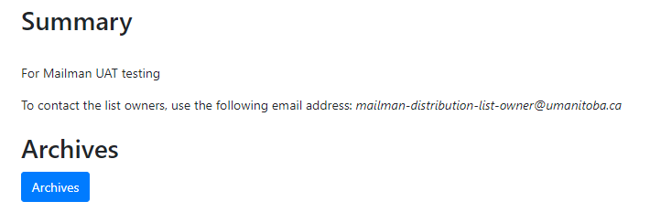

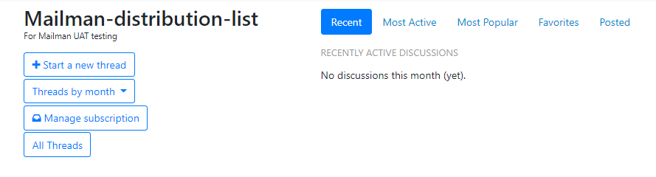

How to Promote Members to list owner or moderator

- From the Mailing List page. Click on the list name to continue, as shown below.

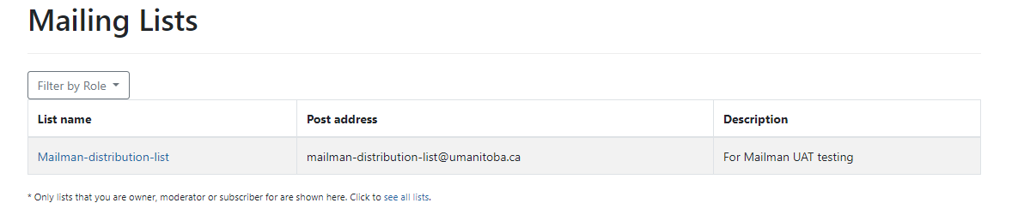

- Click on the Users drop down menu and click Owners to continue.

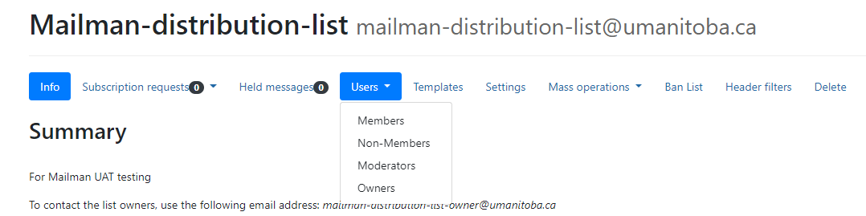

- To promote a member, click the email address field and add the member email. You can alternatively search a member by clicking the search member field and then enter the name. Click the search icon to continue. Once added the name will appear on the address list as shown below.
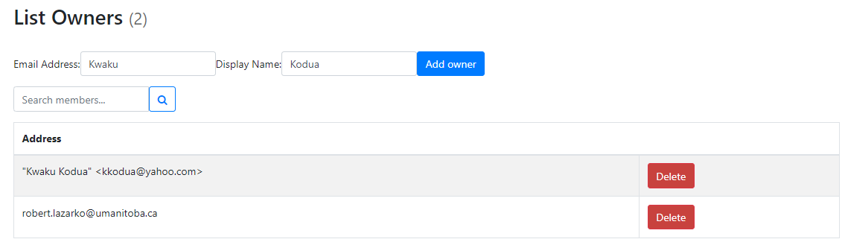

Appendix A MailMan 3 Service Process

Appendix B MailMan 3 Support Process

