Classroom 223: UseR Guide
Contents
Show instructor content to students 2
Using the Instructor PC 2
Using your own laptop 3
Sending instructor’s content on all student screens 4
Student participation 5
Logging into student computers 5
Showing a student display on the main screen 7
Showing a Student display to all student screens 8
Use videoconferencing 9

Show instructor content to students
This section discusses how instructors can display content to students either on the main screen or on all the student displays in the classroom. It discusses the following scenarios:
- Showing the in-classroom instructor PC on the main display
- Showing an instructor’s own device on the main display
- Showing instructor content, either from the Instructor PC or from an instructor’s device, to all the student displays

Using the Instructor PC
- To turn on the control panel, tap its screen.
- To display the Instructor PC on the main display, set the control panel as follows: Select the Present tab, Front Display and then Instructor PC.
- Use the instructor PC mouse and keyboard to log in with your account.
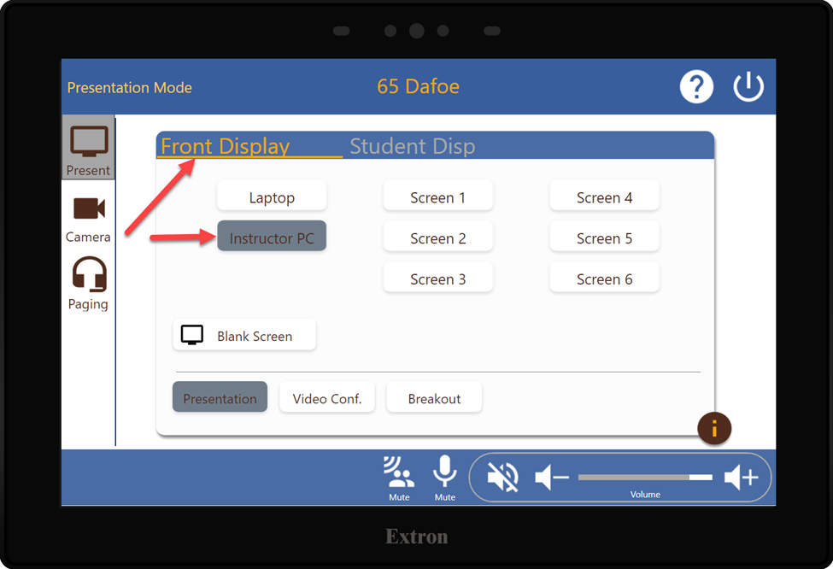

Using your own laptop
- To use your own laptop with the main display, connect your laptop to the HDMI cable on the instructor desk.
- Tap Present on the wall panel, and on the Front Display tab, select Laptop.
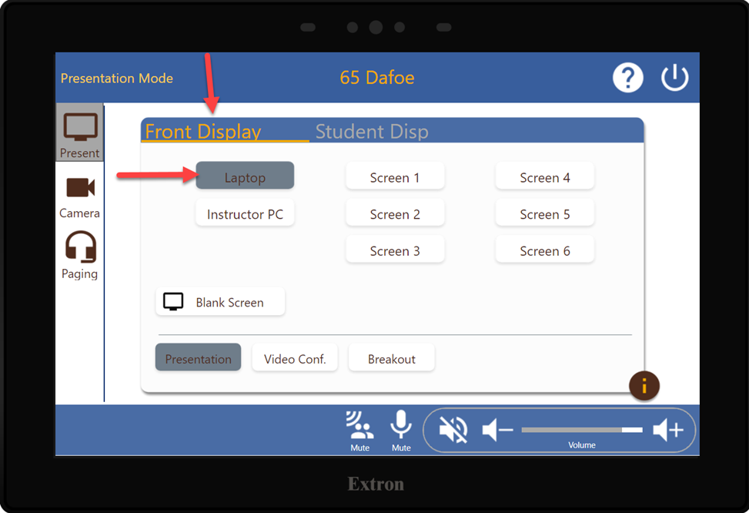

Sending instructor’s content on all student screens
- To display the instructor’s content on all the student displays, on the control panel, tap Present> Student Display tab.
- Select Instructor PC or Laptop.
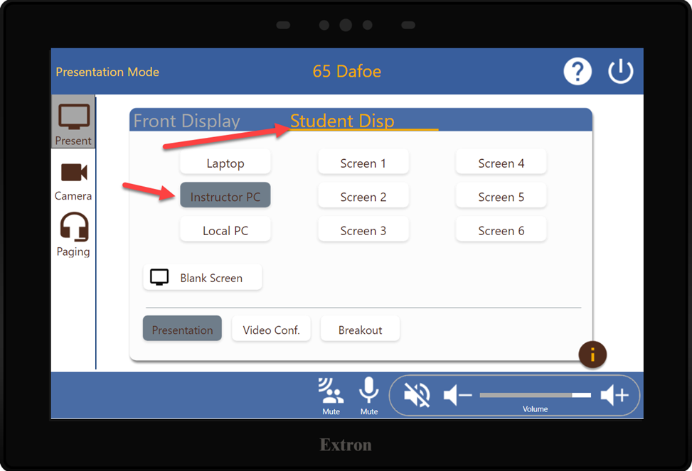

Student participation
This section shows how the instructor can enable students to participate through the student computers. There are six (6) student computers in the classroom and students can log into the local computers to work on activities during the class. The instructor can show students’ work from any of the student computers to the main display, or to all the student displays.

Logging into student computers
NOTE: Students will be only able to login on to the computers if Local PC is selected on the Student Display tab in the wall panel.
- The instructor can set the students’ local PCs to display in their own stations. To show each local PC on the student displays, on the control panel, tap the Student Display tab, and then select Local PC.
- Once the student computers show up on the student displays, students can log into their student computers.
- To log into a student computer, students can press the space bar of the keyboard to bring up the log in screen, and then enter their UM ID credentials.
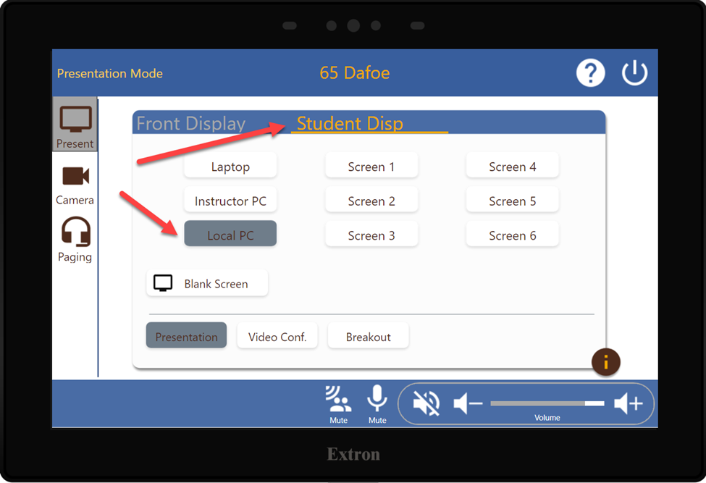

Showing a student display on the main screen
- To switch the main display to show a student display, on the control panel, tap the Front Display tab, and then select the station number you wish to display.
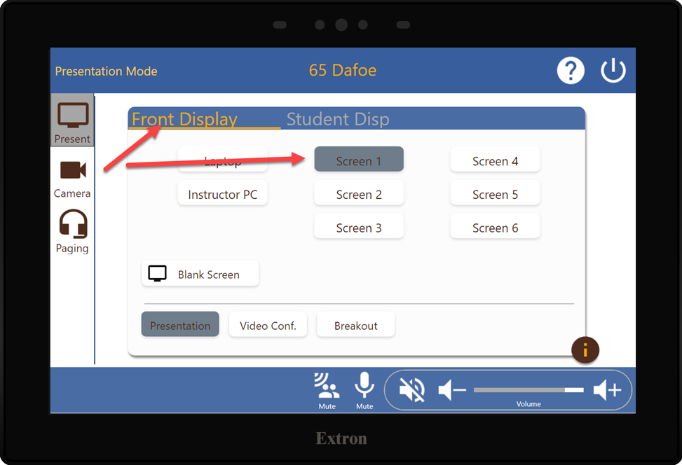

Showing a Student display to all student screens
- To show a student display to all student stations, on the control panel, tap Student Display tab, and then select the station to be displayed.
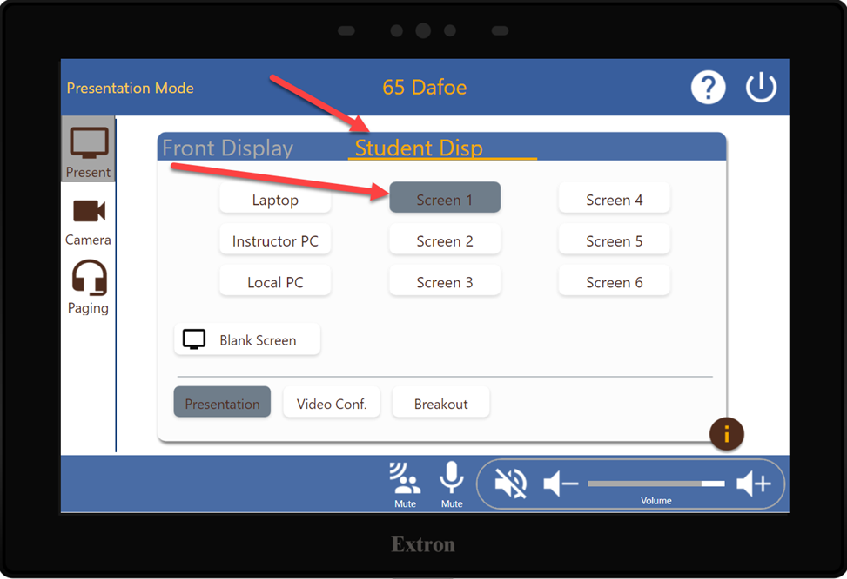

Use videoconferencing
- To Use Zoom, Webex, or Teams for remote participants, start the meeting application you wish to use on the instructor PC (we will use Zoom in this example).
- Create the meeting from Zoom through umanitoba.zoom.us, enter all the required information like date, start and end time, attendees’ email addresses, etc.
- Start the meeting.
- On the control panel, tap the Camera tab, and select the camera you want the remote viewers to see on their screen.
Note: To share your screen from your PC, Use the Zoom share screen feature.
