Student Welcome Package 2021-2022

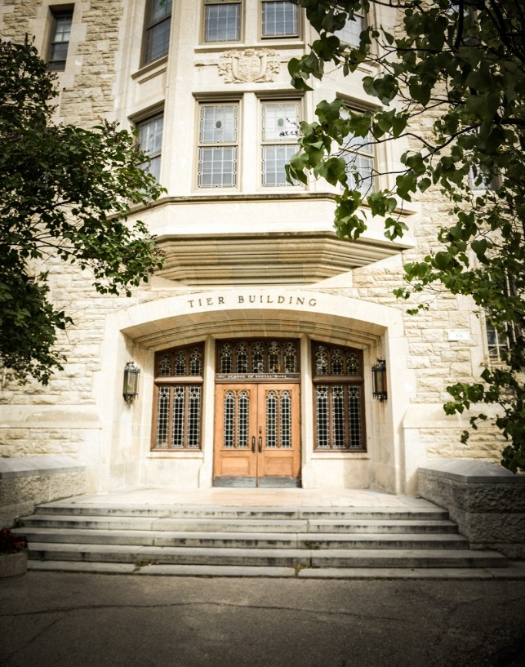
Contents
Introduction 3
Distance Delivery Social Work Team 3
Office Assistant 6
Orientation 2021 6
Online Study and Web Conference Requirements 6
Academic Advising 7
Bachelor of social Work Course Requirements 7
Written English & Math Elective Requirement 8
Required Social Work Courses 9
Foundation Courses 9
Theory Courses 10
Field 11
Field Courses 11
Field Options 12
Summer Option 13
Fall/Winter Regular Session Option 13
Fall/Winter Accelerated Option 13
Degree Plan Worksheet 14
Claim Your U of M Computer ID 14
UM Learn 15
Email 15
Information Services & Technology (IST) 15
Library Services 15
Aurora 16
Academic Schedule 16
Final Examinations 16
Fees 17
Scholarships and Bursaries 17
University of Manitoba Student Photo Identification Cards 17
Replacement Cards 17
Accessibility Services 18
Keep Us Posted 18
Join us on Facebook and Instagram 18

Introduction
Congratulations on your admission to the Distance Delivery Bachelor of Social Work degree program and welcome to the Faculty of Social Work! We are pleased that you have chosen social work as a profession. We hope that your studies in the Distance Delivery Bachelor of Social Work degree program will be motivating and rewarding. Our Distance Delivery Social Work Team members are here to provide assistance and support throughout your course of study. The purpose of this package is to introduce the Distance Delivery Social Work Team and to provide some information regarding the Faculty of Social Work Distance Delivery BSW program.
A Note on COVID-19: Approval of field placements are on a case by case basis, with approval coming from the Dean of the Faculty of Social Work. Given that things are ever evolving and the future of the pandemic still to be played out, we feel compelled to outline the uncertainty of any future placements to our new admits. Our field team is working hard on coming up with creative ways for students to complete their placements and hours but want to caution students on making assumptions about any particular placement they may have in mind. For more information on COVID-19 please visit https://umanitoba.ca/coronavirus/resources-students

Distance Delivery Social Work Team

Acting Distance Delivery Program Coordinator
The Program Coordinator’s role is to ensure you receive quality education. If you have any concerns while receiving your degree, please do not hesitate to contact Joan.
Joan Churley
Email: Joan.Churley@umanitoba.ca
Phone: (204) 295-2789

Distance Delivery Field Coordinator
The Field Coordinator’s role is to ensure that you are well prepared and supported throughout your field placement. Please contact Jacqueline regarding any Field/PLAR inquiries.
Jacqueline Shortridge
Email: Jacqueline.Shortridge@umanitoba.ca
Phone: (431) 275-6843

Distance Delivery Program administrator
The Program Administrator’s role is to manage the office as well as assist with field coordination.
Leslie McKenzie
Email: Leslie.Mckenzie@umanitoba.ca
Phone: (204) 474-9537

Curriculum and instructional technology facilitator
Lynette Phyfe
Email: Lynette.Phyfe@umanitoba.ca
Phone: (204) 474-9947
The Curriculum and Instructional Technology Facilitator promotes and facilitates quality curriculum design and delivery.

Distance Delivery Academic Advisors

Joel Montgomery
Email: Joel.Montgomery@umanitoba.ca
Phone: (204) 915-8170

The Academic Advisor’s role is to support students while they pursue their degree. Advisors can help you with course registration, authorized withdrawals, degree planning, graduation requirements and any other questions you might have. Your Academic Advisor is here to support you.
Julia Florek Turcan
Email: Julia.Florek@umanitoba.ca
Phone: (431) 336-6802

Louise Sabourin
Email: Louise.Sabourin@umanitoba.ca

Educational Tech Programmer & Support
Dave Nicholls
Email: Dave.Nicholls@umanitoba.ca
Phone: (431) 275-5951

Morsal Arianta
Email: Morsal.Arianta@umanitoba.ca
Phone: (431) 275-5738

Erin Jansen
Email: Erin.Jansen@umanitoba.ca
Phone: (431) 277-2543

The Educational Tech Programmers will work with you to ensure you are ready for web conferences, design courses in UM Learn and offer workshops and training for instructors and students.

Eden Metrik
Email: Eden.Metrik@umanitoba.ca
Phone: (431) 275-4319

Scott Thomas
Email: Scott.Thomas@umanitoba.ca

Alton Graham
Email: Alton.Graham@umanitoba.ca
Alton Graham

Office Assistant
Collins Songok
Email: ddsocial.work@umanitoba.ca
The Office Assistant’s role is to provide information and advice regarding various University of Manitoba Policies and Procedures. They can help answer general inquiries, and direct students based on their particular needs.

Orientation 2021
You will be required to attend a mandatory two-hour Online Orientation Web conference scheduled the week of July 5th – 9th. This session will introduce you to our orientation modules, and will cover the following topics:
- Bachelor of Social Work Degree Program and the Faculty of Social Work, BSW degree requirements and degree planning
- Educational technology, Cisco WebEx, Aurora, and UM Learn
- Distance and online education, Academic Learning Centre, Student Advocacy, Accessibility Services and other online resources
- Off-Campus library services, academic writing and APA for citing and referencing
Upon completion of your online orientation web conference, you must complete the orientation modules over the remainder of the summer. These modules are filled with knowledge and information that is designed to help you succeed in our program and can be referred back to at any point throughout your studies. There will be a mandatory Wrap-up Session to consolidate all this information the week of August 9th – 13th. Completion of the Orientation requirements will give you the opportunity to register for courses. Failure to complete the Orientation requirements will jeopardize registration in Sept courses.
Your Academic Advisor will speak to you at the online orientation session and work with you to plan your Degree. Your Academic Advisor will be in contact with you on a regular basis, reminding you of important registration dates, Voluntary Withdrawal dates and review grades and degree plans with you.
You will be receiving an email with further information about both the Orientation Session and the Wrap-up Session.

Online Study and Web Conference Requirements
All of the courses that you enroll in will require you to attend online web conferences. Please ensure that you have the requirements listed below to ensure a smooth transition into the web conference.
Please contact the Educational Tech Programmer if you have any questions regarding the information presented in this section.

Windows
- Processor: 1.4 GHz Intel Pentium 4 or faster processor (or equivalent)
- Operating System: Windows 10, Windows 8, or Windows 7
- Memory: 512 MB of RAM (1 GB recommended)
- Web Browser: Google Chrome
- Software: Cisco WebEx Browser Extension, Adobe Reader, Microsoft Office

Mac OS
- Processor: 1.83 GHz Intel Core Duo or faster processor
- Operating System: Mac OS X 10.13, 10.14 and 10.15
- Memory: 512 MB RAM (1 GB recommended)
- Web Browser: Apple Safari
- Software: Cisco WebEx Browser Extension, Adobe Reader, Microsoft Office

Additional Hardware
- USB Headset with Microphone
- A webcam is highly recommended
- Please note that Chromebooks and Chrome OS are not supported by Cisco WebEx
- Microsoft Teams is available to all students as part of the MS Office Suite
- https://umanitoba.ca/microsoft-365/build-your-skills-microsoft-teams

Internet Requirements
- Bandwidth: 512 Kbps internet speed required for web conferences. Use of satellite internet is discouraged as the latency causes disconnects from web conferences.

Academic Advising
You will have an Academic Advisor assigned to you to support you throughout your BSW degree. Academic Advisors have specialized knowledge about processes and policies; they can help you map out your courses, advise on course selection, assist you with registration issues, direct you to appropriate resources, and answer other questions you may have about your program. Your Academic Advisor is here to help! If you don’t know who to ask, start with your Advisor! They will point you in the right direction.

Bachelor of social Work Course Requirements
The University of Manitoba Bachelor of Social Work Degree Program consists of 123 credit hours of course work, including:
- 72 credit hours of required social work courses, including two field practicums
- 51 credit hours of electives, taken at the student’s discretion in terms of subject areas (except social work) and must include a 3credit hour elective course in math and a 3 credit hour elective course in written English.
Effective May 2015, students can only count three credit hours of social work elective courses towards the BSW degree, including any social work transfer credits. Students have up to 9 years to complete the BSW degree. The actual completion time will vary with individuals depending on such factors as the number of credit hours transferred in, work and personal circumstances, etc.
Students can transfer in up to 51 credit hours of electives from their previous studies based on the completion of a degree from a recognized educational institution. However, in the event that a degree has not been completed, the University of Manitoba Enrollment Services determines admissibility of elective credits on an individual basis. Students who have taken social work courses at other universities have the opportunity to make a request to the Faculty of Social Work through the Admissions Office for equivalency within the 6-month period following their acceptance into the Faculty of Social Work as a regular student. Please note that any social work courses for which you are making the request must be completed within the last 9 years and must be from a program that is accredited by the Canadian Association for Social Work Education. Also, note that only 3 credit hours of social work elective courses, including transfer credits, will be applied to the Bachelor of Social Work degree.

It is also important to note that a student enrolled in the Social Work BSW Program at the University of Manitoba cannot enroll in any other degree program.

Written English & Math Elective Requirement
As per the University of Manitoba policy “all students are required to complete, within the first 60 credit hours of their programs, a minimum of one 3 credit hour course with significant content in written English, and a minimum of one 3 credit hour course with significant content in mathematics.” Students that completed baccalaureate degrees and students admitted before the 1997-98 regular Session are exempt from this requirement (see Written English and Mathematics Requirements for Undergraduate Students in University of Manitoba Calendar).
All students admitted to the program who have not completed the University of Manitoba written English and/or mathematics requirement must satisfy both within the first 60 credit hours of their program. All credit hours used for the purpose of admission into the BSW program is part of the 60 credit hour count for their program. If a student does not satisfy both the written English and mathematics requirement (with a minimum grade of D) within the first 60 credit hours, students will not be permitted to register for any social work courses until they have registered in the mathematics and written English requirement courses. A student accepted at the University of Manitoba cannot graduate without meeting the Math and English requirement.

Required Social Work Courses
The 72 credit hours of required social work courses include foundation courses, field and practices courses and theory courses. It is important that you consult with your Distance Delivery Academic Advisor on a regular basis for assistance with planning. As you consider which courses to take, please note that you must complete the four foundation courses (SWRK 1310, SWRK 2080, SWRK 2090, and SWRK 3140) before you can take the Field Instruction and Field Practices courses, as well as some of the theory courses. Course descriptions, prerequisites and co-requisites for the various courses outlined in the Course Catalogue in Aurora.

Foundation Courses

Foundation Courses (15 CH) |  | CH
SWRK 1310 | Intro Social Welfare Policy | 3
SWRK 2080 | Interpersonal Communication Skills | 3
SWRK 2090 | Human Behavior in Social Work | 6
SWRK 3140 | Intro to Social Work Practice | 3

SWRK 1310 Introduction to Social Welfare Policy-3 credit hours
Examination of social welfare policy as the end product of ideologies. Introduction of elements of ideology and the comparison of competing ideological systems. The relationship of economic, political and ethical views of society and their manifestation in societal responses to human need and social services.

SWRK 2080 Interpersonal Communications Skills-3 credit hours
A basic core of interpersonal skills for communicating effectively and for establishing and maintaining relationships in one-to-one and group situations. Emphasis is on experiential learning using a variety of techniques.

SWRK 2090 Human Behavior and Social Work Practice-6 credit hours
Students are introduced to a broad range of theories and will develop an understanding of how people and environments reciprocally affect each other. Particular emphasis is placed on understanding how gender, race, ethnicity, socioeconomic factors, age, ability, and sexual orientation contribute to and influence human behavior throughout the lifespan.

SWRK 3140 Introduction to Social Work Practice-3 credit hours
Introduces students to ecological and other generalist based practice frameworks and the role of professional social workers. Course emphasizes values and knowledge in context of a rational approach to problem solving which includes problem definition, assessment, contracting, intervention and evaluation. Pre- or co-requisite SWRK 1310, SWRK 2080, and SWRK 2090.

Theory Courses

Theory Courses (21 CH) |  | CH
SWRK 2110 | Emergence of the Canadian Social Welfare | 3
SWRK 3100 | Systematic Inquiry in Social Work | 3
SWRK 3130 | Contemporary Canadian Social Welfare | 3
SWRK 4210 | Feminist Perspectives on SW Practice & Social Welfare Policy | 6
SWRK 4220 | Aboriginal Peoples & Social Work | 6

SWRK 2110 Emergence of the Canadian Social Welfare State-3 credit hours
An examination of the Canadian Social Welfare state from its various colonial inheritances to the Canada Assistance Plan. Social, political, economic, religious, geological, demographic, and cataclysmic factors influencing the development of welfare state are examined and analyzed. Pre-requisite: SWRK 1310.

SWRK 3100 Systematic Inquiry in Social Work-3 credit hours
Relates systematic methods of scientific inquiry to social work practice; theory building for practice; information collection; descriptive data for decision-making; understanding technical research material, introduction to issues of research design.

SWRK 3130 Contemporary Canadian Social Welfare-3 credit hours
An examination of social welfare in Canadian society, leading to an evaluation of present approaches in the light of changing economic and social conditions and changing needs. Pre-requisite: SWRK 1310.

SWRK 4210 Feminist Perspectives on Social Welfare Practice and Social Welfare Policy-6 credit hours
An analysis of social welfare practice and welfare policy from a feminist perspective. Course emphasizes the integration of social work intervention with policy in the social welfare context and overlays concepts such as empowerment, ecological practice, oppression, and practice in context of cultural diversity. Pre-requisites: SWRK 1310, SWRK 2080, SWRK 2090, and SWRK 3140.

SWRK 4220 Aboriginal People and Social Work-6 credit hours
An analysis of social work practice and welfare policy from an aboriginal perspective. Course emphasizes the linkage between practice and policy and overlays concepts such as colonization, decolonization, and approaches to practices which include cross culture, structure, and anti-oppression in the context of Aboriginal world views, experience and helping practices. Pre-requisites: SWRK 1310, SWRK 2080, SWRK 2090, and SWRK 3140.

Field
Field instruction provides students with an opportunity to engage, as beginning practitioners, in the processes of social work assessment, planning, intervention, evaluation and integration of theory from classroom course work to placement setting. Students complete their field placement requirements in a variety of service agencies and organizations. Possible field placement sites may include school settings, government policy departments, correctional services, child and family services, immigrant and refugee services, and health care services to name a few.
Students enrolled in the Distance Delivery Site of the BSW Program are responsible for securing their own Field Placement. Informational web conferences are held to support the process and ensure students are following the guidelines to secure their own placement.
Within the BSW degree, students must complete two field placement courses, including SWRK 3150 Field Instruction I or SWRK 3152 Field Instruction I PLAR and SWRK 4120 Field Instruction II. You must register for and successfully complete SWRK 4200 Field/Focus of Social Work Practice I concurrently with SWRK 3150 Field Instruction I or SWRK 3152 Field Instruction I PLAR, and SWRK 4300 Field/Focus of Social Work Practice II concurrently with SWRK 4120 Field Instruction II. Pre-requisites for field: SWRK 1310, SWRK 2080, SWRK 2090, and SWRK 3140. All Field Placements require the approval of the Field Coordinator.

Field Courses

Field/Practice Placement 1 (18 CH) |  | CH
SWRK 3150 or SWRK 3152 PLAR | Field Instruction I or PLAR | 12
SWRK 4200 | Field Focus of Social Work Practice | 6
Field/Practice Placement 2 (18 CH) |  | CH
SWRK 4120 | Field Instruction II | 12
SWRK 4300 | Field Focus of Social Work Practice II | 6

SWRK 3150 Field Instruction I-12 credit hours
A first educationally directed field experience in which the student will have the opportunity to assume responsibility for social work engagement, assessment, planning, intervention, and evaluation, integrating theory from class. Students must complete 420 hours in the field. This time commitment includes involvement with the agency in planning for, and engaging in, practice activity, and evaluation of performance. It also includes educational contact time with the field instructor in individual and/or group sessions. Subject to satisfactory completion and reports, students are graded on a pass/fail basis. Pre-requisites: SWRK 1310, SWRK 2080, SWRK 2090, and SWRK 3140. Co-requisite: SWRK 4200. All Field Placements require the approval of the Field Coordinator.

SWRK 3152 Field Instruction I Prior learning assessment and recognition (plar) -12 credit hours
A student who has been admitted to the Bachelor of Social Work program, who has two or more years of previous social work experience in the past five years may apply to register for the SWRK 3152 Field Instruction I Prior Learning Assessment and Recognition (PLAR). SWRK 3152 is in lieu of the first field placement SWRK 3150 Field Instruction I. PLAR is a self-study in which the student (upon acceptance) will have the opportunity to demonstrate basic social work knowledge and skills as required of all students in first field placement. Students will be required to demonstrate learning in social work engagement, assessment, planning, intervention, and evaluation, as well as integration of social work values and ethics and theoretical frameworks as attained in pre-requisite foundation courses. The deadlines to submit the PLAR Application, including all required documentation is the first day of December. Prerequisites: SWRK 1310, SWRK 2080, SWRK 2090, SWRK 3140. Co-requisites: SWRK 4200. Students may not hold credit for both SWRK 3152 and SWRK 3150.

SWRK 4200 Field Focus of Social Work Practice I-6 credit hours
A seminar for the critical examination of social work theory, values, policy, and skills in the context of a field or focus of practice. The course integrates policy with practice at micro, meso and macro levels. Course seminar topics may vary from year to year and cover various fields or focus of practice. Pre-requisites: SWRK 1310, SWRK 2080, SWRK 2090 and SWRK 3140; Co-requisite: SWRK 3150 or 3152.

SWRK 4120 Field Instruction II-12 credit hours
A second educationally directed practice experience building on SWRK 3150/SWRK 3152 in which the student will have the opportunity to carry a sustained professional role in situations which require the integration of values, knowledge, and skill at the level of a beginning professional practitioner. Students must complete 420 hours in the field. This time commitment includes involvement with the agency in planning for, and engaging in, practice activity, and evaluation of performance. It also includes educational contact time with the field instructor in individual and/or group sessions. Subject to satisfactory completion and reports, students will be graded on a pass/fail basis. Prerequisites: SWRK 4200, and SWRK 3150 or SWRK 3152. Corequisite: SWRK 4300. All Field Placements require the approval of the Field Coordinator.

SWRK 4300 FielD Focus of Social Work Practice I-6 credit hours
A seminar for the critical examination of social work theory, values, policy, and skills in the context of a field or focus of practice. The course integrates policy with practice at micro, meso and macro levels. Course seminar topics may vary from year to year and cover various fields or focus of practice. Pre-requisites: SWRK 3150 or SWRK 3152 and SWRK 4200. Co-requisite: SWRK 4120.

Field Options
Within the BSW degree, you must complete two field placement courses, including SWRK 3150 Field Instruction I Students are responsible for securing their own field placement. The field coordinator will work closely with students while applying for placements and will ensure affiliation agreements, assigning of field liaisons and insurance is purchased on the student’s behalf. It is important for students to note that it can be difficult to secure placements in some provinces where competition from other schools of social work exist. All Field Placements require the approval of the Field Coordinator.

All students registered in Distance Delivery Field Instruction courses (SWRK 3150 and SWRK 4120) are required to complete several Field Instruction Modules and participate in a one-hour web conference prior to entering field placement.
Completion of the Field Instruction Modules and attendance at Field Instruction Web Conference is mandatory.

Summer Option
SWRK 3150/SWRK 4200 or SWRK 4120/SWRK 4300
4 days per week May- August (30 hours/week) = Total of 420 hours
Students require a minimum Degree Grade Point Average (D.G.P.A.) of 3.0 to be eligible to apply for Summer Field.

Fall/Winter Regular Session Option
SWRK 3150/SWRK 4200 or SWRK 3152 PLAR or SWRK 4120/SWRK 4300
2 days per week September-April
Students require a minimum Degree Grade Point Average (D.G.P.A.) of 2.5 to be eligible to apply for Regular Field.

Fall/Winter Accelerated Option
SWRK 3150 4 days per week September-December (30 hours/week) = Total of 420 hours
SWRK 4120 4 days per week January-April(30 hours/week) = Total of 420 hours
SWRK4200 and SWRK 4300 September-April
To be eligible for an accelerated field placement, you must have completed 75 credits hours of coursework, including all four-foundation courses. (SWRK 1310, SWRK 2080, SWRK 2090, and SWRK 3140) and have a cumulative GPA of 3.0 or higher.

People to contact for any questions regarding Field and/or PLAR
- Jacqueline Shortridge: Field Coordinator
- Leslie McKenzie: Program Administrator
- Louise Sabourin: Academic Advisor
- Collins Songok: Office Assistant

Degree Plan Worksheet
Note: Students will receive the below worksheet as a part of the New Admits Orientation Modules.
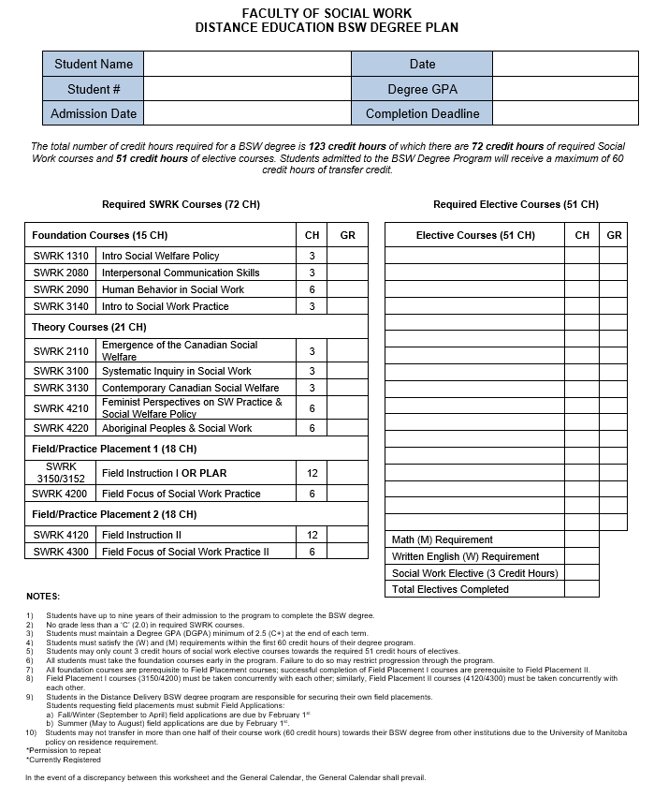

Claim Your U of M Computer ID
Upon accepting your offer from the Admissions Office, you will be required to claim your UM NetID through sign UM. Claiming your U of M computer account gives you access to course websites in UM Learn, JUMP, U of M Email, U of M Libraries, Software Express, Unix and other services.
- Instructions and a tutorial on how to activate your UofM Computer Account
- Claiming your UMNetID

UM Learn
A learning management system that U of M uses to house all of the courses offered. UM Learn will provide you access to your registered course for each distance and online education course. You must claim your UM NetID before you can access the UMLearn Orientation portal. If you have already claimed your UM NetID, you do not need to do this again.

Email
Your UM NetID gives you an email account that you must use for all academic email. Your U of M email address will be the only address used by the University and the DD Social Work Program for all communications. Professors and Instructors will also be using your U of M email address to communicate with you so be sure to check the emails or set it to forward mail to your preferred email address. You must use the university provided email for all communications per university policy.

Information Services & Technology (IST)
The Information Services & Technology Office provides computer support for all University of Manitoba students. They can be reached by phone: (204) 474-8600 or e-mail: support@umanitoba.ca IST
The IST Service Desk is available to assist students, faculty and staff with any IT issues that you may have. We are here to find a solution or point you in the right direction. Service Desk provides University of Manitoba students with information and assistance with computing questions and problems: E-mail Password Resets Supported Software Wired & Wireless Network and More Drop by, phone, chat or visit our IT Service Catalogue.

Library Services
The ability to access the U of M libraries is a vital component in accessing research materials. Over a million full text articles are available online at no cost to you. Accessing the libraries through the internet allows you to research your assignments, access online materials and if necessary, order the appropriate materials directly from the library services. Social Work Off Campus Services will send materials electronically if at all possible, and if not, will send materials to Distance Delivery students through the postal system, with the library absorbing the cost of return postage. Off Campus Library Services staff will assist you with searches, locating research materials and sending them to you, if necessary. Graduates from the BSW through Distance Delivery vouch for the friendly, supportive services that they have received from the library staff. In order to access electronic resources, you must have your UM NetID and password.
Research begins at UM Libraries. Learn at the Libraries is a great place to start, with information for students on academic writing, how to search the library, evaluating resources, and writing citations. As the primary contact for all research needs, your liaison librarian can play a vital role when completing academic papers and assignments. Liaisons can answer questions about locating appropriate resources or managing citations, and will address any other concerns you may have regarding the research process. Liaisons can be contacted by email or phone, and are also available to meet with you online. When working remotely, students can also receive help online through Ask Us! chat. For further detail about the libraries’ services and collections, visit the Libraries’ web site. Regularly check our COVID-19 Update page for available library services and access to resources for Fall 2021.

Request Library Materials
For faster service, request library materials using Request Form available online. You may also request materials via phone, email, or fax. Provide complete information including student number, mailing address and course number. Include your email address or phone number in case we need to confirm request details. Failure to include this information may result in a substantial delay in response time. All University of Manitoba Libraries notices (overdue, recalls, etc.) are sent by U of M email ONLY.

Loan Periods & Fines
Books are available on loan for 60 days. Photocopies of journal articles are yours to keep. Book loan periods are extendable (renewed) if another borrower has not requested the item. Library materials are subject to recall, resulting in a shorter loan period. Fines of $3.00 per day per item on overdue recalled items. If an item is lost or damaged, a replacement charge is applied. Information on the fines and borrow times can be found here.

Research Assistance
To request library searches on research topics, you must provide detailed information about your essay or project including key terms or words, period of time, geographic region and any important individuals, groups or governments. Clear and focused requests will help the librarians provide you with the most relevant materials for your assignment. To request assistance please contact the liaison librarian.

Library Card
Your University of Manitoba photo ID card is also your library card. If you visit the Libraries in person, you must have your photo ID card to borrow material.
Please feel free to call toll-free (North America) 1-800-432-1960 ext. 9183 or via email at disted@umanitoba.ca.

Aurora
Aurora is the University of Manitoba’s Student Management system that will allow you to access the Course Catalogue, Class Schedule and Transfer Credit Equivalencies Database. Within the secured area, you will have access to your Personal Information, Enrolment and Academic Records including registration, your academic transcript, student fee account, etc.

Academic Schedule
The University of Manitoba Registrar’s Office has set out all important dates and deadlines online through the Academic Schedule.
Please pay very close attention to the registration dates, voluntary withdrawal deadlines, fee payment deadlines, refund deadlines and Examination periods.

Final Examinations
You will be required to apply to write all examinations at off campus locations, unless you plan to come into Winnipeg. All students enrolled in Distance and Online Education courses are required to declare the location at which they will write all invigilated final examinations. Exam Invigilation Sites may require that students travel up to two hours (one-way) to the nearest examination center. You must complete The Exam Location Declaration Tool located within the Exam Location Management Widget of your UM Learn courses. Students must declare location for each online course. The Exam Location Declaration Tool will be available within UM Learn courses from the start of term until the application deadline. Late declarations are not accepted.
All dates listed on the Examination Schedule pertain to all Distance Delivery students. Please ensure that you write these dates on your calendar. If there are any questions, please call the appropriate department.
Application deadlines:
- Fall term courses: TBA Mid September to early October
- Winter term courses: TBA Mid January to early February
Questions: Please contact examsoffcampus@umanitoba.ca

Fees
For a complete schedule of Undergraduate fees including undergraduate tuition fees, incidental fees (UMSU Health and Dental Insurance, Registrar’s Office Service Fees), other compulsory fees (Student Service fees, Technology Services fee, Sport and Recreation fee, Registration fee, Library fee) refer to the Registrar’s Office Fee Information Page.
Students will not receive a statement regarding your fees. Fee amounts and due dates can be obtained on your Student Fee Account in Aurora, immediately following your registration. It is a student’s responsibility to pay all required fees by the due dates available in your Aurora Student Fee Account. Students with outstanding balances after due dates will be placed on hold and will be subject to late fees, cancellation of registration in subsequent terms and suspension of grades.

Scholarships and Bursaries
There are several bursaries (generally based on financial need) and scholarships (generally based on academic accomplishment) available to University of Manitoba students; some require only a general application (through Aurora), while others also require a supplemental application form.
Please see the Faculty of Social Work website for a list of Bursaries and Awards that are open only to Social Work students.
You can also search the Awards Database for other awards you may be eligible for.
The deadline to apply for most awards is October 1st 2021.

University of Manitoba Student Photo Identification Cards
Beginning about two weeks after you receive your Certificate of Admission to the University of Manitoba, you may obtain your photo ID. You are encouraged to obtain your card during the summer, before courses start. A fee payment receipt to indicate that you have actually registered is not required.
Please note it is important to obtain a Photo Identification Card early, as you will require photo ID when entering field. The Field Coordinator strongly encourages students to apply for a U of M Photo ID when you enter the program. Your photo identification card is your access key to all student services. It is issued when you first register and is permanent throughout your attendance at the University of Manitoba. Only one U of M photo identification card is required. The photo ID card is also your library card.
Please use the step by step directions to obtain your Photo Identification Card through Aurora.

Replacement Cards
If your photo ID card is lost, stolen, or you change your name, report it to the ID Centre, Registrar’s Office, 400 University Centre. There is a fee for a replacement card regardless of the reason for loss. The exception is in a case where you report the loss to the police and provide a report number to the ID Centre.

Accessibility Services
Student Accessibility Services provides support and advocacy for students with disabilities, such as: hearing, injury-related, learning, mental health, medical, physical, visual or temporary disabilities. They act as a liaison between students, faculty, staff and service agencies. SAS upholds the Manitoba Human Rights Code, the Accessibility for Manitobans Act and the University of Manitoba's Accessibility Policy.
Please visit the Student Accessibility Services website for further information.

Keep Us Posted
It is essential that you inform the University of Manitoba of any changes to your contact information. Please ensure that you update your contact information in Aurora whenever any changes occur (address, telephone number, email address, etc.). In addition, keep the Distance Delivery Social Work Program informed of any changes in your situation so that we can keep our faculty files up to date.
Please email the Distance Delivery Social Work Program Office and remember to provide your name and student number each time you contact us. It is very important to maintain regular contact with the Distance Delivery Social Work Team including your Academic Advisor, Field Coordinator and Program Coordinator. Please feel free to contact us at any time. We are very accessible and we encourage it!

Join us on Facebook and Instagram
The Faculty of Social Work Distance Delivery BSW Program has created a private Facebook group for students, faculty and staff to interact in discussion, ask questions, and share valuable information with each other. We invite all students to join and participate. When joining the group please provide the name you have used to register as a student, we cannot verify adding you to the group if we do not know what your registered student name is.
Join us on Instagram as well @ddbsw_

Good luck!
We look forward to meeting you at Orientation.

