The Angry Bucket
Thanks to Chris Buffie
The demonstration of the Angry Bucket is a simple demonstration that can be used when teaching chemistry. Specifically, this demonstration would fit in with the senior 3 & 4 chemistry curriculum (C11-3-06 & C12-3-08). It could be used in the reaction types unit to demonstrate a combustion reaction. It also shows quite dramatically the influence of surface area on reaction rate. That is the change from reactants to products occurs rapidly as a result of increased surface area.
The demonstration is quite simple, and the only materials which are needed are an ice cream bucket with a tight fitting lid, a candle, corn starch, a length of tubing (probably about 1 meter in length) and some duct tape. A small hole is cut into the bottom of the bucket and the end of the tube is fed into the hole. The tube should be taped so that the opening of the tube is directed along the side of the bucket. The candle should be fixed to the middle of the bottom of the bucket. At least one and a half heaping tablespoons of corn starch are placed at the opening of the tube. The amount of cornstarch may need to be increased if this amount does not work properly.
The demonstration could start by taking a small pile of cornstarch, and explaining to the class that cornstarch is an organic molecule (hydrocarbon) and will combust. You could then take a match, light it, and immediately push the lit match into a pile of cornstarch. Of course the match would extinguish because of the lack of oxygen in the center of the pile of cornstarch. Then a match could again be lit, and held against the surface of a pile of cornstarch. The surface of the pile may begin to burn slightly, but will mostly smolder. Then, the candle in the middle of the bucket is lit. At this point you could tell that class that you will be putting the lid on the bucket, and then blowing into the tube. Ask the class what they think will happen. Most likely they will tell you that the candle will go out either because you put the lid on, smothering the candle, or because of blowing into the tube, the candle will be blown out. Snap the lid onto the bucket and, fairly quickly, blow a quick puff of air into the tube. The lid will be blown off and flames will leap out of the bucket.
This is a very dramatic demonstration of the combustion reaction. The explanation of this demonstration lies in the amount of oxygen present for the reaction to proceed with. In the first case, when the lit match is forced into the pile of cornstarch, there is no oxygen inside the pile of starch. This makes it impossible for the combustion reaction to proceed, and the match is extinguished. The next case is where the lit match is held up to the surface of the pile of starch. In this case, there is oxygen present, but only at the surface of the pile. This allows the molecules on top of the pile to react, but not all the molecules under the surface. The pile may burn slowly, or will smolder.
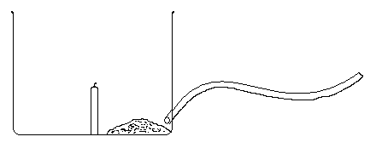Finally, the candle inside the bucket is lit. The dramatic burst of flames which occurs is due to the fact that upon blowing into the tube, the oxygen is mixed thoroughly with the cornstarch. When the cornstarch is spread around inside the bucket, it becomes evenly mixed with oxygen. The starch molecules nearest the candle reach their activation energy, and begin to combust. This reaction supplies the activation energy for the next nearest molecules as well. Since all the molecules are surrounded by oxygen which has been evenly mixed, all these molecules begin to combust as well. The result is a chain reaction which causes all the molecules to begin to combust very rapidly, and an explosion occurs. This is the same type of explosion which may occur in grain storage silos and elevators.
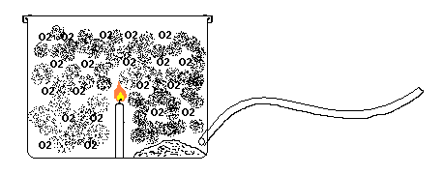 Candle Cornstarch Tube

Oxygen thoroughly mixed with Cornstarch
For this experiment, the demonstrator should wear safety goggles. Make sure that the piece of tubing is at least one meter long. This is to ensure that the demonstrator doesn’t need to be too terribly close to the bucket. As long as you are at least a meter away from the bucket, the likelihood that you would get injured is very small. Ensure that the students are no closer than two meters. They should not be any closer than this. I would also strongly recommend that the students be warned not to try this at home. You may choose to not tell the students that the white powder is cornstarch, and may choose to tell them simply that it is an organic hydrocarbon instead. This will make it harder for them to try something like this at home.

