EVENT COORDINATOR
EVENTS CALENDAR USER GUIDE

Version 0.2
Table of Contents
Read This First 3
Getting Started. 4
Creating an Event 6
Deleting an Event 7
Cross-Posting Events 8
Locations 8
Contact 9
Images 9
Attachments 10
Registration and Products 11
Additional Event Information 13
Attach a Survey 13
Saving and Publishing an Event 17
Appendix A 18
Appendix B 19
Appendix C 20

Read This First
This section of the Events Calendar Training Guide should be read first by all Events Calendar Event Coordinator Roles of the Events Calendar system.
It is important that all Event Coordinators are aware of the following items before the provisioning or use of the new Events Calendar;
- When Events are created within Events Calendar, proper ethics with regards Cross-posting of events must be applied. Events created should not be cross-posted to all categories but only to categories where the category owners have been communicated with prior to Cross-posting event(s).
- The Marketing Communications Office must be contacted for new calendar requests or category name changes. This will be facilitated through the IST Service Desk via a service ticket and the required Events Calendar Provisioning form.
- All event contacts or site event coordinators must know how to find and provide Registrant Information upon request made by Event Registrants.
- The Access and Privacy Office (APO) must be contacted by All Site Administrators to ensure Administrative responsibilities under FIPPA (Freedom of Information Protection and Privacy Act) and follow the rule of “minimum amount” and “need to know” have been provided.
  - Events Calendar Site Administrator must contact the Access and Privacy Office (APO) to obtain a FIPPA privacy notification statement for all Events requiring registrations and/or RSVPs. All Events that require registration, must be submitted directly to Rachelle Ross Rachelle.Ross@umanitoba.ca and to fippa@umanitoba.ca for appropriate FIPPA, PHIA or both statements to be customized for each event.
  - During initial Pilots and Trial, a registration form will be provided to be filled out and sent to the APO. This form will be replaced by APO governing guidelines for registrant data collection in the near future.
- Site Administrators must contact the Access and Privacy Office (APO) regarding Records Authority Schedules.
- All Users of the Events Calendar Site must have a clearly identified and assigned user Role in Events Calendar.
- If you planning a fundraising event, or plan to collect donations at your event, you must contact Donor Relations donor.relations@umanitoba.ca or 1-204-474-9195 for assistance.

Please see Access & Privacy Office Recommendations on Events below;
http://umanitoba.ca/admin/vp_admin/ofp/fippa/media/Event_Registration_Guidelines.pdf

Getting Started.
Navigate to the University of Manitoba Events Calendar tenant site at https://eventscalendar.umanitoba.ca
- On the main UofM Events Calendar site, navigate to your Events Calendar site by selecting from one of the categories in the drop down menus.
- Select your Events Calendar site by clicking on your category name as shown in figure 1.0 below.
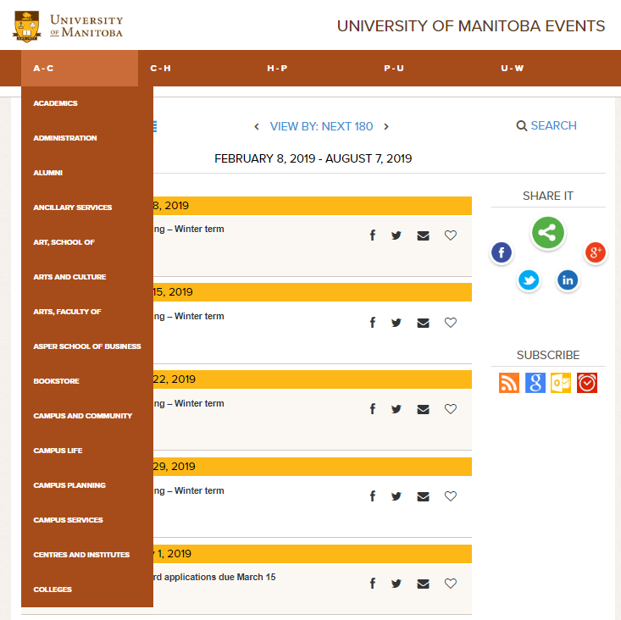
Figure 1.0

- You will be redirected to the University of Manitoba Single Sing-On (SSO) page as shown in figure 1.1 below

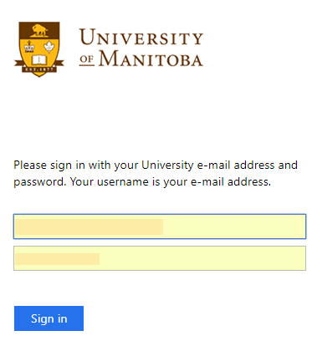
Figure 1.1

Enter your UMNetID authenticated Email address and Password. Click Sign in as shown in figure 1.1 above.
You will see the Events Calendar Dashboard as shown in figure 1.2 below;
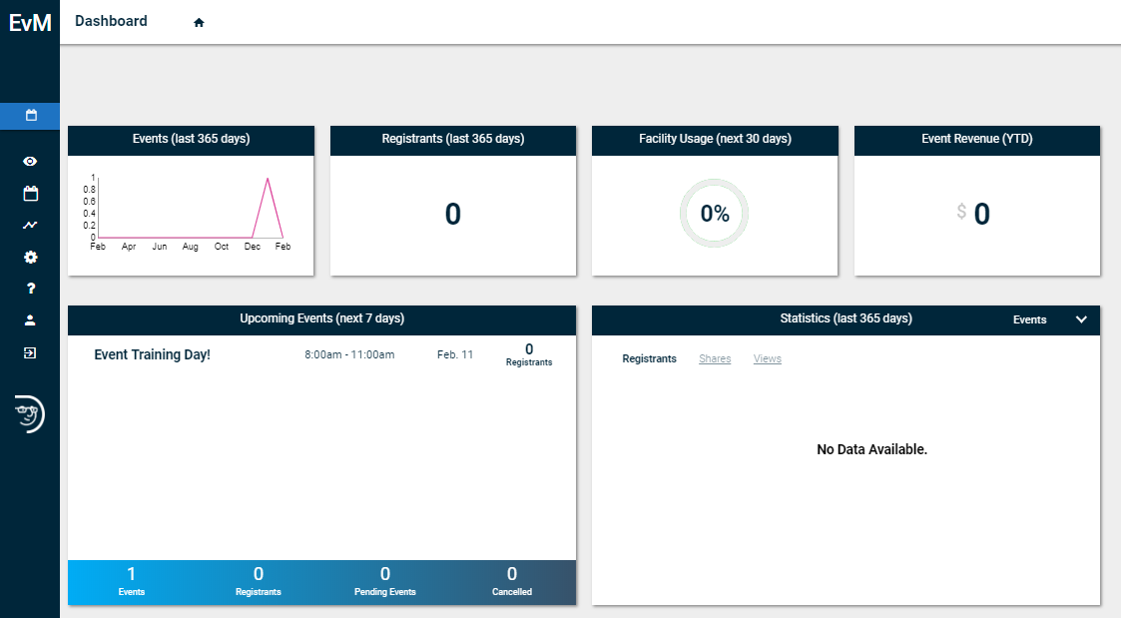
Figure 1.2
Move your mouse to the left hand side of the screen to reveal the drop down options available as shown in figure 1.3 below.
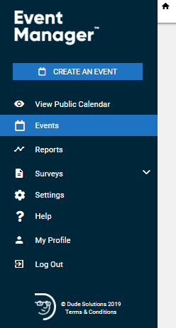
Figure 1.3

Creating an Event
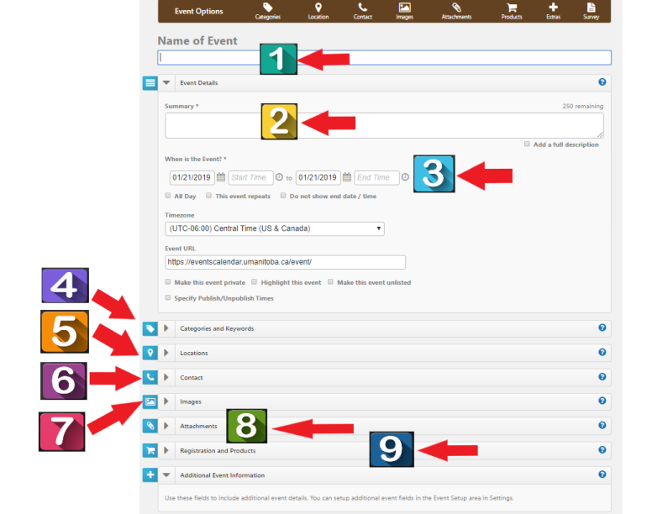
Figure 1.4

Creating an Event
1 | Enter Name of Event
2 | Enter Summary Description of Event (note: 250 characters)
3 | Choose Start Date and Time. Chose End Date and Time.
4 | You MUST Select your Category *(If cross-posting, select categories to cross-post to)
5 | Enter Event Location Details. *(Standard Location naming should be used)
6 | You MUST Enter the Name of Event Contact Person
7 | Select Event Image
8 | Upload Event Attachments (if any) (Note: Uploading of zip files is not permitted at this time)
9 | Create Event Registration(s) (if any)
10 | 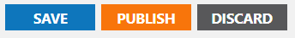  Select Publish

Deleting an Event
Delete an Event
1 | Go to your Events Calendar URL and click sign in | 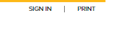
2 | Click ‘Manage’
3 | Select Events | 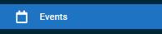
4 | Navigate to the Event you want to delete
5 | Click Select | 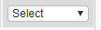
6 | From the drop down options, Select ‘Delete’ | 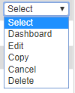
7 | Click Ok on the confirmation pop-up | 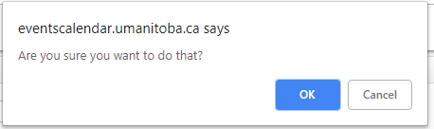

Cross-Posting Events
Categories and Keywords allow you to classify your event to make them easier to find when visitors search your site.
- You MUST Choose Categories that apply to your event as shown in figure 1.5 below. Visitors will be able to search and filter events based on categories.
- Enter any Keywords or tags that visitors may use to search for your event. **Note: If entering multiple keywords or tags, separate them with a comma.
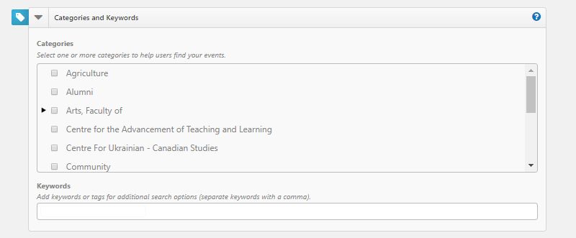
Figure 1.5

Locations
When entering locations for your events, the use of standard naming nomenclature is required.

For example, when entering an event, you MUST enter the location information as follows;

- Name of Faculty / Unit / Department
- Name of Building or Name of Room or Address
- Room Number (if applicable)
- Postal Code (if applicable). This allows Google Maps place a beacon on the event location.

For example an event created in the Faculty of Engineering would have a location description of;
Faculty of Engineering
EITC E3
Room 606
R3T 2N2

Add one or more Locations to your event by searching for it or selecting it from the Location List. Depending on your level of access, you may also be able to enter an Ad-hoc Location. By entering the name and address of the event location in the field.
- Using the search, enter the location name or keyword into the Location field and click Search. Matching results will display below. Check the boxes next to the locations you need and click Add Selected. This will the select those locations in the Location List box.
- Using the Location List, check the boxes next to the locations needed. If a location has sub-locations, use the arrow to expand the list in order to select a sub-location.
- To add an Ad-hoc Location, enter the name and address of the event location in the field and click Add.
- Please make sure you book the location for your event before creating your event.
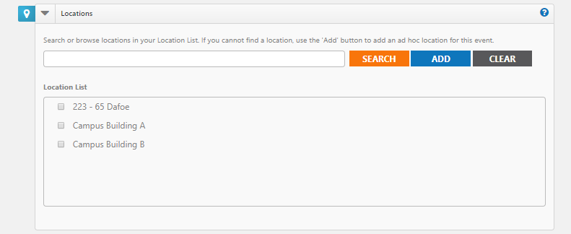
Figure 1.6

Contact
- You MUST Enter a Name, Phone Number, Extension and Email Address of the event coordinator or person whom visitors can contact with questions about the event. Note: This information is publicly displayed for each event.
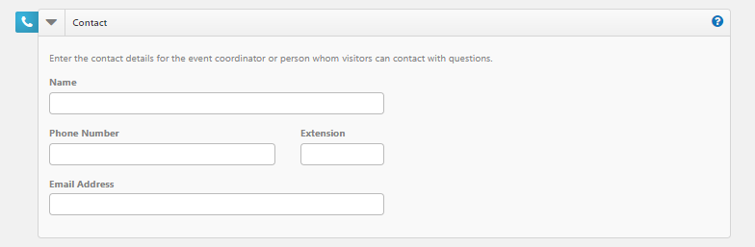
Figure 1.7

Images
You can upload up to 5 images to an event each with a maximum size of 3 MB.
You can Upload your own image by clicking Choose File, browsing for and selecting the file, and clicking Upload.
- Or you can select images from the Media Library.
- If you have multiple images for an event, select the check box in the top left corner of one image to select it as the Primary Image for the event. This is the image that will be used in the default listing of events.
- You can add Alternate Text to your images that will display when moused over. It is also used by visually impaired web browser assistance applications for WCAG conformance. Refer to the University of Manitoba Accessibility Guidelines http://umanitoba.ca/admin/governance/media/Accessibility_Policy_-_2017_09_01.pdf
- Click the red x to remove an image from the event.
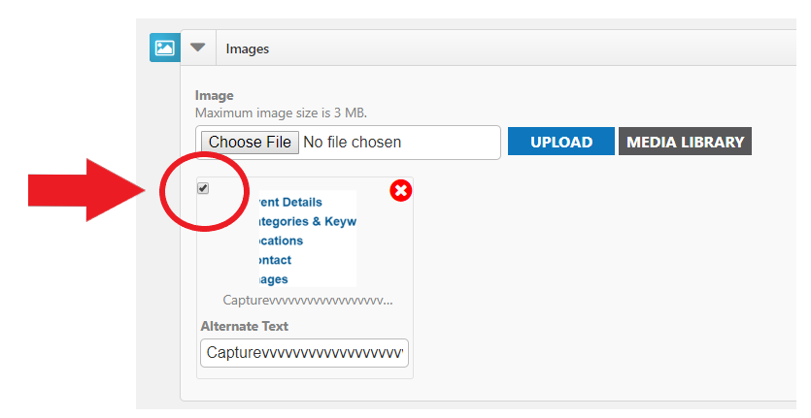
Figure 1.8

Note: Regarding Events Calendar Images, 1.6 : 1 (1600X1000 pixels) will scale properly throughout Events Calendar.

Attachments
Events can have a maximum of 5 attachments that total up to 10 MB. For example, you could upload five 2 MB attachments or three 3.3 MB attachments, or any combination that does not exceed the quantity of 5 or the total size limit of 10 MB.
- Add an Attachment by clicking Choose File, browsing for and selecting the file, and clicking Upload.
- Or you can attach a file from the Media Library.
- Each file has a Display Text label that displays as a link. It will default to the file's name, but you can change this to something better.
- Click the red x on an attachment to remove it from the event as shown in figure 1.9 below.
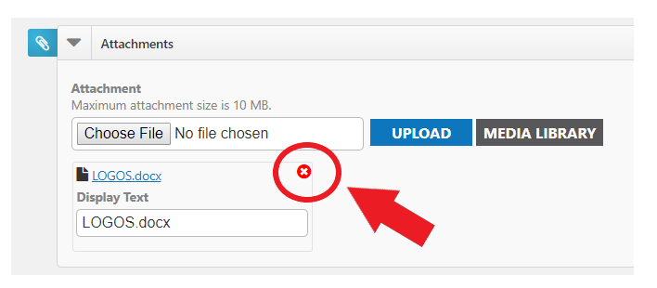
Figure 1.9
Note: Attachment of zip files is prohibited at this time to reduce any incidences of Malware.

Registration and Products
Registration allows you to track attendance and create tickets for your event. When adding a Registration, the system will collect first name, last name, and email addresses for reporting purposes. Adding a Sale Item will not collect this information. You can also use a pre-made product template to add items to your event.

Adding a Registration or Sale Item
- Click Add Registration.
- Check if you would like to Enable Ticketing. This will include a printable ticket that can be scanned to track event attendance.
- Enter the Name of the item.
- Enter additional details for this item in the Description field.
- The application can be used for ‘Free’ events. *(Future Online Payments functionality will be available soon. You can provide the Cost associated with this item at that time).
- Add ‘Quantity available’. *(Future Online Payments functionality will be available soon for the option of collecting ‘Donations’ for events).
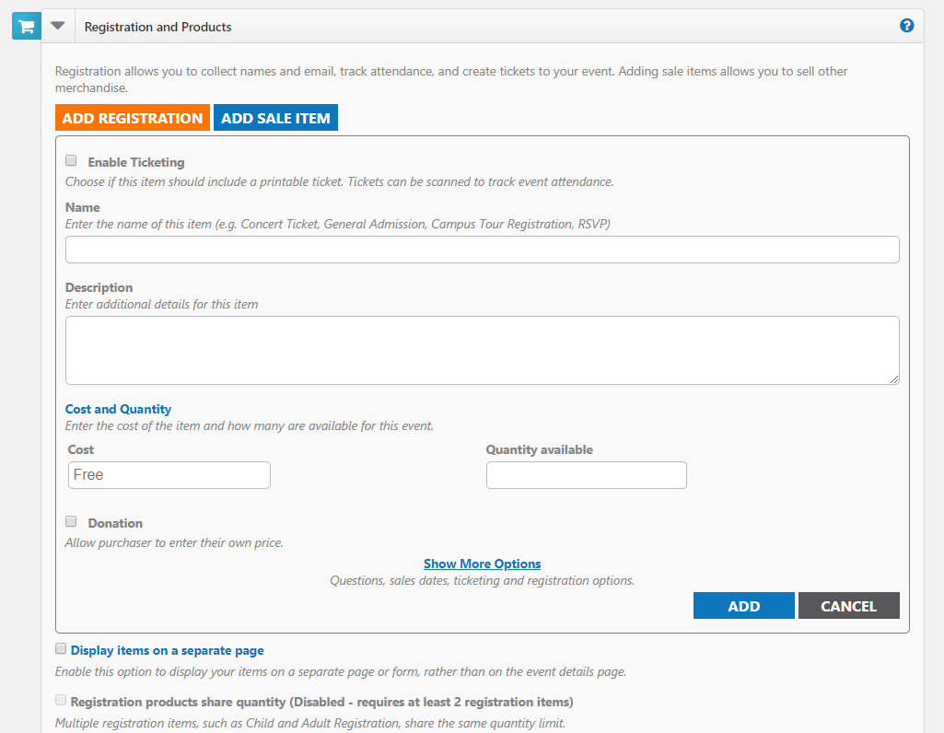
Figure 2.0

Note: Remember to Click Add as shown in figure 2.1 below,
before saving or submitting your Event.

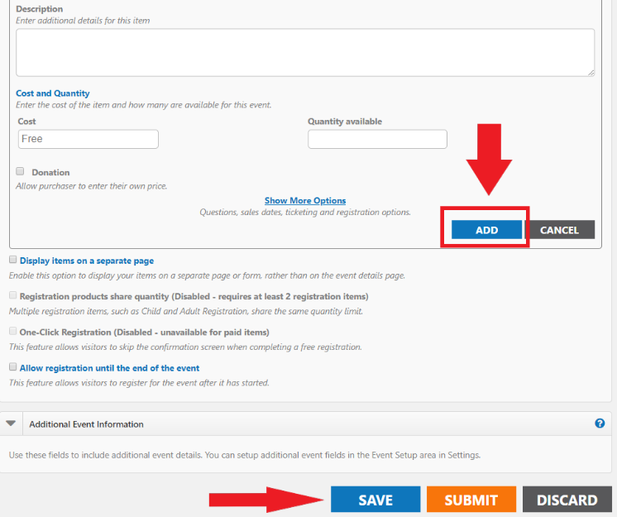
Figure 2.1

- Click Show More Options to view additional options.
  - On the Questions tab, select which information you would like to collect. *Note: If you selected Add Registration, First Name, Last Name, and Email Address will already be marked as required fields.
  - On the Add a Question tab, you can add custom questions for other information you may want to collect. Note: Access and Privacy Office (APO) will be providing guidelines for what types of questions can be asked from Event Registrants.
  - The Sale Dates tab allows you to set a timeframe for when ticket or product sales will begin and end, as well as minimum and maximum number of items that can be purchased at one time.
  - The Advanced tab allows you to enable a Waitlist for sold out events, as well as select a Category for the item. You can also chose to Share Question Information. For example, if 5 tickets are purchased, the system will only require one First Name, Last Name, and Email Address to be entered for the purchase.
- Click Add to save the registration or sale item to the event. Add additional items as needed.

Additional Options
- Display items on a separate page - All of the items available for the event will be displayed in a new window. The only information that will be displayed on the event details page is a "Register" icon. Clicking on that icon will open the new window showing the available items.
- Registration products share quantity - This allows you to pool or link all registration items together to share quantity. For example, you may have a maximum capacity of 100 registrations, but you can sell any number of Student, Staff, or Guest Registrations up to a total of 100. *Note: Only Items added with a product type of "Registration" can share a maximum quantity.
- One Click Registration - Allows you to configure registration items to use an "express checkout." When enabled, the person registering for the event will bypass the confirmation page, allowing for immediate registration from the event details or dedicated registration form. *Note: One Click Registration is only available on events that do not offer sale items. If sale items are also available, users will complete the normal checkout process.
- Allow registration until the end of the event - Check this option if you would like to offer sales at the door or would like people to be able register for the event after it has started. You will be able to accept registrations up until the set end time of the event.

Additional Event Information
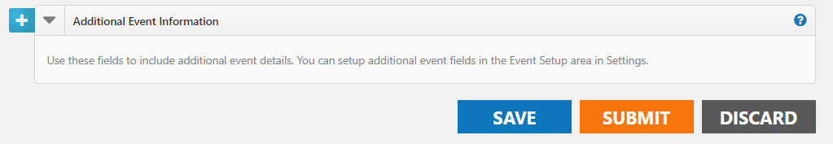
Figure 2.2
This area only appears on sites where the administrator has configured Custom Event Fields on the Event Setup page to collect additional information for each event. Required fields are marked with an asterisk (*) symbol.

Attach a Survey
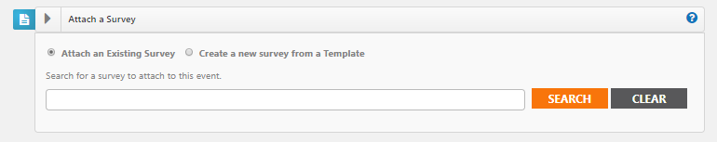
Figure 2.3

Creating a Survey
Surveys can be used to gather important feedback about your events.
How to Create a Survey
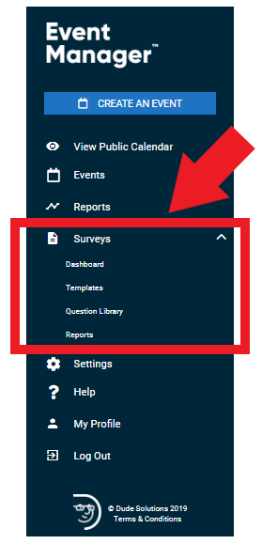
Figure 2.4

- Click on the Surveys menu option to expand it as shown in figure 2.5 below.
- Click on Dashboard.
- Click on Create a Survey.
- Choose from one of the following options:
  - Create New: Create a brand new survey from scratch.
  - Use a Template: Start with a survey template and make any changes needed before saving.
  - Copy From Existing: Use an existing survey as a starting point and make any changes needed before saving.
- Enter a name for the survey, then click Get Started.
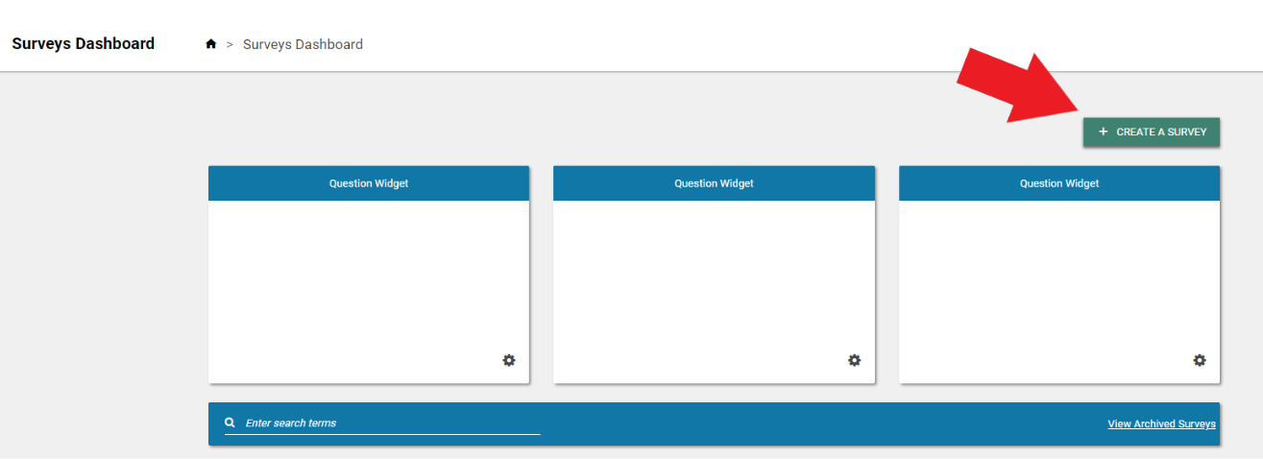
Figure 2.5
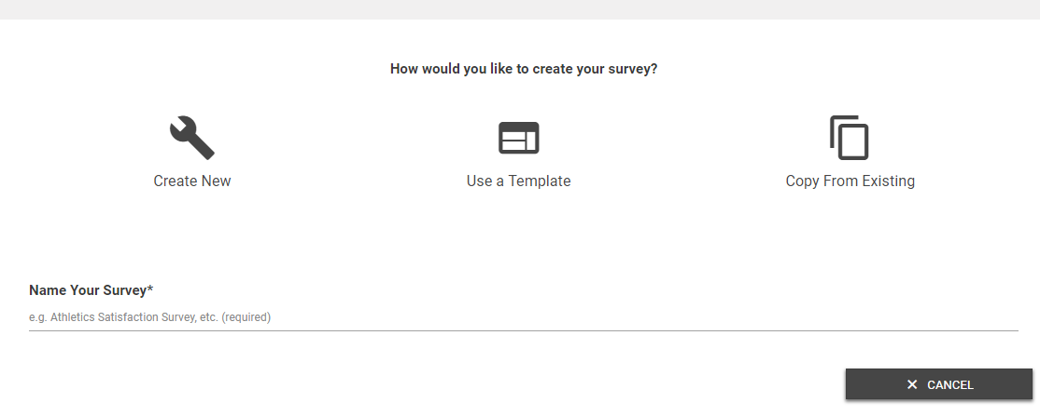
Figure 2.6
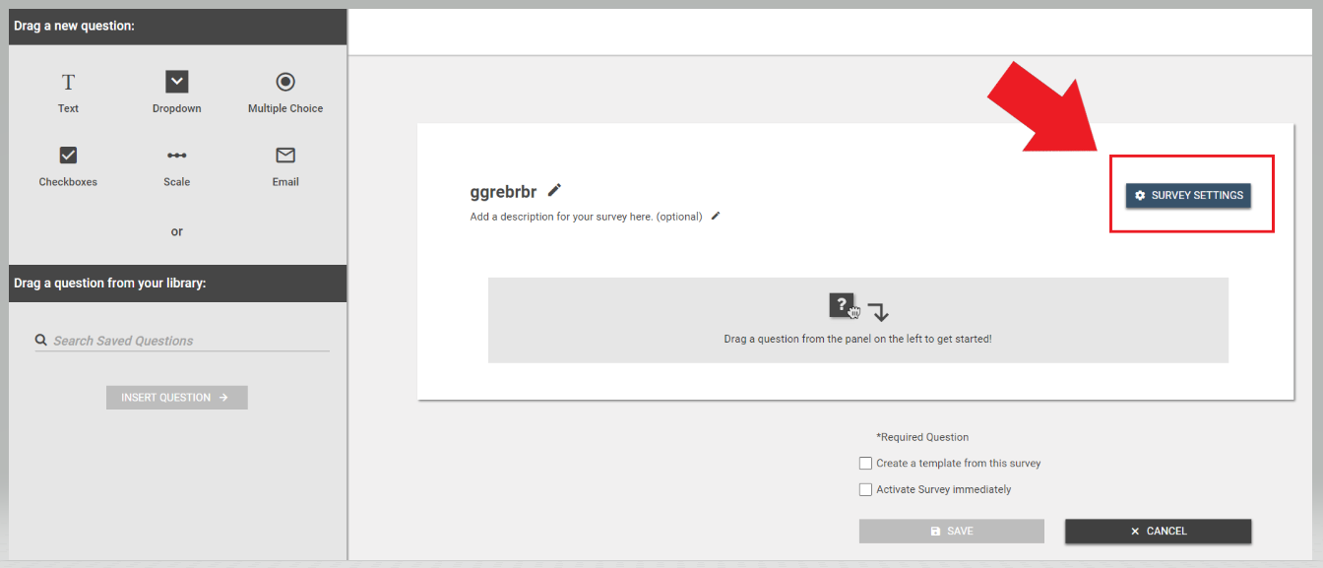
Figure 2.7
- Click on the Survey Settings button to customize the message a user will see after completing the survey, as well as the logo that appears.
- You can also attach the survey to a particular event by clicking on Add an Event Attachment.
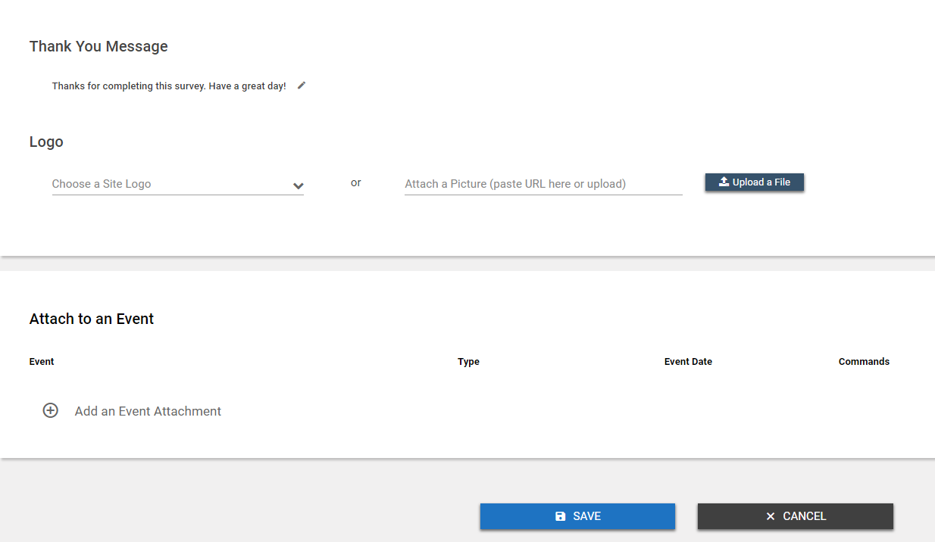
Figure 2.8

- Select the event.
- Choose the time frame after the event that the survey will Activate and Deactivate. *Note: Active surveys can be answered by anyone with access to the survey link.
- If this event included registration, check the box to Email Registrants a link to this survey when it is activated.

Adding Survey Questions
If you used a template, or copied an existing survey, any existing questions will show on the screen. If you chose to create a new survey, this area will be blank.

Adding a New Question
- Choose the question type by clicking on the appropriate icon and dragging it to the survey builder area.
- Enter the question text, including any answer option text, if applicable.
- To make this a required question on the survey, check the box next to Required.
- If you would like to provide more information about this question, in addition to the question text, check the box next to Description and enter the Description text.
- If this is a question you would like to use on multiple surveys, check the box next to Save Question To Library.
- Click Save.
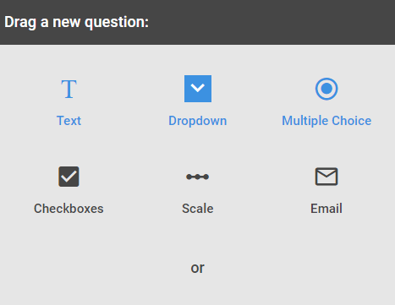
Figure 2.9

Adding a Question from the Question Library
- To add a question from the question library, click and drag the question to the appropriate place in the list of questions.
- Questions can be reordered by hovering over the left side of the question box and clicking on the arrows icon. Drag the question to the correct location in the list.
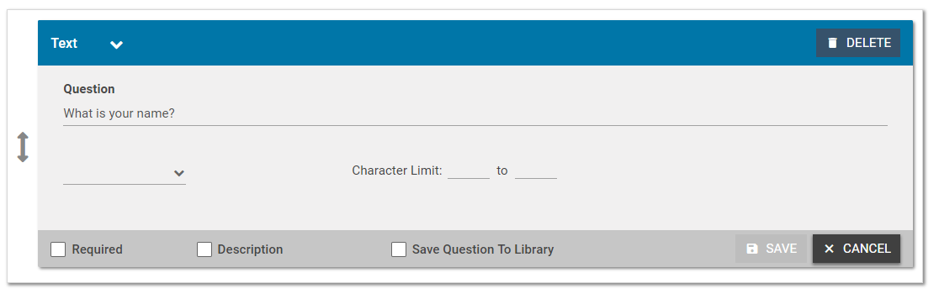
Figure 3.0

Saving the Survey
- If you would like to Create a template from this survey, check the box at the bottom of the screen as shown in figure 3.1 below.
- If you would like the survey to be active immediately upon saving, check the Activate Survey immediately box. Active surveys can be answered by anyone who has been given the survey link.
- When all questions have been added and are in the correct order, click Save to add this survey to the survey list.
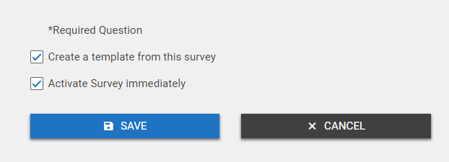
Figure 3.1

Saving and Publishing an Event
- Click the Save button at the bottom of the form to save the details of the event. *Note: This does not submit the event for approval or publish the event to the calendar.
- Click the Submit button to save the event and submit it for review and approval. *Note: Only Standard users will see the Submit button.
- Click the Publish button to save the event and publish it on the calendar. *Note: Only Site Administrators and Tenant Administrators will see the Publish button.
- Click the Discard button to cancel requesting the event and return to the Events Dashboard.
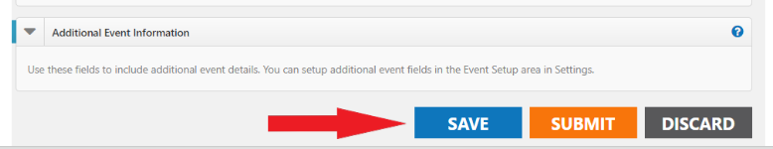
Figure 3.2

Appendix A
Click here for more detailed help and instructions.

Appendix B
List of all Events Calendar Site Administrators
Note: The information captured in the attached spreadsheet may change.

Appendix C
Events Calendar Provisioning – Approval Form

