SIT-STAND WORKSTATIONS

Health Information on Sitting
Sitting is a good example of a sedentary activity, as it requires very low energy expenditure. In our workplace, sedentary behaviour is often seen in the form of sitting at a desk, usually working on a computer. There is now a growing body of evidence that identifies prolonged periods of sitting as a risk factor for developing chronic disease. Based upon this information, experts are now recommending that we start to develop new habits to help us avoid prolonged periods of sitting.

Tips for Sitting Less at Work
There are many simple changes you can make to reduce the time you spend sitting at work. Introducing a height-adjustable workstation (or sit-stand desk) is just one.
Ways to sit less at work include:
- Stand up during meetings
- Conduct standing meetings or add one or more standing agenda items
- Stand and take a break from your computer every 30 minutes
- Stand during phone calls (considering ordering a headset)
- Eat your lunch away from your desk
- Move your garbage can away from your desk
- Conduct walking meetings where appropriate
- Walk to a colleague’s desk instead of phoning or emailing
- Drink more water
- Use the stairs
- Stand to greet a visitor
- Go for a short walk at lunchtime
- Stand at the back of the room during long presentations
- Have standing morning/afternoon coffee breaks

Sit-Stand Workstation Considerations
- Sit-stand workstations are one of a variety of ways to reduce sedentariness. They shouldn’t be considered a ‘fix all’ for obtaining adequate physical activity over the course of the day and should be supplemented with a healthy lifestyle and other strategies for sitting less.

- The cost of a sit-stand workstation, any office modifications required, and additional assistive equipment will need to be approved by the employee’s department. Funding may be available on an equal cost share basis through the University’s Reasonable Accommodation Fund (RAF). An RAF Application Form will need to be completed.
- Sit-stand workstations can in some instances aggravate existing injuries/medical conditions or present a risk for new injury. For example lower back, knee and ankle injuries as well as conditions such as arthritis, high blood pressure, varicose veins, cardiac conditions, and postural hypertension can be aggravated by increased standing. It is important that the implementation of a sit-stand desk is in line with an employee's treating health practitioner's recommendations.

Steps to Take if Interested in a Sit-Stand Workstation
- Schedule an ergonomic assessment with the Occupational Health Coordinator (OHC) from Environmental Health & Safety at ohreport@umanitoba.ca. The OHC will:
  - Assess the employee’s current workstation set-up, job demands and impact of any medical conditions on their work capacity.
  - Make recommendations in an assessment report which may include modification to work techniques, workstation set-up or ergonomic equipment.
  - Outline in their recommendations whether a sit-stand workstation is indicated. This recommendation is based around physical requirement and suitability rather than employee preference for a sit-stand workstation. Also included will be considerations for the supervisor around current office configuration and space/storage requirements.
  - Provide a Clinical Recommendation Form to be completed by the employee’s treating health practitioner outlining their opinion on the suitability of a sit-stand workstation, medical conditions that may be contraindicated and recommendations for implementation.
- Employee to complete and return the Clinical Recommendation Form to Employee Wellness (bryan.wiebe@umanitoba.ca), who will review and consider recommendations from the health practitioner. (Note: this is still recommended to be completed in the case of private purchase of sit-stand workstation).
- Once reviewed, Employee Wellness will contact the employee and manager to confirm the recommendations. The OHC can be contacted for advice on the type of workstation to meet individual and office requirements. Considerations include:
  - Current office configuration
  - Space/storage requirements
  - Cost of purchasing
- Consider additional assistive equipment required for use in conjunction with the workstation (anti-fatigue mat, foot stool).
- Review the model of workstation proposed to ensure compatibility with existing office configuration. The OHC can provide advice as required.
- Schedule an ergonomic assessment once implemented to ensure correct use and positioning at the new workstation.

Information for Supervisors
- Where a sit-stand workstation is being considered without recommendation from the University’s Occupational Health Coordinator you should still encourage the staff member to have the Clinical Recommendation Form completed prior to implementation to ensure they are not at risk of injury or aggravation.
- The cost of a sit-stand workstation, any office modifications required, and additional assistive equipment will need to be approved by your department. Funding can be applied for through the University’s Reasonable Accommodation Fund, though any funding approved will normally only be provided on an equal cost share basis.
- Once a sit-stand workstation has been deemed suitable, the supervisor should:
  - Review product information on the particular sit-stand model being recommended
  - Review recommendations for additional assistive equipment - cost and supplier information.
  - Liaise with the department financial team to order the sit-stand workstation.
  - Liaise with Physical Plant or IST if the work area or computer equipment requires modification
  - Encourage the staff member to schedule an ergonomic assessment upon receipt of the sit-stand workstation to review the set up and provide education on correct use.

Setting up a Sit-Stand Desk
Once the sit-stand workstation has been received and installed an ergonomic assessment should be performed to receive guidance on:
- Ergonomic positioning for both sitting and standing
- Electronically pre-setting the sitting and standing heights if the function is available
- Regular postural breaks, every 20-30 minutes when sitting or standing (or as recommended by the health professional who filled out the Clinical Recommendation Form).
- Alternating between sitting and standing on a regular basis, every 45-60 minutes (or as recommended by treating allied health professional)
- Using a footstool to alternate weight bearing while standing
- Wearing flat, supportive footwear and use of an anti-fatigue mat
- Other safety considerations – including cable management, office layout – access and egress, safe storage of furniture not in use, and manual handling requirements involved in adjusting workstation height and equipment.
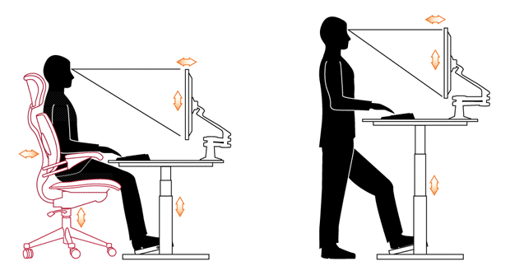

Supplier Information
There are a number of options for sit-stand desks, ranging in price from around $400 - $2000.
Where the existing workstation is unable to be modified, a model such as the Ergotron Workfit S or Ergotron Workfit T as carried by the University Bookstore is a reasonably priced option that is easy to adjust and work with. Contact the Bookstore at 204-474-7000. The bookstore also has various sit-stand desks on display in the Computers on Campus section.
For further information contact the Occupational Health Coordinator at ohreport@umanitoba.ca.

