SITE ADMIN
EVENTS CALENDAR TRAINING GUIDE

Version 0.1
Table of Contents
Read This First 3
Guidance 3
Getting Started. 4
Assign Roles 5
Site Administrator 8
Assign Roles 9
Syndicating 9
Site Approver 15
Edit Events 15
Approve Events 18
Cross-Post Events 21
Site Event Coordinator 22
Creating an Event 22
Event Details 24
Categories & Keywords 25
Locations 26
Contact 27
Images 27
Attachments 28
Registration and Products 29
Additional Event Information 31
Attach a Survey 31
Saving and Publishing an Event 36
Appendix A 37
Appendix B 38
Appendix C 39

Read This First
This section of the Events Calendar (Event Publisher) Training Guide should be read first by all User Roles of the Events Calendar system.
It is important that all users are aware of the following items before the provisioning or use of the new Events Calendar (Event Publisher) System;
- When Events are created within Events Calendar, proper ethics with regards Cross-posting of events must be applied. Events created should not be posted to all categories but only to categories where the category owners have been prior communication about the Cross-posted event(s).
- The Marketing Communications Office must be contacted for new calendar requests or category name changes via a service ticket and the required Events Calendar Provisioning form.
- All event contacts or site event coordinators must know to provide Registrant Information upon request made by Event Registrants.
- The Access and Privacy Office (APO) must be contacted by All Calendar/Site Administrators to ensure Administrative responsibilities under FIPPA (Freedom of Information Protection and Privacy Act) and follow the rule of “minimum amount” and “need to know” have been provided.
  - Event Publisher Calendar/Site Administrator must contact the Access and Privacy Office (APO) to obtain a FIPPA privacy notification statement for all Events requiring registrations and/or RSVPs. All Events that require registration, must be submitted directly to Rachelle Ross Rachelle.Ross@umanitoba.ca and to fippa@umanitoba.ca for appropriate FIPPA, PHIA or both statements to be customized for each event.
  - During initial Pilots and Trial, a registration form will be provided to be filled out and sent to the APO. This form will be replaced by APO governing guidelines for registrant data collection in the near future.
- Site Administrators must contact the Access and Privacy Office (APO) regarding Records Authority Schedules.
- All Users of the Events Calendar Site must have a clearly identified and assigned user Role in Events Calendar.
- If you planning a fundraising event, or plan to collect donations at your event, please contact donor.relations@umanitoba.ca or 1-204-474-9195 for assistance.

Please see Access & Privacy Office Recommendations on Events below;
http://umanitoba.ca/admin/vp_admin/ofp/fippa/media/Event_Registration_Guidelines.pdf

Guidance
For Site Administrator Role jump to page 8.
For Site Event Approver Role jump to page 15.
For Site Event Coordinator Role jump to page 22.

Getting Started.
Navigate to the University of Manitoba Events Calendar tenant site at https://eventscalendar.umanitoba.ca

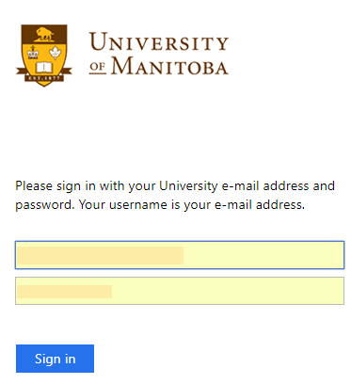
Figure 1.0

Enter your UMNetID authenticated Email address and Password. Click Sign in as shown in figure 1.0 above.
You will see the Events Calendar Dashboard as shown in figure 1.1 below;
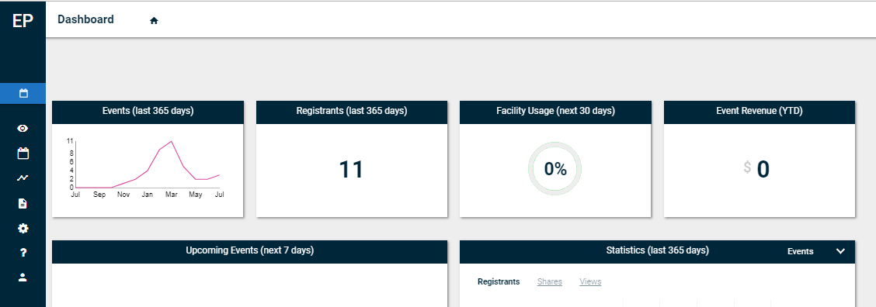
Figure 1.1
Move your mouse to the left hand side of the screen to reveal the drop down options available as shown in figure 1.2 below.
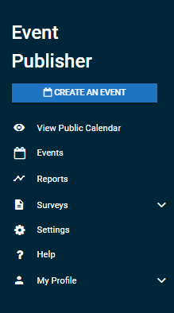
Figure 1.2

Assign Roles
Note: The assigning or roles and adding users to roles will be completed by the IST Service Desk and Site Admins would not be required to complete this for their Events Calendar Sites.
Navigate to Settings, click the gear icon as shown in figure 1.3 below.

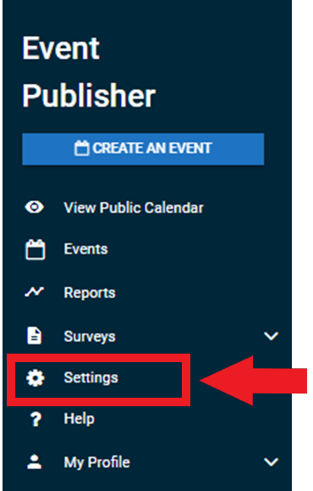
Figure 1.3
Under Manage Users, select User as shown in figure 1.4 below.
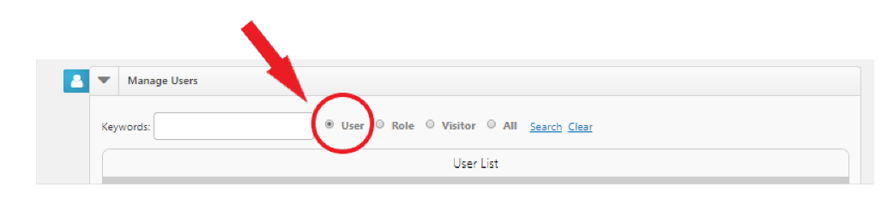
Figure 1.4
Click Add new user as shown in figure 1.5 below.
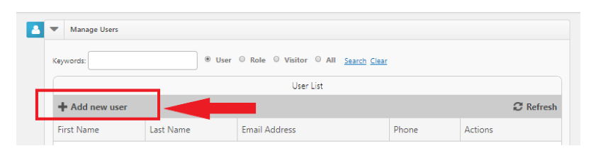
Figure 1.5

Under User Information, Enter User Email Address, Click Add as shown in figure 1.6 below.
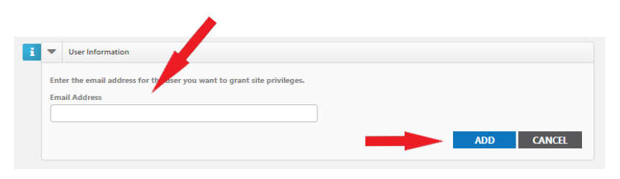
Figure 1.6
Note: If there are any previously created Roles, they will show in the Roles Access list.
Under Manage Users, select Role as shown in figure 1.7 below.
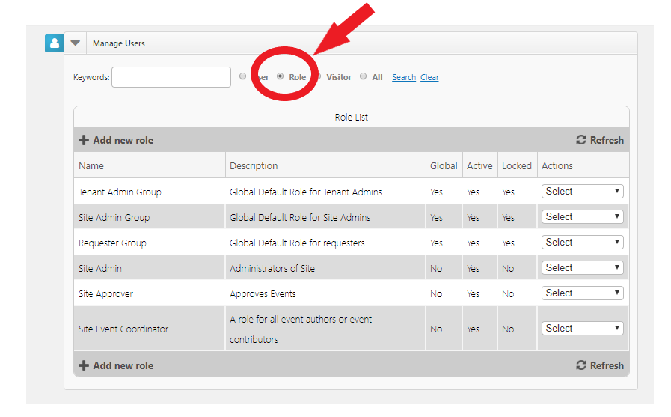
Figure 1.7
Under Roles list, select the Role you want to Assign the User to, Click Edit as shown in figure 1.8 below.
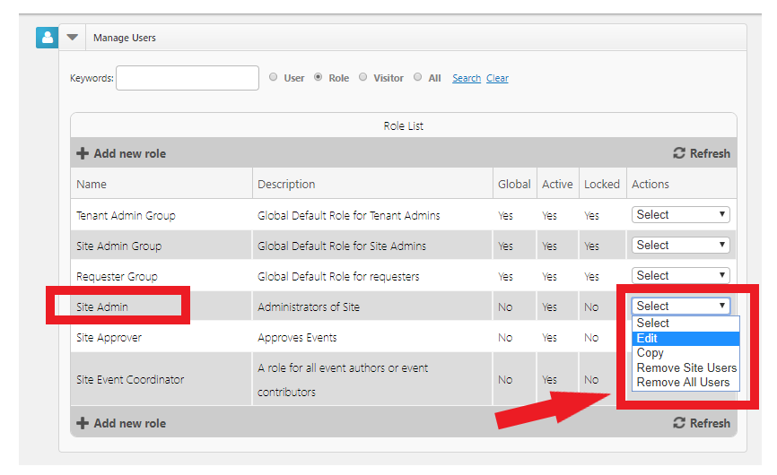
Figure 1.8
Under User Role Access, select the user you want to assign to this Role, Click Add as shown in figure 1.9 below.
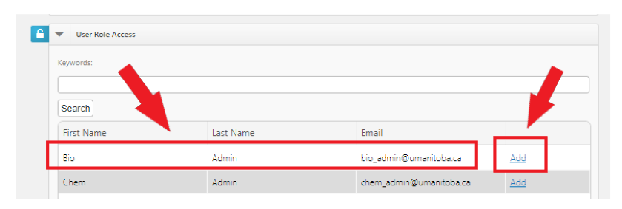
Figure 1.9

Site Administrator
This identified role will have access to Assigning roles and make use of the Syndication functionality and feature available in Events Calendar.
Under Site Access, this Role will have permissions as shown in figure 2.0 below.
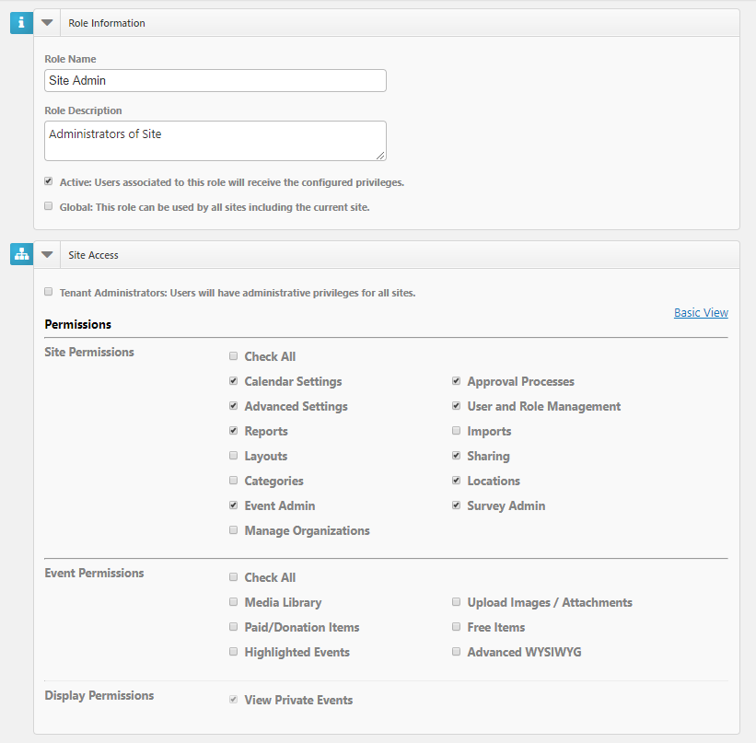
Figure 2.0

Assign Roles
Steps for Assigning Roles, please refer to page 5 – 7 above.

Syndicating
Navigate to Settings, Click on the gear wheel as shown in figure 2.1 below.
Figure 2.1

Under Site Administration, Click Sharing Tile as shown in figure 2.2 below.
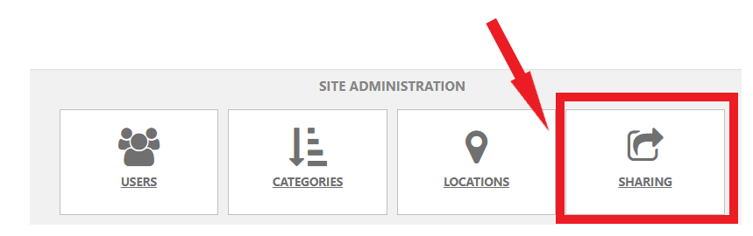
Figure 2.2
Under Sharing & Syndication, Click Add new share as shown in figure 2.3 below.
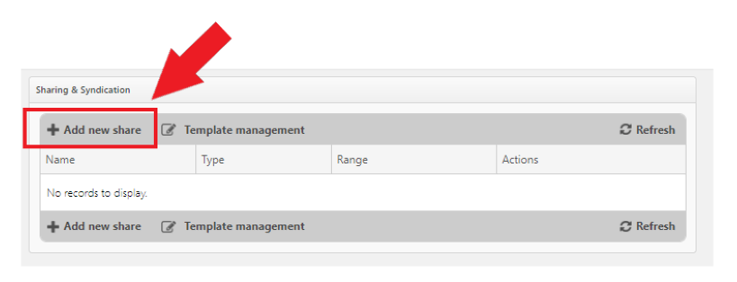
Figure 2.3

Fill in Name field and select Type from drop down list as shown in figure 2.4 below.
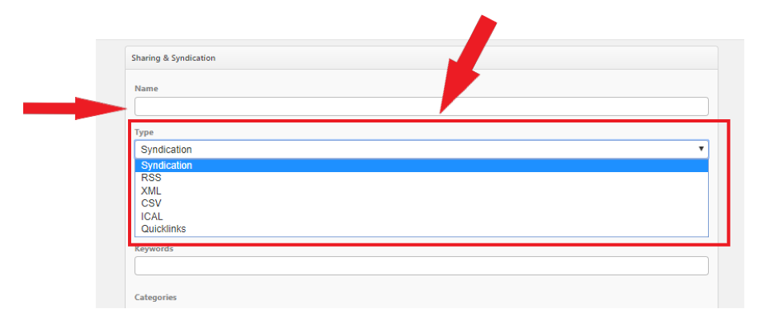
Figure 2.4
Select the Type of share:
- Syndication: Select this option to receive a JavaScript code. This will return a block of script that can be embedded onto your webpages by your Webpage Administrator.
- RSS: Select this option to create an RSS feed. This will return a hyperlink (URL) that can be accessed via a web browser or RSS reader. Once you have navigated to the URL, your can add the RSS feed to any RSS reader like Microsoft Outlook, Live Bookmarks, or to your list of RSS feeds in your favorites.
- XML: Select this option to generate an XML export. XML is most commonly used in Open Source Content Management systems. This will return a hyperlink (URL) that can be accessed via a web browser, embedded onto your webpages, or accessed by a third party application to return a raw output of structured XML.
- CSV: Select this option to create a CSV export. This will return a hyperlink (URL) that can be accessed via a web browser, or accessed by a third party application (for example, Microsoft Excel) to prompt a download of a structured CSV file.
- iCal: Select this option to create an iCal export. This will return a hyperlink (URL) that can be accessed via a web browser, or accessed by a third party application (for example: Microsoft Outlook) to prompt a download of a structured iCal file.
- Quicklinks: Select this option to provide a URL for a filtered display of calendar events. This will return a hyperlink (URL) that can be accessed by a web browser. This link will display a filtered view of the calendar application (based on the keywords, categories, and locations selected) using the default layout and view type.
Select a Date Range as shown in figure 2.5 below.
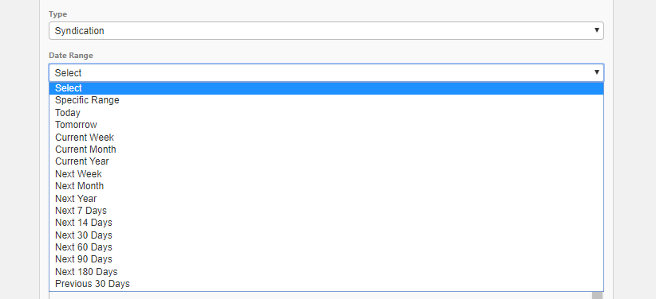
Figure 2.5
The date range will limit the amount of events shown in the share based on the events dates. You can enter a custom date range by choosing Specific Range from the drop down menu, or you can select from the predefined options.
Keywords
This is an optional field. Enter one or more keywords to limit the results to events associated with those specific keywords as shown in figure 2.6 below.
Figure 2.6
Under Categories, select the Category you want to create your syndication for as shown in figure 2.7 below.
This is an optional field. Choose one or more categories to limit the results to events associated with specific categories. The share returns all events that include at least one of the categories that you choose.
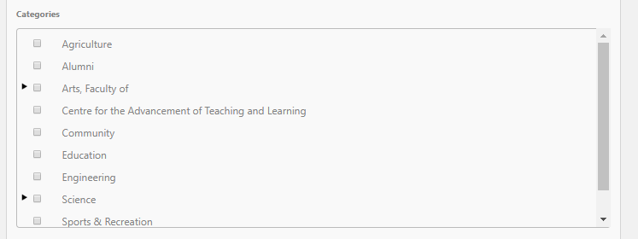
Figure 2.7
Locations
This is an optional field. Check one or more locations in this field to limit results to events taking place at those locations as shown in figure 2.8 below.
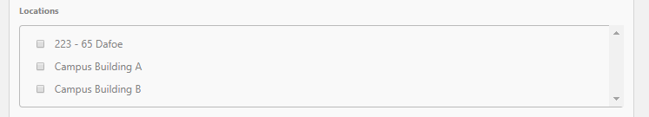
Figure 2.8
Custom Events
This is an optional field. Select one or more entries in this field to limit results to events that have the selected custom fields assigned to them. You can only filter by custom event fields that are either a single or multiple choice field as shown in figure 2.9 below.
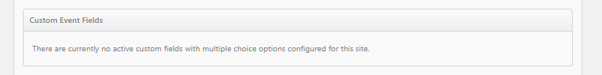
Figure 2.9
As shown below in figure 3.0;
- Highlighted Events: Select to include or exclude highlighted events from the list of syndicated events. You can also choose to show only highlighted events.
- Private Events: Select this option to include or exclude private events. The share will return both public and private events if private events are included. You can also choose to only share private events.
- Unlisted Events: Select this option to include or exclude unlisted events. The share will return both listed and unlisted events if unlisted events are included. You can also choose to only share unlisted events.
- Cancelled Events: Select this option to include or exclude cancelled events. The share will return both active and cancelled events if cancelled events are included. You can also choose to only share cancelled events.
- No Events Message: Enter the text you would like displayed if there are no events found from the criteria selected in the share.
- Enter the maximum Number of Events that will show in the share.
- Recurring Events Rule: For recurring events, choose whether you would like the share to display only the next event in the series or all events in the series.
- Template: Templates are used to stylize the share. Choose a template from the drop down menu. *Note: Selecting a template only applies to a Syndication.
- Choose whether you would like to remove events from the share after the start date/time.
- Click Save and Get Code. The page will refresh with the URL or HTML depending on the Share Type that was selected.

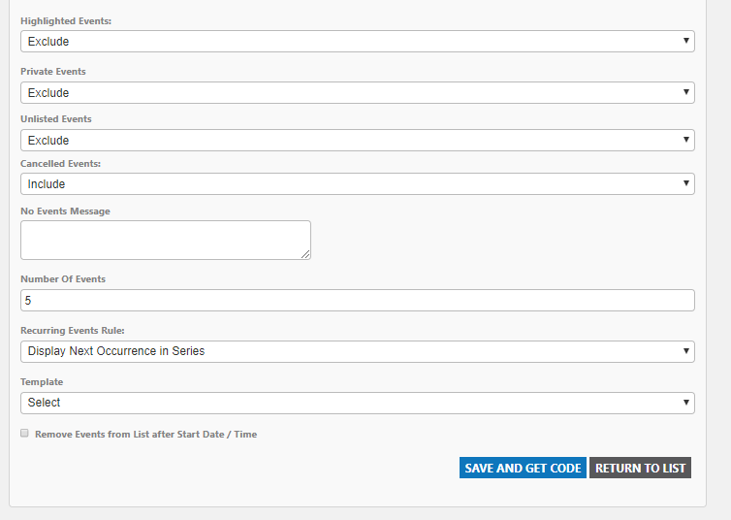
Figure 3.0

Site Approver
This identified role is for individuals who would be tasked with the responsibility of approving events for their specific Events Calendar Sites.
This role has limited functionality within Events Calendar and would only be able to Edit Events, Approve Events and/or Cross-Post Events to other Calendars.
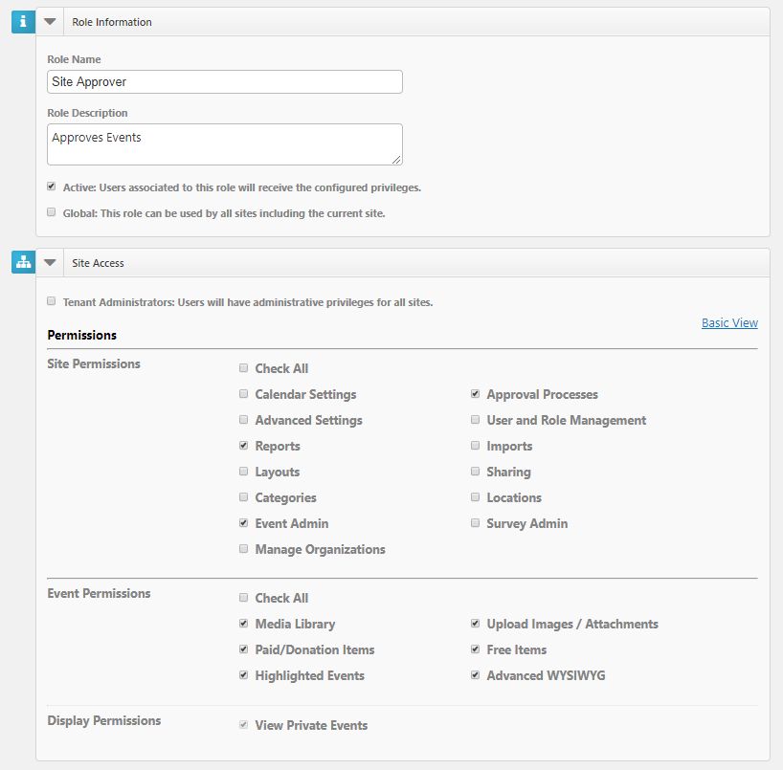
Figure 3.1

Edit Events
Navigate to the left hand side of the screen and select Events as shown in figure 3.2 below.
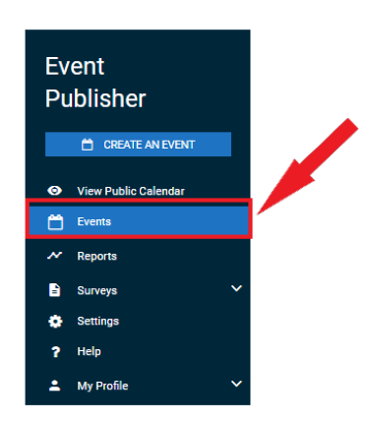
Figure 3.2
Under Events, select the event you would like to Edit as shown in figure 3.3 below.
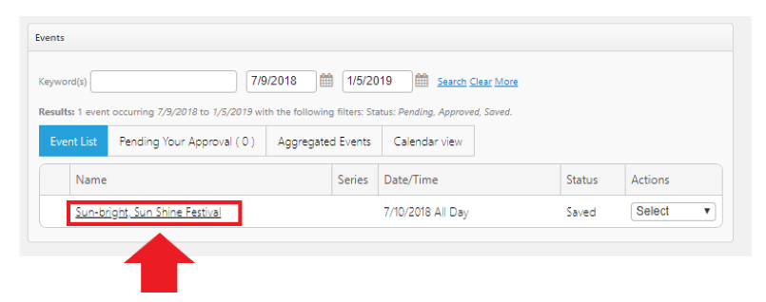
Figure 3.3

Edit the event as shown in figure 3.4 below.
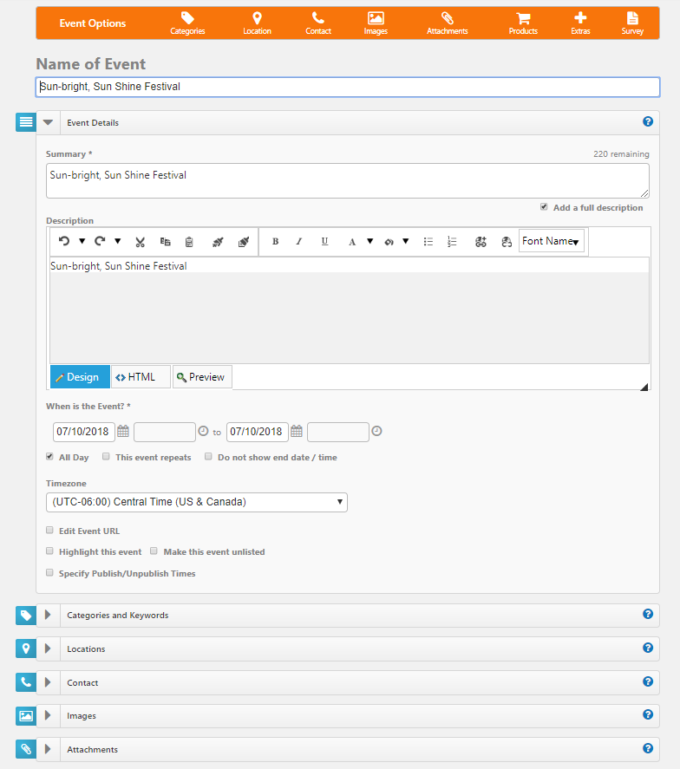
Figure 3.4
Click SAVE as shown in figure 3.5 below.
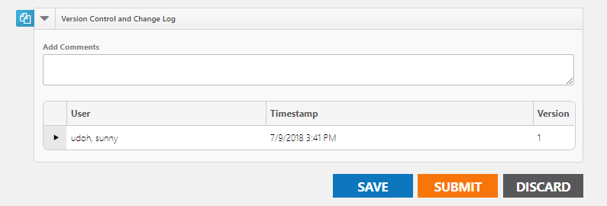
Figure 3.5
Note: As the Site Administrator, you can also choose SUBMIT as shown in the same figure 3.5 above.
Under Events, you will see your event pending Approval as shown in figure 3.6 below.
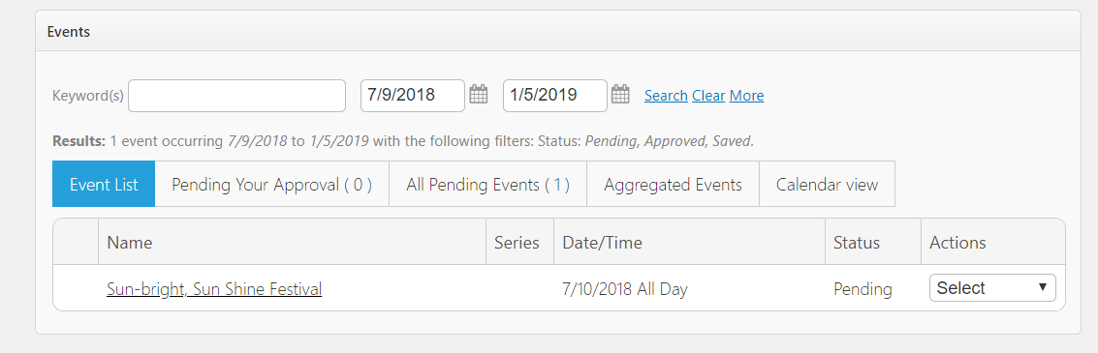
Figure 3.6

Approve Events
Click All Pending Events as shown in figure 3.7 below.
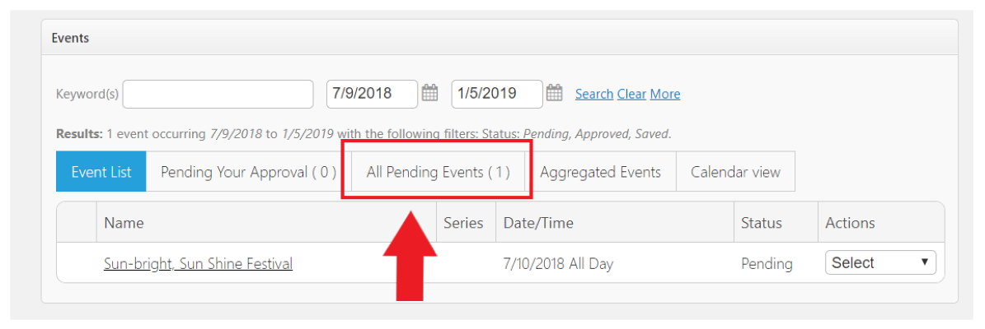
Figure 3.7
Next to the Event, select Force Approval from the drop down menu options as shown in figure 3.8 below.

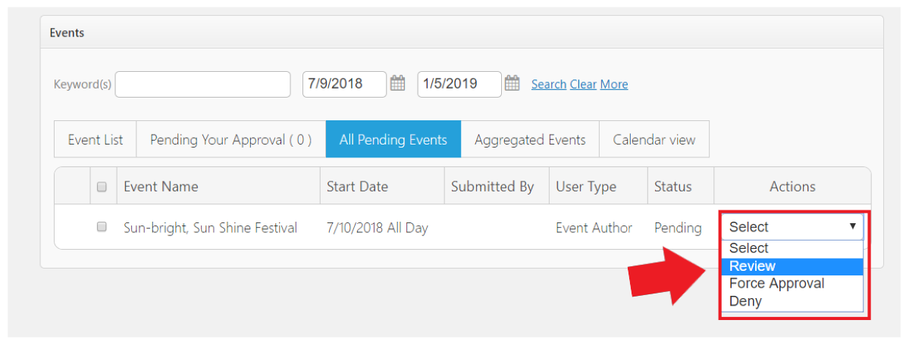
Figure 3.8
From the pop up as shown below in figure 3.9, Select Force All Approvals and Publish.

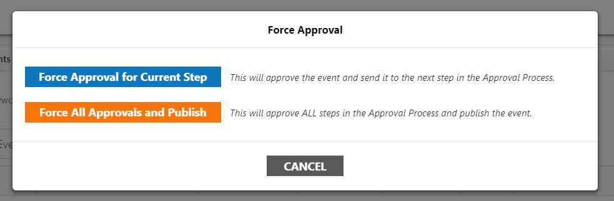
Figure 3.9
Click Public Calendar as shown in figure 4.0 below.
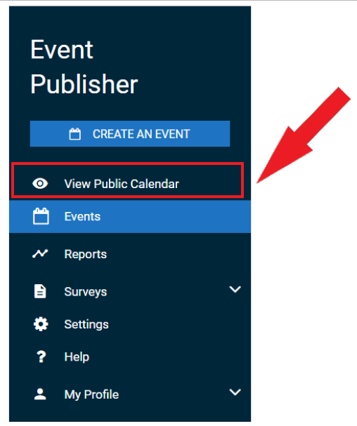
Figure 4.0

Your event will be displayed as shown in figure 4.1 below.
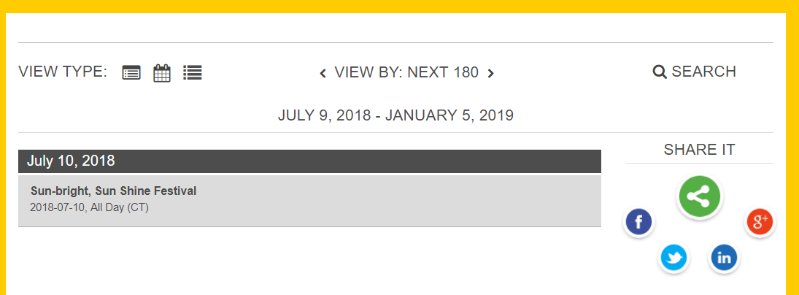
Figure 4.1

Cross-Post Events
Categories and Keywords allow you to classify your event to make them easier to find when visitors search your site.
- Choose Categories that apply to your event as shown in figure 4.2 below. Visitors will be able to search and filter events based on categories.
- Enter any Keywords or tags that visitors may use to search for your event. **Note: If entering multiple keywords or tags, separate them with a comma.
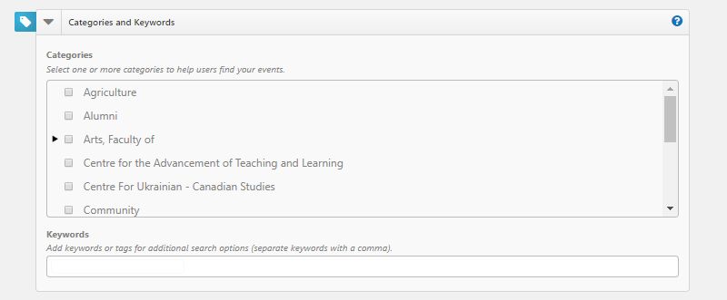
Figure 4.2

Site Event Coordinator

Creating an Event
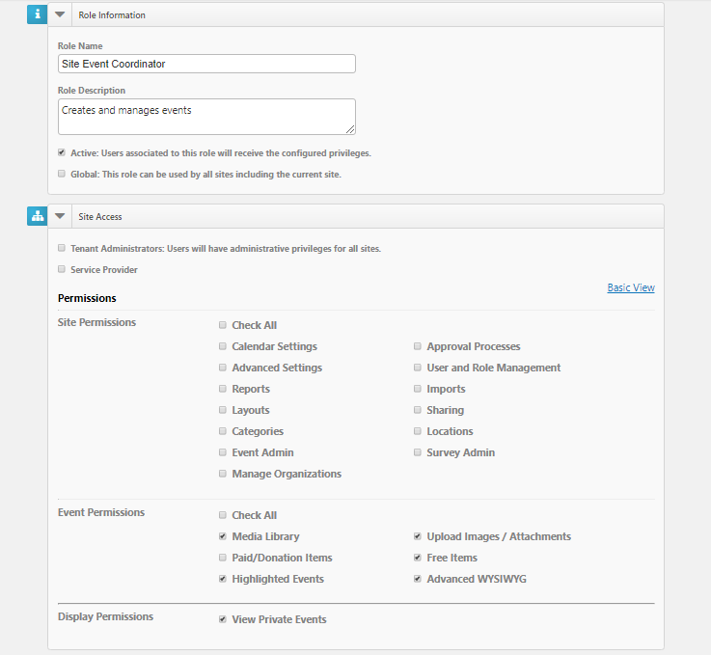
Figure 4.3
- Click on Create an Event as shown in figure 4.4 below.
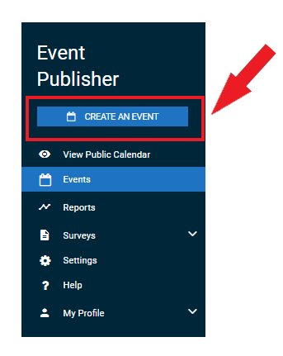
Figure 4.4
- Enter the name for the event in the Name of Event field as shown in figure 4.5 below.
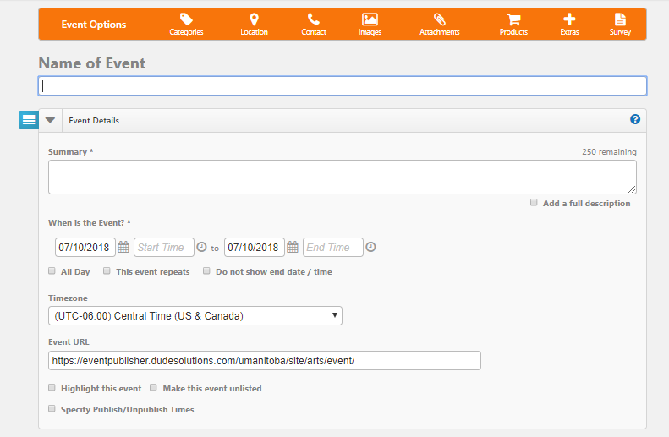
Figure 4.5
This will appear by default on all calendar views when visitors are looking for events on your site.
- The Event Details section of the event form will open automatically for you. You can navigate to other sections of the form by using the Event Options menu at the top of the form (figure 4.6 below) or clicking on the sections to expand them.
Figure 4.6

Event Details
- In the Event Details section, enter a short description of the event in the Summary field.
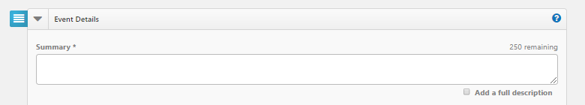
Figure 4.7
- Put a check mark in the Add a full description box to enter a complete description of the event using up to 10,000 characters. The system will copy the current text of the Summary field into the Description area and then you can add any additional details you would like viewers to see on the Event Details page as shown in figure 4.8 below.
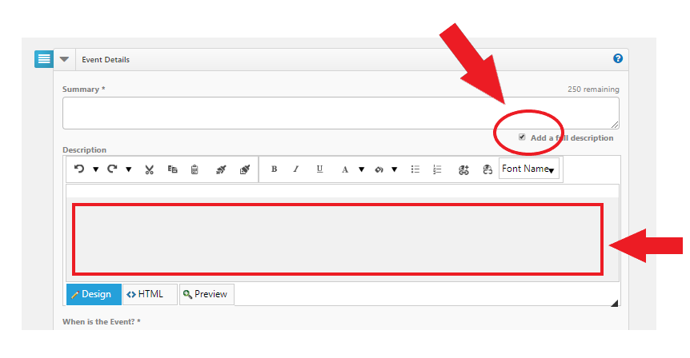
Figure 4.8
- In the When is the Event? Field, enter the start date and time and end date and time of the event.
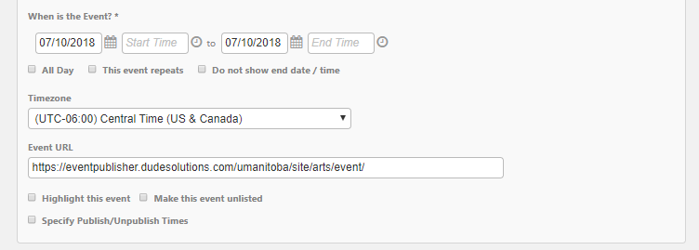
Figure 4.9
- All Day - Select this option if the event lasts all 24 hours in the date range specified. You can also use this options if the event does not have a set start and end time.
- This event repeats - Select this option if this is a recurring event (daily, weekly, monthly, etc.) and choose the desired recurrence schedule from the drop down that appears.
- Do not show end date/time - Select this option to display the start date and time of the event, but not the end date and time. An end date and time are still required to publish the event, but this setting ensures the event will properly download and display on personal calendars and in Event Sharing.
- The Timezone will default to the value set by your Site Administrator, but you can change it if needed.
- Every event you create in Events Calendar has a unique URL. Once you enter a name for the event, the Event URL will update in this field.
- Check the Make this event private option to hide the event from the general public. The event will only be visible to users with appropriate rights and privileges when they are logged into the site. The event is also excluded from sharing.
- Check with MCO if the Highlight this event option can be used to prominently feature the event at the top of your calendar.
  - Highlighted events must occur within the next 30 calendar days to be displayed.
  - Highlighted event must have an image to be displayed.
  - By default, the next 4 Highlighted events will be displayed.
- Check the Make this event unlisted option to hide the event from the calendar. The time will still be blocked off, but only users who have access to the event URL will be able to access the event information.
- Use the Specify Publish/Unpublish Times to control when your event is visible to visitors on the calendar. You can enter only a Publish Date/Time, only an Unpublish Date/Time, or both a Publish and Unpublish Date/Time.

Categories & Keywords
Categories and keywords allow you to classify your event to make them easier to find when visitors search your site.
- Choose Categories that apply to this event. Visitors will be able to search and filter events based on categories.
- Enter any Keywords or tags that visitors may use to search for your event. *Note: If entering multiple keywords or tags, separate them with a comma.
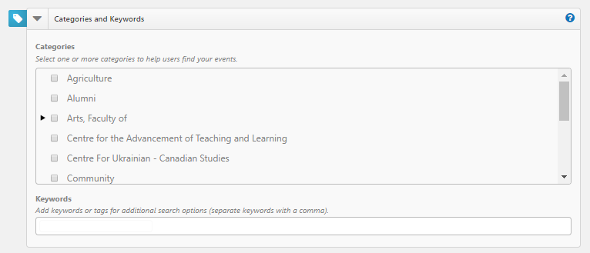
Figure 5.0

Locations
Add one or more Locations to your event by searching for it or selecting it from the Location List. Depending on your level of access, you may also be able to enter an Ad-hoc Location. By entering the name and address of the event location in the field.
- Using the search, enter the location name or keyword into the Location field and click Search. Matching results will display below. Check the boxes next to the locations you need and click Add Selected. This will the select those locations in the Location List box.
- Using the Location List, check the boxes next to the locations needed. If a location has sub-locations, use the arrow to expand the list in order to select a sub-location.
- To add an Ad-hoc Location, enter the name and address of the event location in the field and click Add.
- Please make sure you book the location for your event before creating your event.
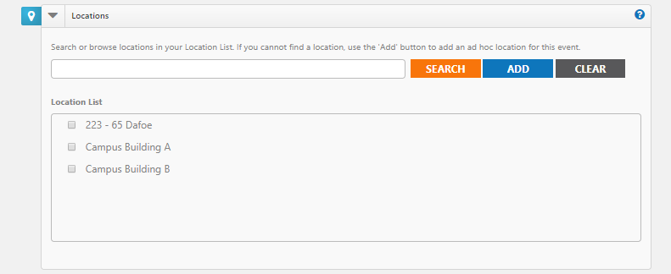
Figure 5.1

Contact
- Enter the Name, Phone Number, Extension and Email Address of the event coordinator or person whom visitors can contact with questions about the event. Note: This information is publicly displayed for each event.
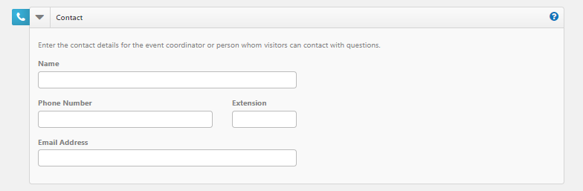
Figure 5.2

Images
You can upload up to 5 images to an event each with a maximum size of 3 MB.
You can Upload your own image by clicking Choose File, browsing for and selecting the file, and clicking Upload.
- Or you can select images from the Media Library.
- If you have multiple images for an event, select the check box in the top left corner of one image to select it as the Primary Image for the event. This is the image that will be used in the default listing of events.
- You can add Alternate Text to your images that will display when moused over. It is also used by visually impaired web browser assistance applications for WCAG conformance.
- Click the red x to remove an image from the event.
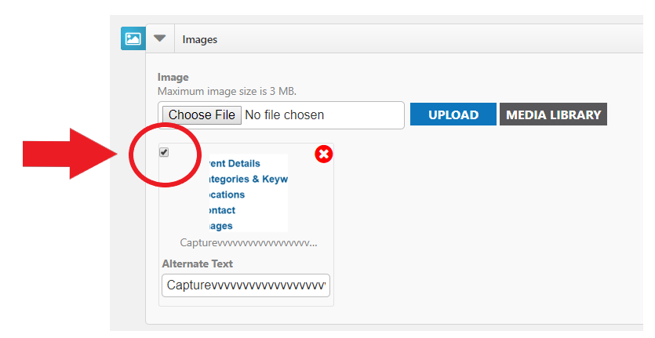
Figure 5.3
Note: Regarding Events Calendar Images, 1.6 : 1 (1600X1000 pixels) will scale properly throughout Events Calendar.
If you require a specific Events Calendar Image to be created such as a Banner Image or a Promo Button, a formal request needs to be put in with the MCO.

Attachments
Events can have a maximum of 5 attachments that total up to 10 MB. For example, you could upload five 2 MB attachments or three 3.3 MB attachments, or any combination that does not exceed the quantity of 5 or the total size limit of 10 MB.
- Add an Attachment by clicking Choose File, browsing for and selecting the file, and clicking Upload.
- Or you can attach a file from the Media Library.
- Each file has a Display Text label that displays as a link. It will default to the file's name, but you can change this to something better.
- Click the red x on an attachment to remove it from the event as shown in figure 5.4 below.
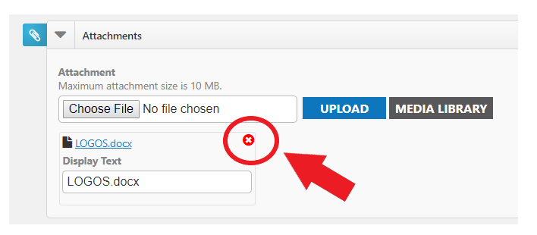
Figure 5.4

Registration and Products
Registration allows you to track attendance and create tickets for your event. Adding a Sale Item allows you to offer tangible goods that can be purchased. When adding a Registration, the system will collect first name, last name, and email addresses for reporting purposes. Adding a Sale Item will not collect this information. You can also use a pre-made product template to add items to your event.

Adding a Registration or Sale Item
- Click either Add Registration or Add Sale Item.
- Check if you would like to Enable Ticketing. This will include a printable ticket that can be scanned to track event attendance.
- Enter the Name of the item.
- Enter additional details for this item in the Description field.
- Provide the Cost associated with this item and the Quantity available.
- Put a check mark in the Donation box if you would like to allow the purchaser to specify the cost of the item.
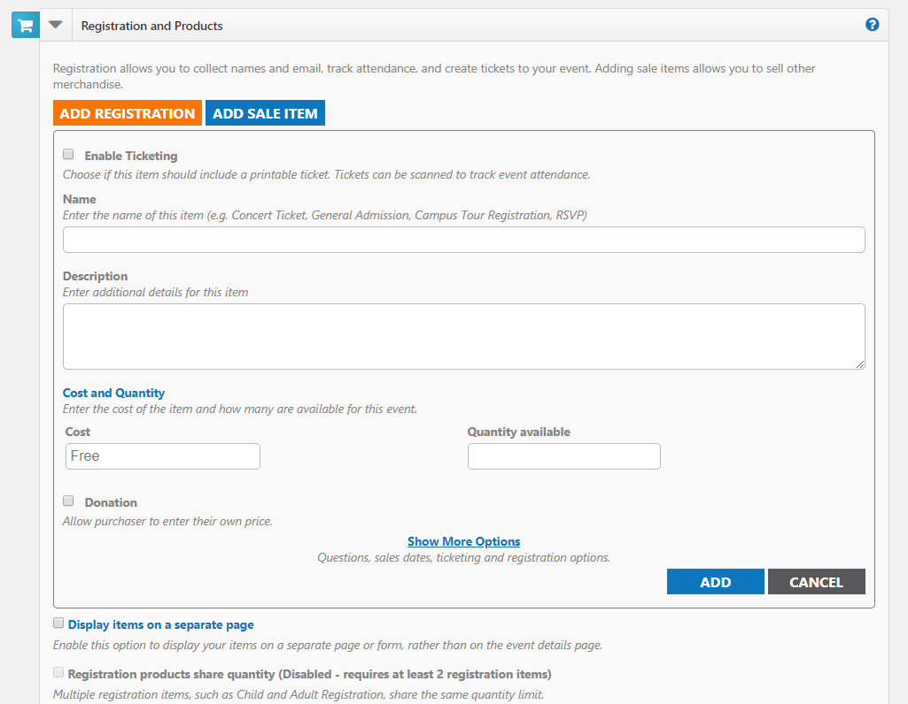
Figure 5.5
Note: Remember to Click Add as shown in figure 5.6 below, before saving or submitting your Event.

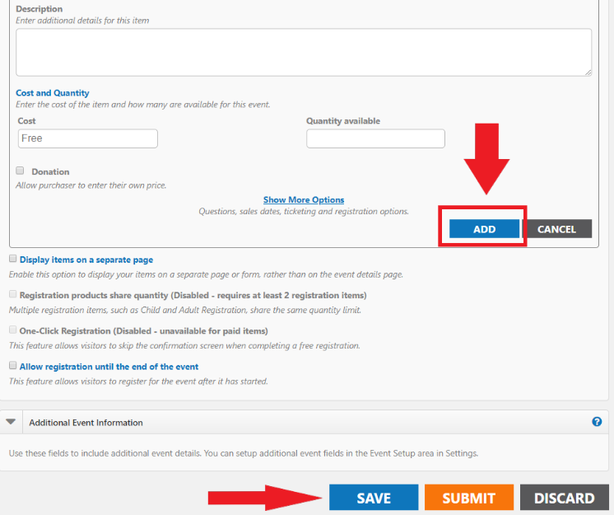
Figure 5.6
- Click Show More Options to view additional options.
  - On the Questions tab, select which information you would like to collect. *Note: If you selected Add Registration, First Name, Last Name, and Email Address will already be marked as required fields.
  - On the Add a Question tab, you can add custom questions for other information you may want to collect. Note: Access and Privacy Office (APO) will be providing guidelines for what types of questions can be asked from Event Registrants.
  - The Sale Dates tab allows you to set a timeframe for when ticket or product sales will begin and end, as well as minimum and maximum number of items that can be purchased at one time.
  - The Advanced tab allows you to enable a Waitlist for sold out events, as well as select a Category for the item. You can also chose to Share Question Information. For example, if 5 tickets are purchased, the system will only require one First Name, Last Name, and Email Address to be entered for the purchase.
- Click Add to save the registration or sale item to the event. Add additional items as needed.

Additional Options
- Display items on a separate page - All of the items available for the event will be displayed in a new window. The only information that will be displayed on the event details page is a "Register" icon. Clicking on that icon will open the new window showing the available items.
- Registration products share quantity - This allows you to pool or link all registration items together to share quantity. For example, you may have a maximum capacity of 100 registrations, but you can sell any number of Student, Staff, or Guest Registrations up to a total of 100. *Note: Only Items added with a product type of "Registration" can share a maximum quantity.
- One Click Registration - Allows you to configure registration items to use an "express checkout." When enabled, the person registering for the event will bypass the confirmation page, allowing for immediate registration from the event details or dedicated registration form. *Note: One Click Registration is only available on events that do not offer sale items. If sale items are also available, users will complete the normal checkout process.
- Allow registration until the end of the event - Check this option if you would like to offer sales at the door or would like people to be able register for the event after it has started. You will be able to accept registrations up until the set end time of the event.

Additional Event Information
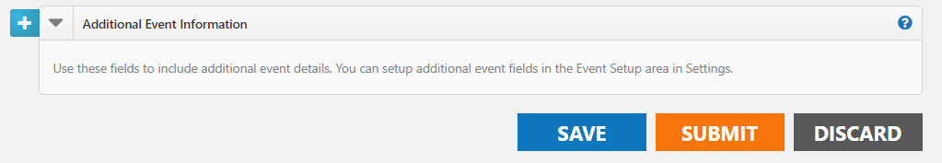
Figure 5.7
This area only appears on sites where the administrator has configured Custom Event Fields on the Event Setup page to collect additional information for each event. Required fields are marked with an asterisk (*) symbol.

Attach a Survey
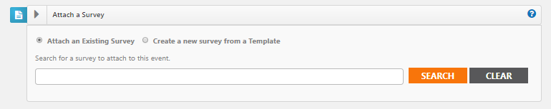
Figure 5.8

Creating a Survey
Surveys can be used to gather important feedback about your events.
How to Create a Survey
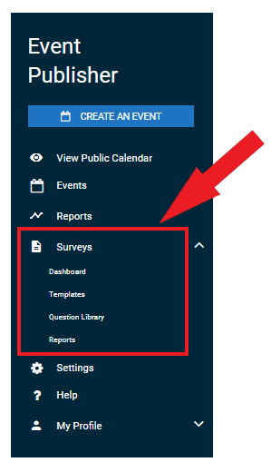
Figure 5.9
- Click on the Surveys menu option to expand it as shown in figure 6.0 below.
- Click on Dashboard.
- Click on Create a Survey.
- Choose from one of the following options:
  - Create New: Create a brand new survey from scratch.
  - Use a Template: Start with a survey template and make any changes needed before saving.
  - Copy From Existing: Use an existing survey as a starting point and make any changes needed before saving.
- Enter a name for the survey, then click Get Started.
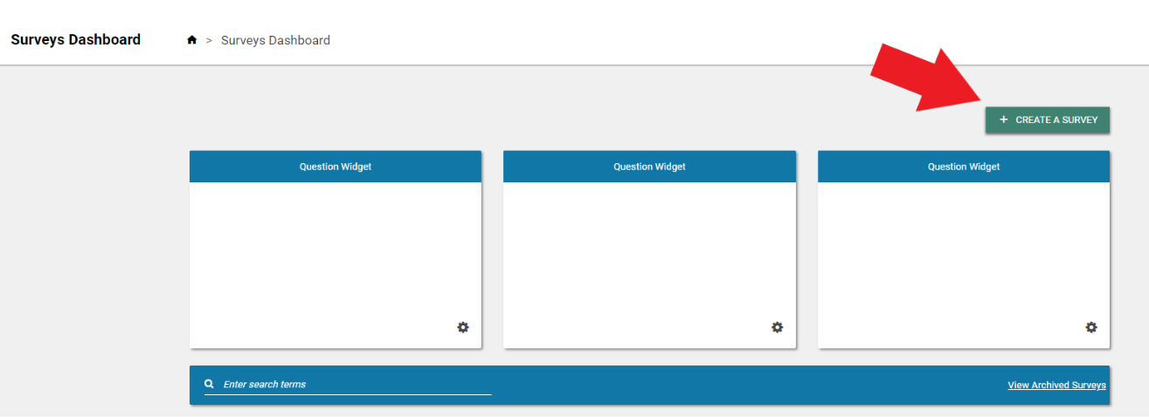
Figure 6.0

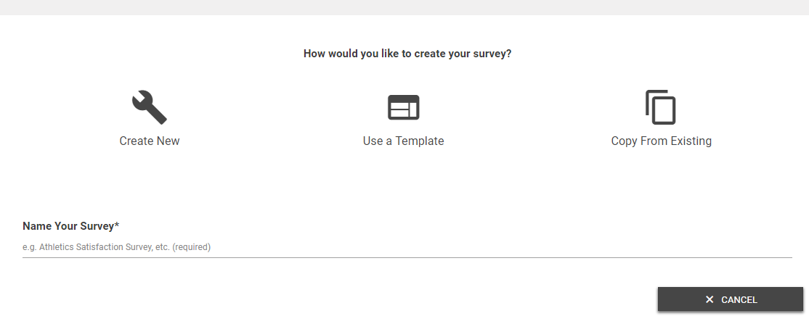
Figure 6.1

Survey Settings
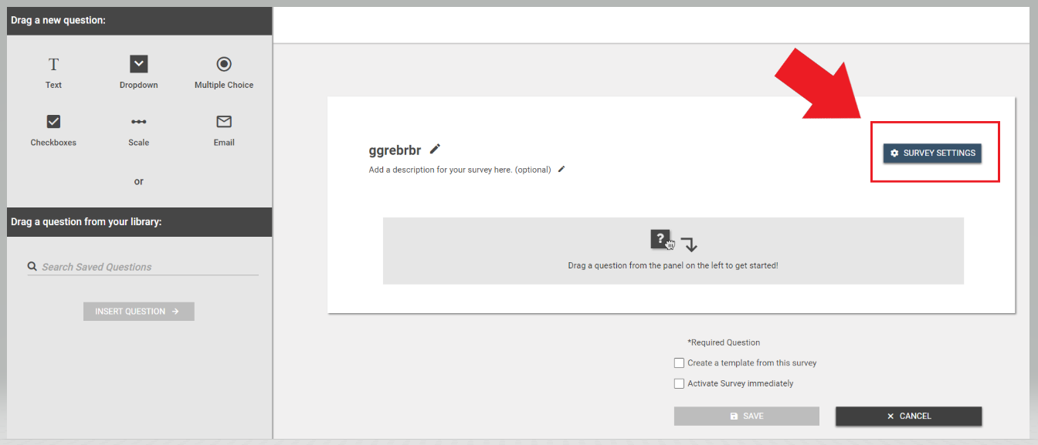
Figure 6.2
- Click on the Survey Settings button to customize the message a user will see after completing the survey, as well as the logo that appears.
- You can also attach the survey to a particular event by clicking on Add an Event Attachment.
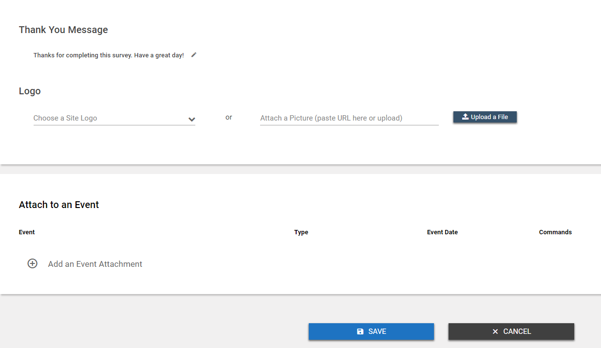
Figure 6.3
- Select the event.
- Choose the time frame after the event that the survey will Activate and Deactivate. *Note: Active surveys can be answered by anyone with access to the survey link.
- If this event included registration, check the box to Email Registrants a link to this survey when it is activated.

Adding Survey Questions
If you used a template, or copied an existing survey, any existing questions will show on the screen. If you chose to create a new survey, this area will be blank.

Adding a New Question
- Choose the question type by clicking on the appropriate icon and dragging it to the survey builder area.
- Enter the question text, including any answer option text, if applicable.
- To make this a required question on the survey, check the box next to Required.
- If you would like to provide more information about this question, in addition to the question text, check the box next to Description and enter the Description text.
- If this is a question you would like to use on multiple surveys, check the box next to Save Question To Library.
- Click Save.
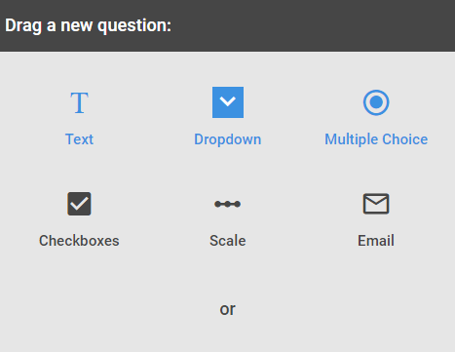
Figure 6.4

Adding a Question from the Question Library
- To add a question from the question library, click and drag the question to the appropriate place in the list of questions.
- Questions can be reordered by hovering over the left side of the question box and clicking on the arrows icon. Drag the question to the correct location in the list.
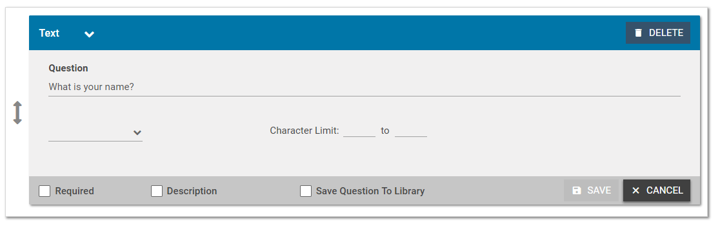
Figure 6.5

Saving the Survey
- If you would like to Create a template from this survey, check the box at the bottom of the screen as shown in figure 6.6 below.
- If you would like the survey to be active immediately upon saving, check the Activate Survey immediately box. Active surveys can be answered by anyone who has been given the survey link.
- When all questions have been added and are in the correct order, click Save to add this survey to the survey list.
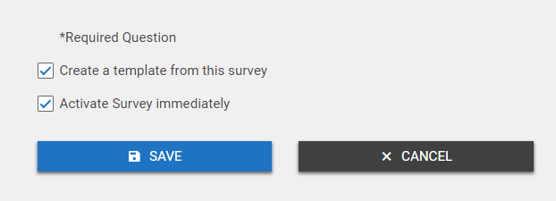
Figure 6.6

Saving and Publishing an Event
- Click the Save button at the bottom of the form to save the details of the event. *Note: This does not submit the event for approval or publish the event to the calendar.
- Click the Submit button to save the event and submit it for review and approval. *Note: Only Standard users will see the Submit button.
- Click the Publish button to save the event and publish it on the calendar. *Note: Only Site Administrators and Tenant Administrators will see the Publish button.
- Click the Discard button to cancel requesting the event and return to the Events Dashboard.
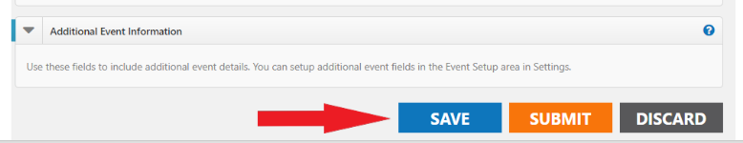
Figure 6.7

Appendix A
Click here for more detailed help and instructions.

Appendix B
List of all Events Calendar Site Administrators

Appendix C
Events Calendar Provisioning – Approval Form

